Melbourne Water System Strategy

Melbourne Water
990 La Trobe Street, Docklands, Vic 3008
PO Box 4342 Melbourne Victoria 3001
Telephone 131 722 Facsimile 03 9679 7099
melbournewater.com.au
ISBN 978-1-925541-07-6
© Copyright March 2017 Melbourne Water Corporation. All rights reserved.
No part of the document may be reproduced, stored in a retrieval system, photocopied or otherwise dealt with without prior written permission of Melbourne Water Corporation.
Disclaimer: This publication may be of assistance to you but Melbourne Water and its employees do not guarantee that the publication is without flaw of any kind or is wholly appropriate for your particular purposes and therefore disclaims all liability for any error, loss or other consequence which may arise from you relying on any information in this publication.
All actions in this strategy will be delivered subject to funding.

Foreword
Water is essential to making Melbourne a vibrant, liveable and sustainable city both now and in the future. It underpins the health of people and the environment, enhances community well-being, and supports economic growth and jobs.
Our growing city and changing climate present challenges for managing water resources across Melbourne and the surrounding region.
This Melbourne Water System Strategy describes how we will continue to work together with our partners, customers and the community to make Melbourne a great place to live in the face of these challenges. In this strategy we take a long-term view, considering the water resource management challenges and opportunities across the Greater Melbourne region over the next 50 years. The strategy outlines an adaptive portfolio approach: we will make the most of the water supply system, support the community to use water even more efficiently, diversify the sources of water we use, and optimise the water grid and market.
This is one of our key strategies that collectively outline our contribution to implementing the Victorian Government’s water plan, Water for Victoria and that guide our vital contribution to the daily lives of Melburnians through a commitment to healthy people, places and the environment.
Making our city liveable and sustainable is a shared responsibility. During the development of the Melbourne Water System Strategy we worked closely with our customers, government and the community. Collaboration will also be essential to implementing the Melbourne Water System Strategy – a liveable city is built through strong and effective partnerships. Throughout the implementation of this strategy, we will use the latest available information and projections, and adapt our approach to ensure it remains aligned with community needs and expectations as we meet the challenges of Australia’s fastest growing city in a changing climate.
We will continue to deliver safe, affordable, and reliable water services to all our customers, enhancing life and liveability across Melbourne and the surrounding region.
John Thwaites, Chairman.
Michael Wandmaker, Managing Director.

Aboriginal acknowledgement
Melbourne Water proudly acknowledges Aboriginal people as Australia’s first peoples and the local Traditional Owners as the original custodians of the land and water on which we rely and operate. We pay our respects to their Elders past, present and future.
We acknowledge the continued cultural, social and spiritual connections that Aboriginal people have with the lands and waters, and recognise and value that the Traditional Owner groups have cared for and protected them for thousands of generations.
In the spirit of reconciliation, we remain committed to working in partnership with local Traditional Owners to ensure their ongoing contribution to the future of the water management landscape while maintaining their cultural and spiritual connections.

Contents
Summary 5
1. Introduction 15
The challenges we face 29
2. Our growing and changing region 30
3. Our changing and variable climate 42
Meeting the Challenges 61
4. Making the most of the water supply system 62
5. Using water efficiently 87
6. Using diverse sources of water 102
7. Optimising the water grid and market 117
Appendix A Exploring possible implementation scenarios 132
Appendix B Reference guide to Melbourne’s water supply system 145
Appendix C Notes on water balance for Melbourne 160
Abbreviations 162
Glossary 163
Endnotes 172

Summary
Melbourne Water treats and supplies drinking and recycled water, removes and treats most of Melbourne’s sewage, and manages waterways and major drainage systems across the Port Phillip and Westernport region. Our vision is ‘Enhancing Life and Liveability’.
The services Melbourne Water provides are integral to the liveability of Melbourne and the surrounding region, underpinning public health and safety, and supporting active transport links, recreation, urban cooling, and a sense of community and place.
There are many stakeholders and customers of our services with whom we work in partnership: the community, Traditional Owners, retail water corporations, regional water corporations, Southern Rural Water, the Victorian Environmental Water Holder, developers, local governments, and state and Commonwealth governments. We engage extensively with the community of Melbourne to understand and embrace their needs. Throughout this strategy, the importance of working together with our customers and stakeholders to provide integrated and valued services to the community is a key theme.

Developing the Melbourne Water System Strategy
The Melbourne Water System Strategy presents a system view of water resource management across Melbourne and the surrounding region over the next 50 years.
This strategy addresses the requirements of the Statement of Obligations issued by the Minister for Water, and the associated Guidelines for the Development of Urban Water Strategies and the Melbourne Water System Strategy prepared by the Department of Environment, Land, Water and Planning (endnote 1). The Melbourne Water System Strategy also outlines Melbourne Water’s contribution to implementing relevant policy directions set by Water for Victoria, the Victorian Government’s water plan.
We face a number of challenges as we look toward 2065. This strategy explores the challenges we face, and outlines an adaptive portfolio approach to meeting the challenges: making the most of the water supply system, using water efficiently, using diverse sources of water, and optimising the water grid and market.
This strategy identifies key directions and opportunities for Melbourne Water over the next 50 years, and is structured around two key groups of challenges, and the four elements of our portfolio approach illustrated in Figure 1.

Figure 1. The Melbourne Water System Strategy explores the challenges we face and outlines an adaptive portfolio approach to meeting the challenges
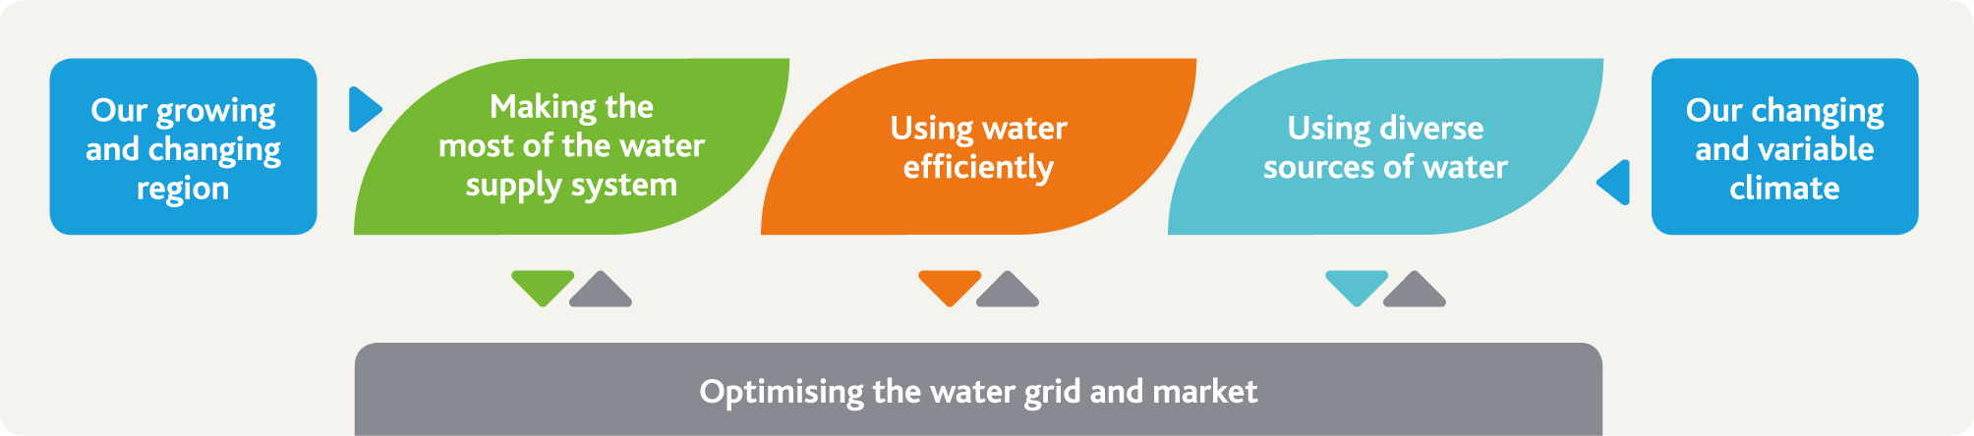

Challenges we face
This strategy explores two key challenges affecting Melbourne Water’s management of water resources:
our growing and changing region
our changing and variable climate.

A changing and growing region
Over the next 50 years, the population of Melbourne and the surrounding region will continue to grow. Although it is growing rapidly around the edges, metropolitan Melbourne is also becoming an increasingly dense city. Having access to safe, affordable water – for households, businesses, and other users, and for keeping our open spaces green – is essential for Melbourne as a vibrant, growing city. At the same time, we need to ensure our waterways and wetlands receive the environmental water they need to thrive.

A changing and variable climate
To plan and manage Melbourne’s water resources we need to understand the relationship between climate and water availability from our assets. We live in a variable climate: research suggests that there have been regular droughts in Australia for thousands of years (endnote 2).
We need to be prepared for droughts – potentially even droughts more significant than the Millennium Drought we observed between 1997 and 2009. Victoria’s climate is changing, and will continue to change in the future, leading to an expected long-term decline in rainfall over our water supply catchments. To plan our water needs, we need to know how much water we can expect from the water supply system and compare this against our long-term demand scenarios. We also need to plan for impacts on water quality, waterway health, stormwater and sewage.

Meeting the challenges
The water supply system we depend on today has been shaped by the foresight and planning of earlier generations. Since 1857, when Melbourne’s first water supply reservoir was completed and began to supply water, the water supply system has gradually grown to become the reliable source of high quality water we enjoy today.
In planning for the future, we need to consider new and innovative approaches that:
respond to long-term patterns of cultural, social, environmental and economic change
enhance the liveability of Melbourne and the surrounding region
capitalise on opportunities to strengthen the effective use of rainwater, stormwater and recycled water.
The complex challenges we face mean that there is no single solution. We take a thorough and robust approach to identifying and evaluating all potential water resource management options. This strategy outlines an adaptive portfolio approach, as described in Figure 1, involving:
making the most of the water supply system
using water efficiently
using diverse sources of water
optimising the water grid and the south central market.
This strategy outlines the strategic directions and actions we will take to explore and deliver each element of our portfolio approach.

Making the most of the water supply system
More than four million people in Melbourne and the surrounding region are currently connected to the water supply system. The reliable, high quality water from the water supply system supports liveability, economic growth and jobs across Melbourne and the surrounding region. In Melbourne, the water supply system is currently the primary, and often the only, source of supply for many people. Some elements of the system also deliver environmental water and water to irrigators.
We will continue to manage available water resources to deliver as much value as possible for all of our customers and the environment through the existing water supply system, including the Victorian Desalination Project.

Using water efficiently
The Millennium Drought from 1997 to 2009 highlighted that water from any source is a valuable resource, which we need to use efficiently. Melburnians made some great achievements during the Millennium Drought, with water consumption decreasing by more than 30% between 1997 and 2009 despite the population growth that occurred during that time – around 500,000 additional people in Melbourne. Building on these achievements, there may still be opportunities to use water more efficiently. The community expect an ongoing focus on water efficiency – not just during droughts.

Using diverse sources of water
Rainwater, stormwater and recycled water are valuable resources which can potentially be used to reduce demand on the water supply system. These water resources are expected to continue to grow in volume in the future, as our population grows and more land becomes covered with impervious surfaces like roofs and roads.
Working out how to best use rainwater, stormwater and recycled water resources is complex, and different approaches will need to be taken in different parts of Melbourne and the surrounding region to ensure we provide water servicing solutions that meet the needs of local communities.
We will work with the Department of Environment, Land, Water and Planning and our customers to undertake place-based planning to evaluate, plan, deliver and manage solutions that use diverse sources of water and contribute to the liveability of Melbourne and the surrounding region. By working with our customers and stakeholders to capture and use these resources, we will support flood management and the health of waterways and bays across our region. We need to consider and realise these broader benefits of using diverse sources of water in our evaluation, planning, delivery and management frameworks.

Optimising the water grid and the market
The water grid, and the water market that emerges from the south central market trial (outlined in Water for Victoria) will support the portfolio approach we outline in this strategy.
Water can be transferred through the water grid across our region to our customers wherever it is needed most. Together, we can enable and optimise investments in the water supply system, water efficiency initiatives, and diverse sources of water like rainwater, stormwater and recycled water.
Making the most of the water supply system, and ongoing investment in water efficiency initiatives and diverse sources of water will help to defer any need for major augmentations of the water supply system. However, in the longer term, with climate change and population growth, the capacity of the water supply system may need to be augmented within the next 50 years to ensure that enough water is available to meet all of our customers’ needs across Melbourne and the surrounding region through the water grid.

Actions the Melbourne Water System Strategy will drive
Throughout this strategy we have included 38 actions that, collectively, will help manage the challenges we face over the next 50 years, with a focus on actions that will be taken over the next 5 years. Although some actions will be delivered by Melbourne Water alone, the majority of them will be delivered in partnership with our customers and stakeholders. Figure 2 summarises the actions in the Melbourne Water System Strategy, mapping the benefits of each action to the three pillars that underpin Melbourne Water’s vision: healthy people, healthy places and healthy environment.
Figure 2. Tables describing actions in the Melbourne Water System Strategy and their benefits
Action number | Actions in introduction | Healthy People | Healthy Places | Healthy Environment
1.1 | Develop a long-term strategic engagement plan in partnership with Traditional Owners | • | • | •
1.2 | Understand and reflect community needs and expectations in our business activities | • | • | •

Action number | Actions in chapter 2 related to our changing and growing region | Healthy People | Healthy Places | Healthy Environment
2.1 | Explore opportunities to use our land to deliver improved green spaces for shade and cooling | • | •
2.2 | Ensure our core service strategies are linked across the water cycle | • | • | •
2.3 | Enable the community to use our land assets to enhance liveability | • | •
2.4 | Work to improve demand forecasts to enhance consistency and accuracy | •

Action number | Actions in chapter 3 related to our changing and variable climate | Healthy People | Healthy Places | Healthy Environment
3.1 | Invest in climate research and operationalise outcomes to build resilience | • | • | •
3.2 | Become a net-zero greenhouse emissions business |  |  | •
3.3 | Define climate risks to environmental values of waterways and wetlands |  | • | •

Action number | Actions in chapter 4 related to making the most of our water supply system | Healthy People | Healthy Places | Healthy Environment
4.1 | Update annual operational planning to continue to meet customer needs, improve transparency and address climate change impacts | •
4.2 | Review arrangements for operation of the Thomson Reservoir hydroelectric plant to prepare for future opportunities | •
4.3 | Review desalinated water order advice development process | •
4.4 | Identify potential improvements to the way we deliver environmental water |  |  | •
4.5 | Continue to develop asset management and information systems and reports, and improve integration with other processes to support optimal asset management | • | • | •
4.6 | Establish clear roles, responsibilities, strategic objectives and management plans for our forested water supply catchments | • |  | •
4.7 | Continue to identify efficient and innovative approaches to managing emerging water quality risks in our water supply catchments | • |  | •
4.8 | Review system performance analysis at least every three years | •
4.9 | Drive integration between water supply system models used by Melbourne Water and our customers | •
4.10 | Explore options to make the most of existing water entitlements and water supply assets | • |  | •
4.11 | Undertake study to understand the trade-off between water quantity, quality and affordability of water from catchments under climate change | •

Action number | Actions in chapter 5 relating to using water efficiently | Healthy People | Healthy Places | Healthy Environment
5.1 | Support delivery of the Target 155 program | •
5.2 | Collaborate to deliver research on water efficiency into the future | •
5.3 | Periodically review the drought preparedness plans for Melbourne | • | •
5.4 | Build a shared understanding of the costs and benefits of water restrictions | • | •
5.5 | Review the Water Outlook to ensure it meets community needs | •

Action number | Actions in chapter 6 related to using diverse sources of water | Healthy People | Healthy Places | Healthy Environment
6.1 | Collaborate through integrated water management forums and plans to deliver up to 80 GL/yr (subject to further investigation) from diverse sources of water instead of the water supply system by 2065 | • | • | •
6.2 | Investigate use of diverse sources to deliver environmental water |  |  | •
6.3 | Enhance capabilities to model diverse sources of water to support investment decisions | •
6.4 | Monitor applications of diverse sources and associated community views | • | • | •
6.5 | Support the development of a comprehensive and transparent investment evaluation framework | • | • | •

Action number | Actions in chapter 7 relating to optimising the market and grid | Healthy People | Healthy Places | Healthy Environment
7.1 | Examine possible future Sugarloaf (North-South) Pipeline management options | •
7.2 | Support the development of a water grid oversight function | • |  | •
7.3 | Support the south central market trial | • |  | •
7.4 | Continue to identify and evaluate potential long-term water supply options that could add capacity to the water grid | •
7.5 | Develop a water resources information management plan | • |  | •
7.6 | Streamline our water allocation and accounting processes and information | •
7.7 | Enhance water resources modelling and analysis capabilities to improve decision support | • |  | •
7.8 | Review our network of streamflow, groundwater and climate information monitoring sites to support ongoing knowledge development | • |  | •

Implementing the Melbourne Water System Strategy adaptively
This strategy forms one element of the broader adaptive management framework used by the water industry to ensure that our collective planning, capital works delivery and operational activities are matched to our operating environment. In this strategy, adaptive management refers to a systematic process of continuously updating and improving water resource management practices, to ensure they always reflect the latest available information and technology, as described in Figure 3. Adaptive management enables actions to be taken even when the future is uncertain, and ensures those actions reflect any lessons that can be learned from the past or from other places. We plan to review and update the Melbourne Water System Strategy every five years.
We will implement the Melbourne Water System Strategy adaptively, but it is clear that there are some elements of our portfolio approach which we need to focus on in the short term to enable them to play a key role in the longer term. Using diverse sources of water and optimising the water grid and market are currently the least mature elements of our portfolio approach, and we need to focus on them especially over the next five years, in addition to retaining our focus on the other elements. These implementation priorities are described in Figure 4.

Figure 3. Adaptive management process
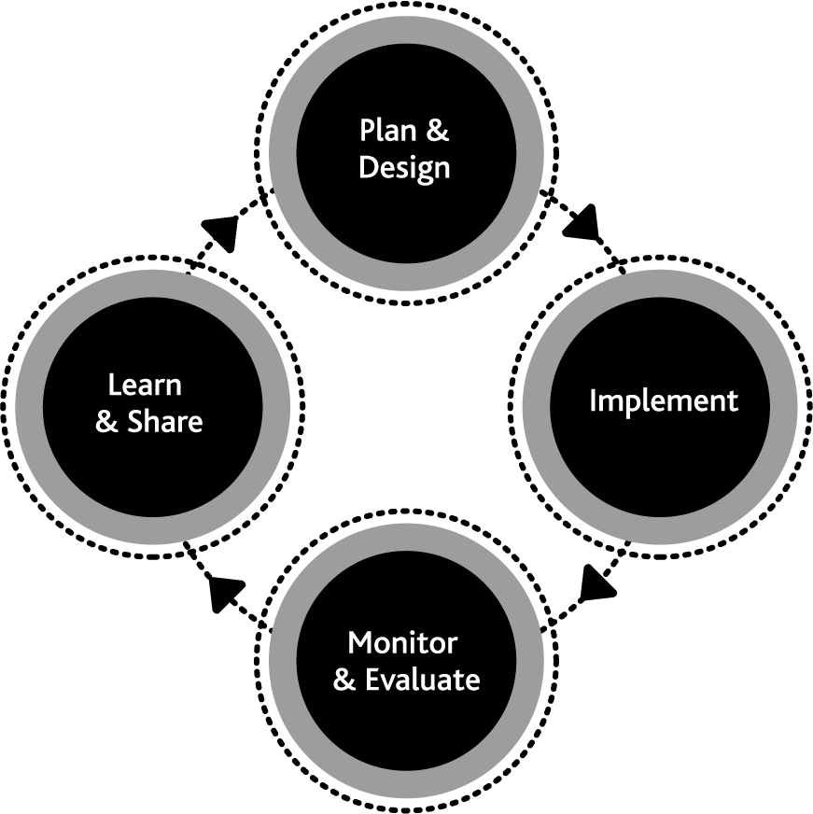
Figure 4. The Melbourne Water System Strategy implementation priorities
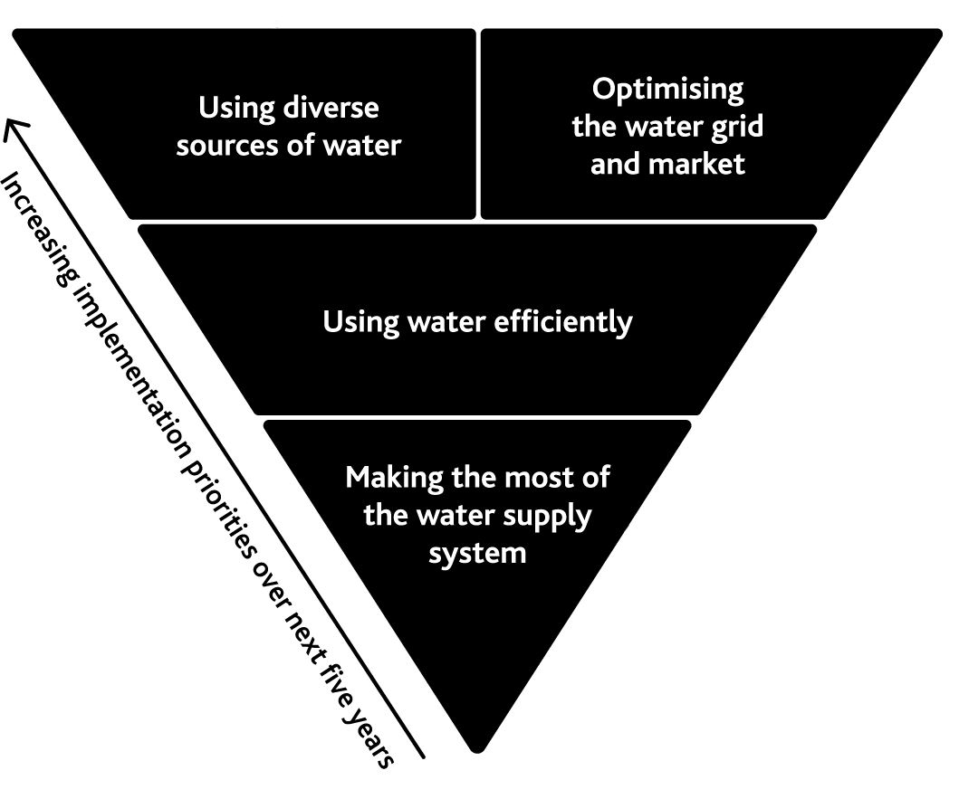

Using diverse sources of water
Our priority is to use sources of water like rainwater, stormwater and recycled water whenever the benefits outweigh the costs. Harnessing these sources of water will enhance the liveability of our city.
Optimising the water grid and market
The water grid and market have important roles to play in supporting the use of diverse sources of water and other elements of the portfolio approach outlined in this strategy, so these are also a high priority.

Using water efficiently
The community expects Melbourne Water and the retail water corporations to be encouraging and supporting ongoing water efficiency. Opportunities to use water even more efficiently may exist, although it is unlikely using water more efficiently will be able to drive the rapid and significant reductions in the demand for water seen over the past 20 years – we already use water efficiently in Melbourne.

Making the most of the water supply system
The water supply system is the primary, and often the only source of water for the community in and around Melbourne. Optimising our existing water supply system, including the Victorian Desalination Project, is important to ensure services from the water supply system are as affordable as possible.
In the longer term, potential augmentations of the water supply system and the water grid may need to be considered under some scenarios of climate change and demand growth, but only after we have fully explored the potential of water efficiency initiatives and sources of water like rainwater, stormwater and recycled water.

Implementation scenarios and insights
To explore how this strategy could be implemented adaptively under different climate change scenarios and demand scenarios, we considered three broad strategic scenarios:
- low change scenario: lower growth in water demands and low climate change
- incremental change scenario: medium growth in water demands and medium climate change
- rapid change scenario: higher growth in water demands and high climate change.
Discussion of how this strategy would be implemented adaptively under each of these scenarios is included in Appendix A.
When we considered these scenarios, some trends and themes emerged, which we then reflected in the actions in this strategy. Key trends and themes include:
Melbourne Water cannot deliver this strategy alone – we need to continue to work closely with our customers and stakeholders.
Ongoing investment in water efficiency is required under all future scenarios – even those with lower demand growth and climate change impacts.
Diversifying our sources of water by using rainwater, stormwater and recycled water is important under all future scenarios – the community expects us to invest in these sources, and it will help with flood management and protecting the health of our waterways and bays.
The water grid and market are becoming increasingly important – even under the scenarios where no water resource shortfalls occur, we need to be able to move water around our region to ensure it can be supplied when and where it is needed most, for both environmental and consumptive purposes.
Making the most of the existing water supply system will remain a key foundation of water resource management in Melbourne and the surrounding region, especially to ensure we are well prepared for future droughts – we need to keep a buffer of water in storage, subject to cost, for maintaining supply through future severe droughts which may last for more than a decade.
Despite ongoing investment in water efficiency and diverse sources of water, there are some scenarios where major augmentations of the water supply system and the water grid may be necessary. We need to work with our customers and stakeholders to ensure we are prepared by exploring options, adaptive pathways, and trigger points for strategic water resource planning and investment decisions.

1. Introduction
This Melbourne Water System Strategy describes the challenges we face and actions we will take to meet the needs of our customers and the community over the next 50 years, to ensure the Melbourne water system will continue to support a prosperous and liveable city.

Our actions and their benefits
Action number | Actions in introduction | Healthy People | Healthy Places | Healthy Environment
1.1 | Develop a long-term strategic engagement plan in partnership with Traditional Owners | • | • | •
1.2 | Understand and reflect community needs and expectations in our business activities | • | • | •

About this strategy
This strategy has been developed to align with the policy objectives identified in Water for Victoria, and reflects Melbourne Water’s vision of enhancing life and liveability.
The Minister for Water, through the Statement of Obligations (General), requires Melbourne Water to prepare a Melbourne Water System Strategy (MWSS) once every five years. This strategy reflects the requirements of the Statement of Obligations as well as the associated Guidelines for the Development of Urban Water Strategies and the Melbourne Water System Strategy prepared by the Department of Environment, Land, Water and Planning (DELWP).
In this strategy we take a long-term view, considering the water resource management challenges and opportunities across the Greater Melbourne region over the next 50 years. We also consider relevant recent history, whenever understanding the past can help us to prepare for the future.
This strategy has been developed in collaboration with our customers and is aligned with their urban water strategies and other strategic planning processes. More information about our customers is included later in this chapter.

The state water plan: Water for Victoria
Water for Victoria is the Victorian Government’s state-wide plan for water. It identifies priorities for water management across the state and sets the following vision:
Water is fundamental to our communities. We will manage water to support a healthy environment, a prosperous economy and thriving communities, now and into the future.
The MWSS is one of a linked set of strategies prepared by Melbourne Water, our customers, and our stakeholders, which work together to deliver the objectives of Water for Victoria.

Melbourne Water: enhancing life and liveability
Owned by the Victorian Government, Melbourne Water treats and supplies drinking and recycled water, removes and treats most of Melbourne’s sewage, and manages waterways and major drainage systems across the Port Phillip and Westernport region.
Melbourne Water is committed to working with government, our customers and other stakeholders to deliver the objectives of the MWSS and Water for Victoria.
Melbourne Water’s formal roles that are relevant to this strategy include:
Storage Manager. We plan, deliver, maintain and operate the infrastructure we use to harvest, store, treat and transfer water across the Greater Melbourne region.
Resource Manager. We provide water allocation and water accounting services across the Greater Melbourne region.
Waterway Manager. We are the designated caretaker of river health for the Port Phillip and Westernport region, with responsibility for ensuring that rivers, wetlands and estuaries are protected and improved for the community.
Melbourne Water has a number of statutory obligations as defined in the Water Act 1989 and in various instruments including the Statement of Obligations, bulk entitlements and service agreements.
Our diverse roles across the Greater Melbourne region mean that we influence a range of factors that make Melbourne the most liveable city in the world.

Healthy people, healthy places, healthy environment
Water is central to life. It sustains the natural environment we live in, the communities we value and the economy we depend upon.
Melbourne Water’s vision of ‘enhancing life and liveability’ is supported by our three pillars.

1. Healthy people
By providing safe, affordable, world-class drinking water and sewage treatment, we protect public health and strengthen the wellbeing of our community.

2. Healthy places
By managing the impacts of climate change, protecting the region from floods and facilitating enhanced public access to nature and green spaces we co-create more desirable places to live.

3. Healthy environment
By being innovative with resource recovery, reducing our greenhouse emissions and improving the quality of waterways, we enhance biodiversity and help protect our natural assets of healthy people, healthy places and a healthy environment.

Highlight box - What is liveability?
At Melbourne Water, we consider that liveability reflects the wellbeing of a community, and the many characteristics that make a place where people want to live, now and in the future. A liveable city or region meets the basic social, environmental and economic needs of its people. It also addresses community values and preferences for amenity, wellbeing and a sense of place.
Melbourne Water aims to enhance liveability by providing services that maximise the social benefits for the community. We do this by considering, across our business activities:
existing liveability attributes, such as public health and public safety
enhanced liveability attributes, such as active transport links, recreation, urban cooling, sense of community and sense of place.
End highlight box.

Sustainable Development Goals
Melbourne Water is a signatory to the United Nations Global Compact, the world’s largest corporate sustainability initiative, and we have made a public statement of support for the United Nations Sustainable Development Goals (SDGs). These aim to mobilise efforts to end all forms of poverty, fight inequalities and tackle climate change.
The Sustainable Development Goals provide a common set of goals to put the world on a sustainable path by 2030 and have been adopted globally by 193 countries.
The vital role of water in creating and delivering sustainable communities puts Melbourne Water in a key position to contribute.
The goals build on our history in sustainability and the pillars of Melbourne Water’s vision align closely with Sustainable Development Goals 6, 11 and 15.
The interdependent nature of the goals also means that by delivering our vision Melbourne Water is contributing across all the goals. We aim to enhance our contribution to the Sustainable Development Goals through all of our activities.
Creating the world’s most liveable city is a collaborative effort. The Sustainable Development Goals provide us, our stakeholders, and our customers with a common framework to deliver improved community wellbeing and a better natural environment. The activities in this strategy have been linked to the goals to which they will contribute.
Figure 5. The United Nations Sustainable Development Goals
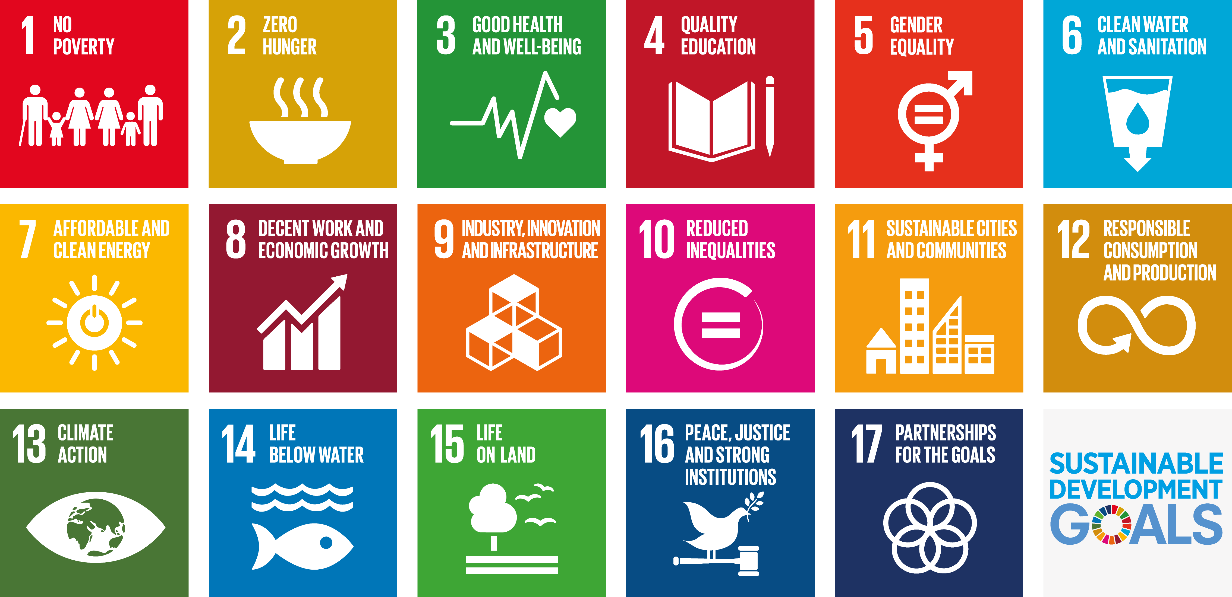

Aboriginal Victorians and Traditional Owners
Aboriginal people have a strong connection to land and waterways. Traditional Owners have managed land and waterways sustainably over thousands of generations.
Water for Victoria recognises this connection and announces the Aboriginal Water Program, a state-wide approach to incorporating Aboriginal values and expertise into water management activities.
This strategy contributes to the objectives of inclusion set out in Water for Victoria and with reference to Melbourne Water’s Reconciliation Action Plan (endnote 3), which is discussed further on the next page.
Melbourne Water has been working with Traditional Owners and Aboriginal Victorians for some years to ensure our management of land and waterways is aligned with Aboriginal values. This MWSS builds on this by explicitly including an action to begin working in partnership with Traditional Owners to include Aboriginal values in our strategic planning processes.
Building meaningful relationships requires ongoing engagement; this will take time. We have already started the process of delivering Action 1.1 in this strategy by holding initial discussions – the beginning of an ongoing conversation – with Traditional Owner groups across our service area.

Action 1.1
Develop a long-term strategic engagement plan in partnership with Traditional Owners.
Delivered by
Melbourne Water, retail water corporations, Western Water
Contributes to the following Sustainable Development Goals
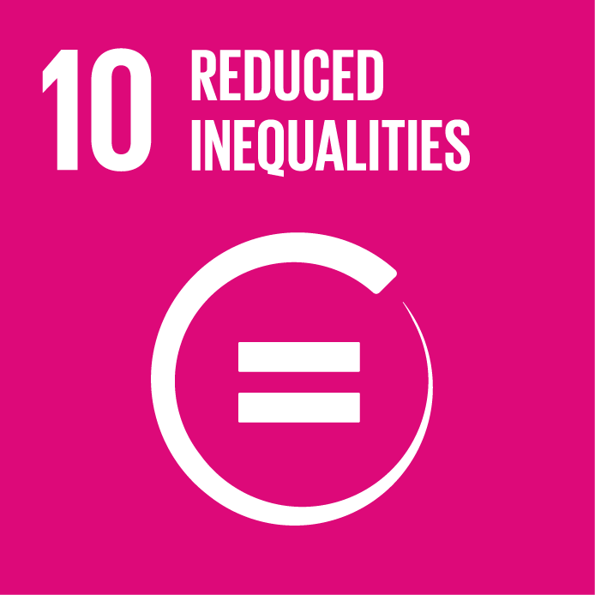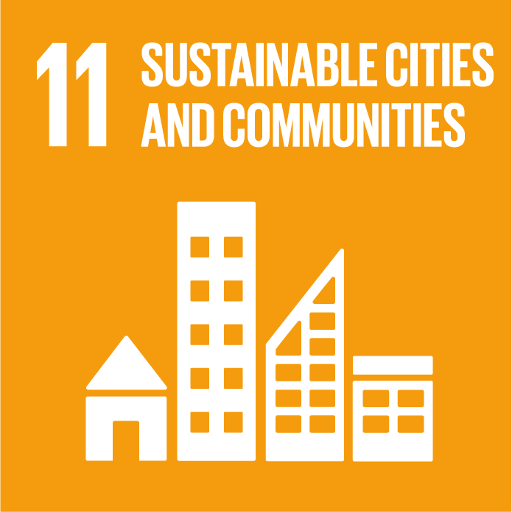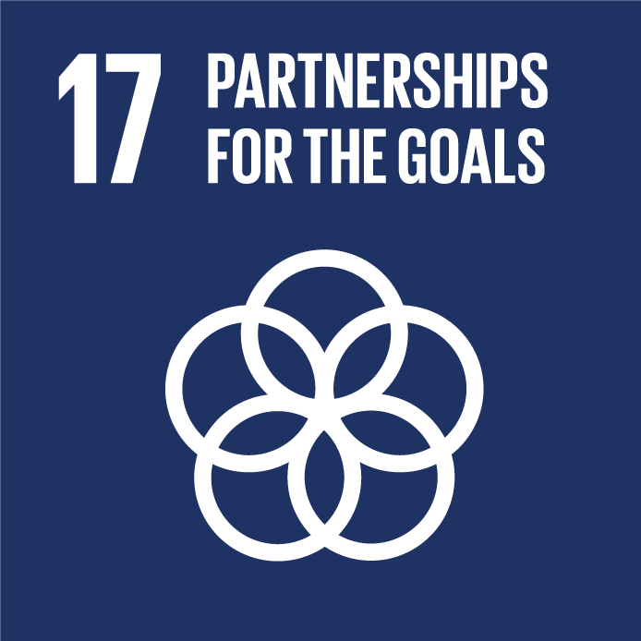

Highlight box - Melbourne Water’s Reconciliation Action Plan
We aim to work in partnership with local Traditional Owner groups to manage our natural resources, upon which our services heavily depend. We recognise that by diversifying and sharing our knowledge, while building meaningful relationships with the community, we can continue to successfully manage our land, water and ecosystems.
Our Reconciliation Action Plan is a natural extension of our commitment to creating a culturally diverse and inclusive business. It provides a framework to move beyond the legislative requirements concerning Aboriginal cultural heritage management, and will help us work towards reconciliation with the broader Aboriginal and Torres Strait Islander communities.
The plan builds our commitment to reconciliation by:
developing opportunities to improve and increase Aboriginal and Torres Strait Islander employment outcomes within Melbourne Water
investigating opportunities to incorporate Aboriginal and Torres Strait Islander diversity within our suppliers
training frontline employees in cultural awareness
providing continual cultural learning opportunities for all employees
working in partnership to support community-initiated cultural projects
participating in key reconciliation events (e.g. National Reconciliation Week, NAIDOC Week)
involving Traditional Owner groups in Melbourne Water open days
establishing a Reconciliation Action Plan Working Group.
The latest version of our Reconciliation Action Plan, which is currently being reviewed, will build on existing initiatives by delivering additional opportunities in a range of areas. The updated plan will include initiatives for developing business arrangements with Traditional Owners and Aboriginal enterprises, and providing all employees with opportunities for cross cultural learning.
End highlight box.

Highlight box - Mapping Aboriginal cultural values linked to the Yarra River
Melbourne Water is working to include Aboriginal values and traditional ecological knowledge when planning the delivery of environmental water. We are doing this through the Water Dependent Cultural Values of the Yarra River Project, which we are delivering in collaboration with the Wurundjeri Tribe and the Victorian Environmental Water Holder (VEWH).
We are engaging with Wurundjeri elders to identify environmental values, such as animals, plants and places that are culturally significant. We will consider the information each year and incorporate it into our seasonal watering proposal to the VEWH, which outlines the ecological objectives we seek to achieve by delivering water to the environment from water storage reservoirs.
We are taking an innovative approach, bringing together traditional ecological knowledge and the latest ecological and hydrological science. Having people with diverse skills working together like this helps us identify the core values that we share and helps us understand differing perspectives.
This project will act as a pilot to inform future options for working with Traditional Owners to deliver shared cultural benefits across the waterways we manage.
End highlight box.

Including the community in securing our water future
To understand how people see the role of water in our rapidly growing city, Melbourne Water worked with the retail water corporations to ask the community about how they value water, and how they think water should be managed in the future. Their responses were diverse; while there was no single representative community view on many issues, there were some significant trends.
In the community, water is highly valued, and seen as essential to life, yet is largely taken for granted. As a key outcome, the community wants sustained access to safe and affordable water services.
This strategy reflects the values and perspectives of the community, who told us they want:
a proactive and adaptive planning approach
water corporations to promote water-efficient behaviours
mild water restrictions when necessary, rather than paying more to avoid them
more use of stormwater and recycled water, but drinking water to still come from the water supply system
expansion of seawater desalination capacity to be the last resort
better, more proactive, and more engaging communication.
Using water to deliver liveability benefits like green open spaces and healthy environmental values in waterways were not front-of-mind issues for many people but, with some discussion, most people agreed they were important and should be considered in water planning and management (endnote 4).
This sort of community research is very valuable, because it enables us to review our services and ensure that they are aligned with community needs and expectations.

Action 1.2
Understand community needs and expectations on an ongoing basis and reflect them in our business activities.
Delivered by
Melbourne Water
Contributes to the following Sustainable Development Goals
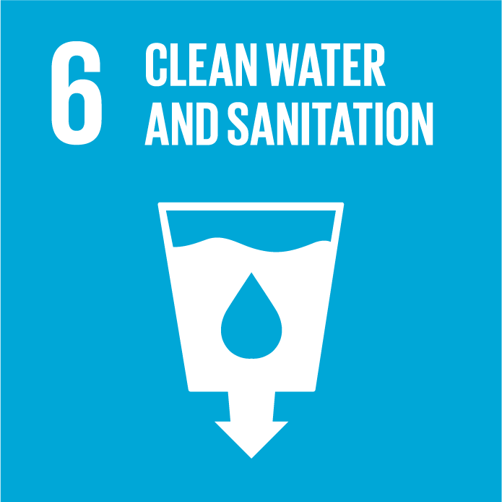

Highlight box - Community education programs
Melbourne Water has a range of established education programs designed to improve water literacy levels in the community. Our resources are tailored to primary, secondary and tertiary students, as well as the broader community.
Our education programs have been developed to improve understanding of water issues in the community and also support broader objectives including:
improving understanding of the impact of climate change on the community
increasing the uptake of science, technology, engineering and mathematics subjects in schools
providing materials that support the National School Curriculum, which covers water as part of Year 7 Science and Geography.
In 2016, we had more than 10,000 participants in our programs, ranging from tours of sewage treatment plants, to citizen science activities like monitoring frogs and platypus. Increasing water literacy facilitates better engagement with water users on a range of issues, from the importance of water efficiency in managing the water supply system into the future, to the impact of behaviour like littering and dumping waste in street gutters on waterways, the bays and the animals that live there. Through engagement and education programs we will continue to build a community that values water and the environment.
End highlight box.

The context of this strategy
Melbourne Water takes an integrated approach to the way we deliver our services; we consider the whole water cycle, and our strategies are linked in the way they explore our challenges and opportunities across the whole urban water cycle. The urban water cycle in Melbourne is illustrated in Figure 6.
This strategy is one of the key Melbourne Water strategies that outline how we deliver our current core services:
- Melbourne Water System Strategy (this strategy)
- Healthy Waterways and Stormwater Strategies (currently under review, refer to endnotes 5 and 6)
- Flood Management Strategy (endnote 7)
- Sewerage Strategy (to be developed in 2018).
These key strategies reflect Melbourne Water’s vision of enhancing life and liveability and embed the three pillars that underpin Melbourne Water’s vision – healthy people, healthy places and a healthy environment – into the way we do business. These strategies also enable Melbourne Water to articulate how we will deliver the policy objectives of Water for Victoria.
This strategy has been developed in parallel with the retail and regional water corporations’ urban water strategies, which set out their approaches to delivering water services to the community. This strategy is aligned with the retail and regional water corporations’ urban water strategies, with key collaborative actions appearing both in this strategy and relevant urban water strategies.

Figure 6. The urban water cycle in Melbourne
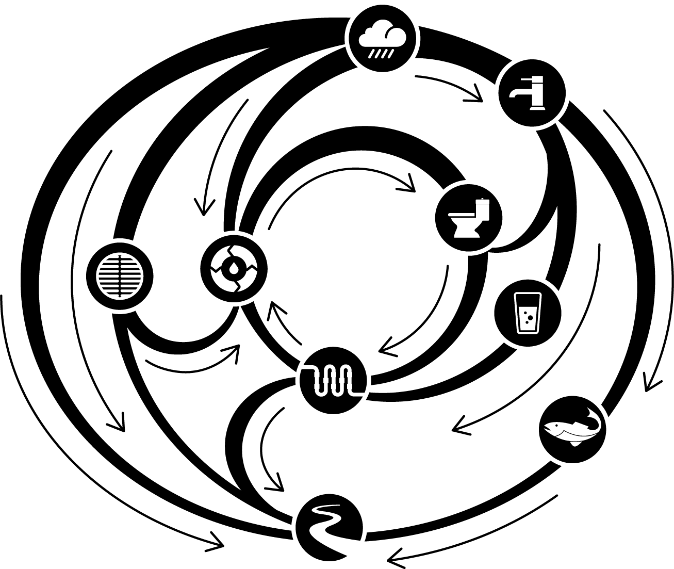

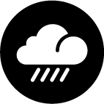 Rain
Rain falls across the region, on urban areas and our water supply catchments. When it rains, some water is used by vegetation, evaporated into the atmosphere or stored in the soil. The remaining rainfall runs off and flows into waterways where some is harvested for use and the rest flows into the bays.

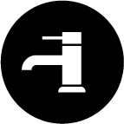 Water supply system
The water supply system includes forested and open water supply catchments, reservoirs and weirs used to harvest and store water, the Victorian Desalination Project, and the networks of rivers, pipes and pumps used to transfer water across the region to our customers.

 Uses of water
Water is used in Melbourne for a range of residential, commercial, institutional and industrial purposes. During the Millennium Drought from 1997 to 2009, total water consumption in Melbourne decreased by more than 30%, despite population growth of over 500,000 people in Melbourne during that time.

 Non-drinking uses of water
Uses like flushing toilets, washing clothes, and watering gardens, parks and sports fields do not need water suitable for drinking.

 Drainage system
When it rains on urban areas, the drainage system, which is managed by Melbourne Water and local councils, captures stormwater and channels it into waterways and bays. This helps to manage the impacts of urban flooding.

 Sewerage system
Most uses of water generate sewage that needs to be managed. The sewerage system captures sewage and transfers it to sewage treatment plants, where contaminants are removed so that the treated water can either be used as recycled water, or safely discharged into waterways, the bays, or Bass Strait.

 Rainwater, stormwater and recycled water
Rainwater and stormwater are sometimes harvested and used for some non-drinking uses. Similarly, recycled water is sometimes used for some non-drinking uses. This reduces the volume of water needed from the water supply system, and reduces the volume of stormwater and treated sewage discharged into waterways and bays.

 Environmental water
Environmental water is released from water supply systems into waterways to ensure they get enough water to support environmental values. Although it is primarily planned and delivered to support environmental values, environmental water can also help to support recreational and cultural values as shared benefits.

Waterways and bays
Waterways, Port Phillip Bay and Western Port support a range of economic, environmental and social values. The volume and quality of water in our waterways and bays have been changed as a consequence of urban development across the region – we need to work to manage the impacts of these changes on the values our waterways and bays support.

Highlight Box - Integrated water management
Integrated water management brings together consideration of all facets of the water cycle, as illustrated in Figure 6, to maximise social, environmental and economic benefits. By considering the whole water cycle when planning and delivering services, as well as key interfaces with urban development and broader land and resource management processes, we can take advantage of links between different elements and develop solutions that have broader benefits over a long period of time. This wouldn’t be possible if we planned and managed the water supply system, sewerage system, drainage system, and waterways in isolation.
Integrated water management is enabled by collaboration between community leaders, Traditional Owners, and planners from water corporations, local government, state government, catchment management authorities, and other relevant organisations.
The benefits of integrated water management often extend beyond the solution to the initial problem. Water for Victoria outlines five key elements of resilient and liveable cities and towns that can be delivered through an integrated water management approach:
safe, secure and affordable supplies in an uncertain future
effective and affordable sewerage systems
effective stormwater management that protects our urban environment
healthy and valued urban landscapes
community values reflected in place-based planning.
This strategy is one element of Melbourne Water’s approach to delivering integrated water management across Melbourne and the surrounding region.
End highlight box.
All of Melbourne Water’s core service strategies, the retail and regional water corporations’ urban water strategies, (and other plans and strategies prepared by our other customers) come together to inform, and be informed by integrated water management forums and plans as initiatives from Water for Victoria.
This strategy has also been developed in the context of the planned review of the Central Region Sustainable Water Strategy and development of Long-Term Water Resource Assessments, both of which will be led by DELWP over the next few years.
Figure 7 describes how all of these strategies relate to each other.

Figure 7. Strategies and processes related to the Melbourne water system
`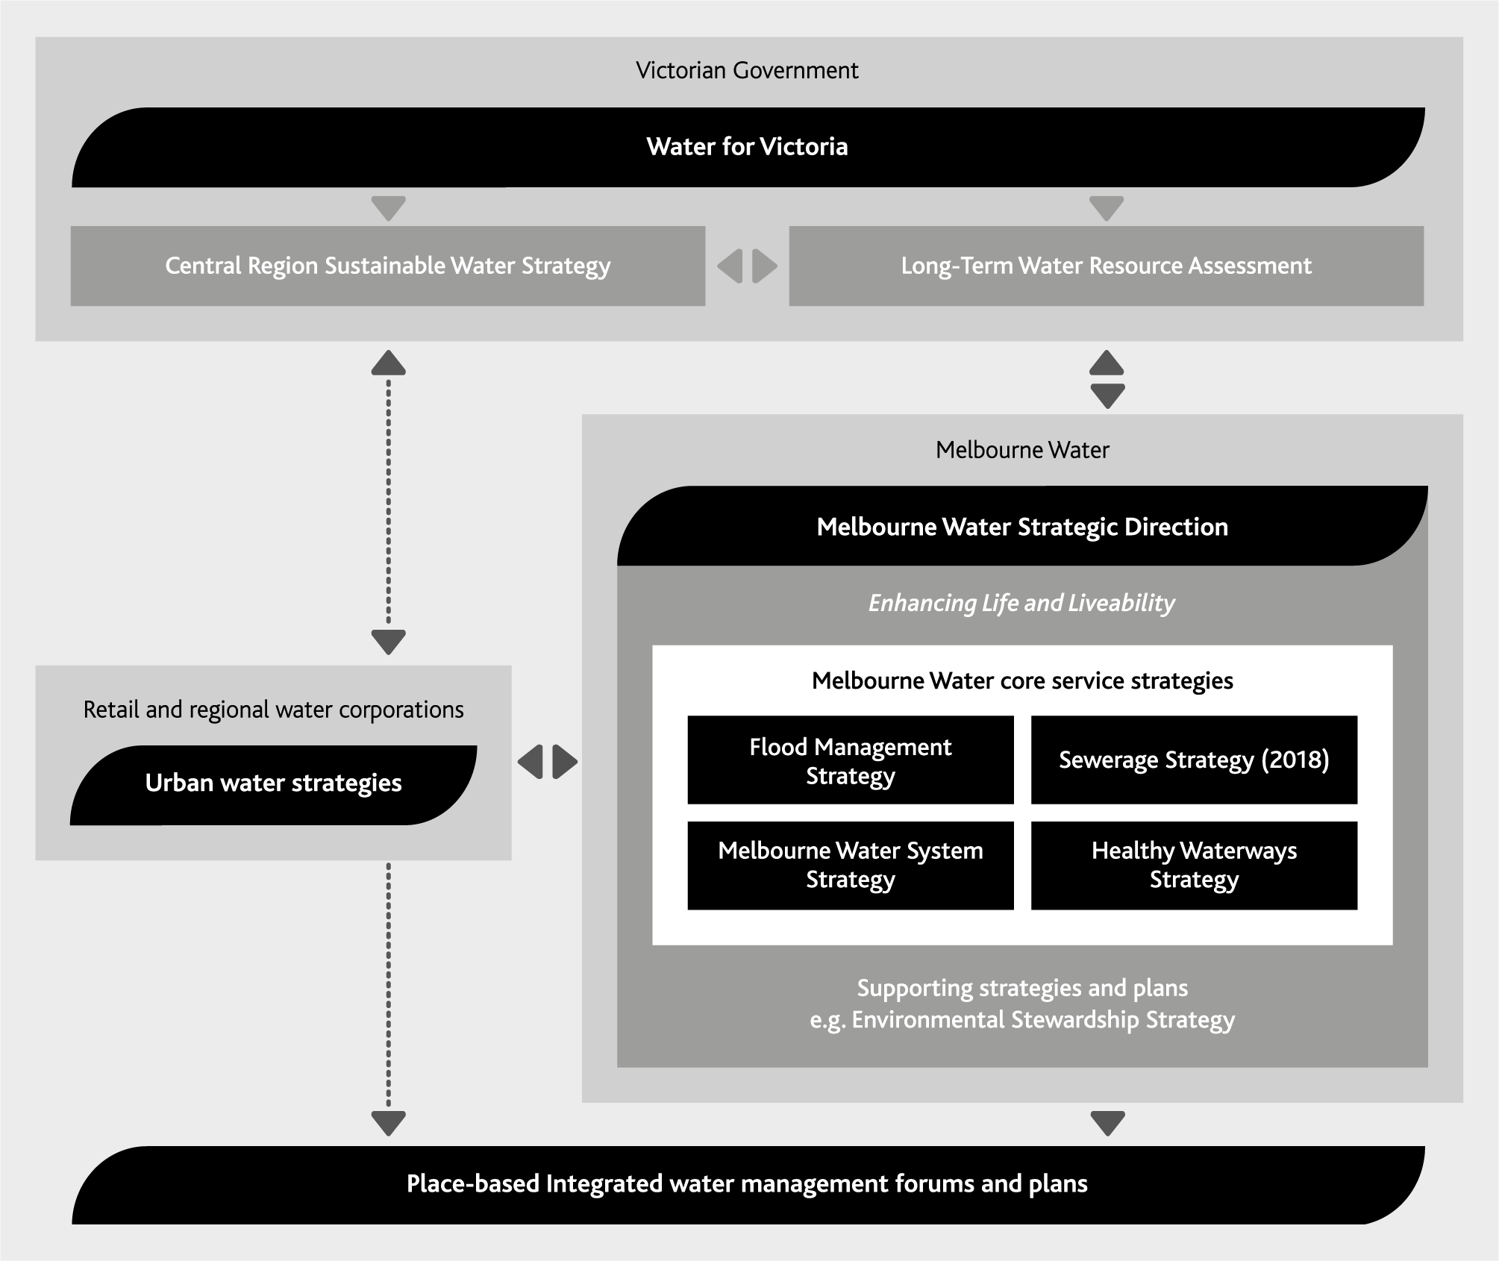

Scope of this strategy
This strategy considers the Melbourne water system: the natural and built infrastructure that is used to provide and deliver water to our customers and the environment across the Greater Melbourne region. This includes the water supply system, (illustrated in Figure 8) and comprises:
forested and open catchments used for supply of water
reservoirs and weirs used to harvest and store water from rivers and creeks
the network of rivers, pipes and pumps used to transfer water across the region
the Victorian Desalination Project – the newest element of the Melbourne water system – owned and operated by AquaSure and able to deliver up to 150 GL/yr of drinking quality water.
For the purposes of this strategy, the Melbourne water system also includes infrastructure to harvest, store, treat and transfer rainwater, stormwater and recycled water to provide for uses that otherwise would have to be serviced from the water supply system.
Figure 8. The water supply system
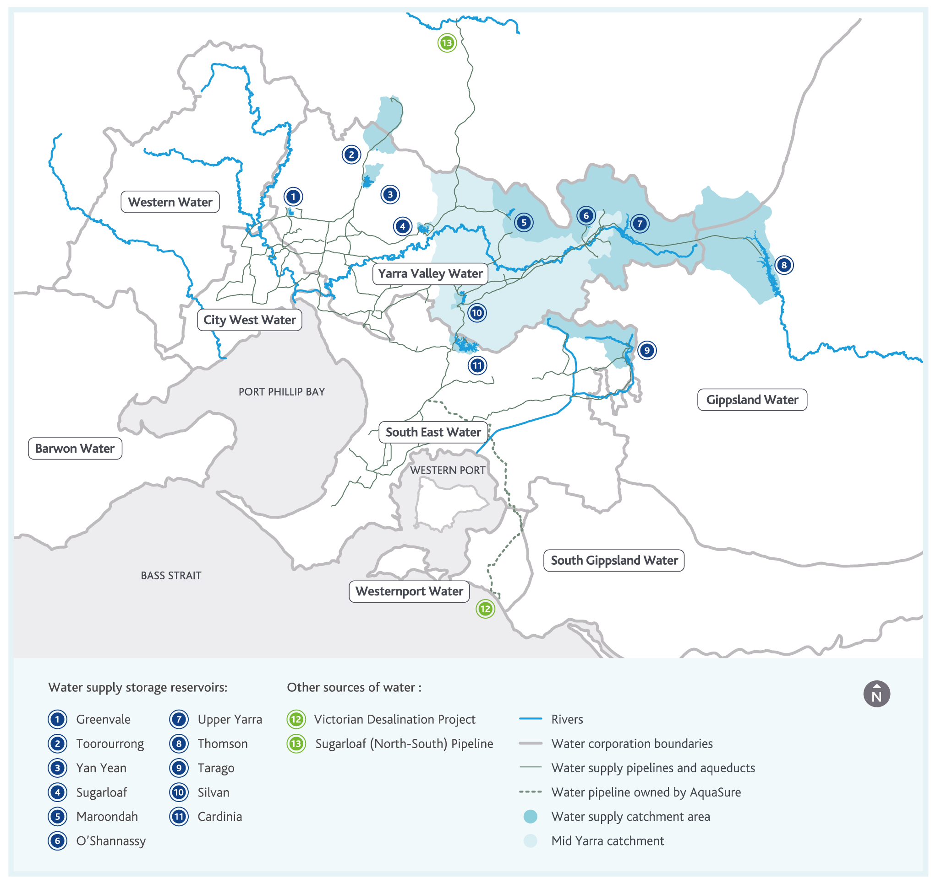

Highlight box - Diverse sources of water: rainwater, stormwater and recycled water
This strategy presents an overview of water resources available across Melbourne and the surrounding region – including rainwater, stormwater and recycled water, as illustrated in Figure 6. There are many definitions of rainwater, stormwater and recycled water. We use the following terms in this strategy:
Rainwater is the water that runs off roofs when it rains.
Stormwater is the water that runs off impervious surfaces like roads and footpaths when it rains, that would have seeped into the ground and been taken up by vegetation before urban development occurred. Unless rainwater is captured, it also contributes to stormwater.
Recycled water is water derived from sewage or trade waste that has been treated for the purposes of re-use.
Rainwater, stormwater and recycled water are sometimes called ‘alternative sources of water’ because they are alternatives to the sources traditionally used for water supply in Australia such as rivers, creeks and groundwater.
In this strategy we refer to rainwater, stormwater and recycled water as ‘diverse sources of water’ because they can introduce valuable diversity into our set of water supply options. This terminology is consistent with the broader objectives of integrated water management, which considers the roles of all water resources.
End highlight box.

Melbourne Water’s customers
Melbourne Water delivers services to many different customers across Melbourne and the surrounding region. This strategy focuses on customers that use the Melbourne water system, including the retail and regional water corporations, the Victorian Environmental Water Holder, Southern Rural Water, and the community.
The water services we deliver are enabled by the rights to water granted to each of the water businesses through bulk water entitlements. Melbourne Water holds source bulk entitlements to harvest water in catchments across the Greater Melbourne region, the largest of which are the Yarra River and Thomson River, which together form the Greater Yarra System – Thomson River Pool. Melbourne Water also holds entitlements to harvest water in the Tarago River and Silver Creek and Wallaby Creek catchments, which are tributaries of the Goulburn River.
The water we harvest is then allocated to our customers, who each hold a range of bulk entitlements describing the proportion of harvested water owned by them and held in water storage reservoirs.
There is more detail in Appendix B on the water entitlement structure that underpins the water services we provide our customers.

Retail water corporations
These are the retail water corporations that we work with to supply water to the community across metropolitan Melbourne:
City West Water
South East Water
Yarra Valley Water.
The water supply system is the primary source of water for the retail water corporations and, collectively, these customers use the largest volume of water from the system.

Regional water corporations
These are the regional water corporations that we work with to supply water to the community throughout the region surrounding Melbourne:
Western Water
Barwon Water
Westernport Water
South Gippsland Water
Gippsland Water.
The regional water corporations also have access to their own water resources from local weirs, reservoirs, groundwater and other sources. Consequently, their demands on the water supply system vary from year to year, depending on how much water is available from their own water systems. Compared to the retail water corporations, the regional water corporations currently take a relatively small, but growing, volume of water from the water supply system.

Victorian Environmental Water Holder
The Victorian Environmental Water Holder (VEWH) is responsible for holding and managing Victoria’s environmental water entitlements, which help to protect the environmental values of Victoria’s rivers, wetlands and floodplains.
As Waterway Manager for the Port Phillip and Westernport region, Melbourne Water works with the VEWH and relevant catchment management authorities to ensure environmental water entitlements are used to achieve the best environmental outcome possible with the water that is available. Across the Greater Melbourne region, Melbourne Water manages the Werribee, Maribyrnong, Yarra and Tarago River systems, while the West Gippsland Catchment Management Authority manages the Thomson River system.

Highlight box - Environmental water
Environmental water is used to ensure regulated waterways get enough water to protect environmental values.
The Victorian Government established the environmental water reserve to ensure that the environmental values and health of waterways are protected, even though water is being diverted from a waterway to support urban centres and agricultural activities.
The environmental water reserve is comprised of three key elements:
- minimum passing flows specified at key points along a waterway that must be delivered before any water is diverted for other purposes
- statutory entitlements to water which can be used flexibly by the VEWH to deliver specific environmental needs
- water available beyond the limits to the volume of water available to support urban centres and agriculture.
End highlight box.

Irrigation customers
There are a large number of irrigation customers across the greater Melbourne region and beyond. Many of these customers use relatively small volumes of water, related to more than 1900 licences Melbourne Water issues and manages for farm dams and diversions from waterways. These customers are considered through the Healthy Waterways Strategy.
We also supply water to Southern Rural Water. Among other activities, Southern Rural Water provides water services for a number of irrigation areas, including three key irrigated agriculture centres in the region surrounding Melbourne:
Macalister Irrigation District
Werribee Irrigation District
Bacchus Marsh Irrigation District.

The community
In this strategy, we define the community as the people who live, work or visit Melbourne and the surrounding region. Melbourne Water delivers water and sewerage services to the community through the retail and regional water corporations. We also provide waterways and drainage services directly to the community across the Port Phillip and Westernport region.
In this strategy, we have used the term ‘customers’ to refer primarily to the retail and regional water corporations, the VEWH, or Southern Rural Water, reserving the term ‘community’ for instances where we work directly with, or provide services directly to the community.

The challenges we face
Melbourne Water’s latest Operating Environment Scan identified 15 global trends that could have an impact on our business activities.
We identified the 15 trends (illustrated in Figure 9) through an extensive literature review, desktop scanning and one-on-one interviews. The desktop scan used a STEEP (social, technology, economic, environment and political) framework. We also obtained input from City West Water, South East Water, Yarra Valley Water, Western Water, the Water Services Association of Australia, and Water Research Australia (endnote 8)
Figure 9. The results from our latest Operating Environment Scan
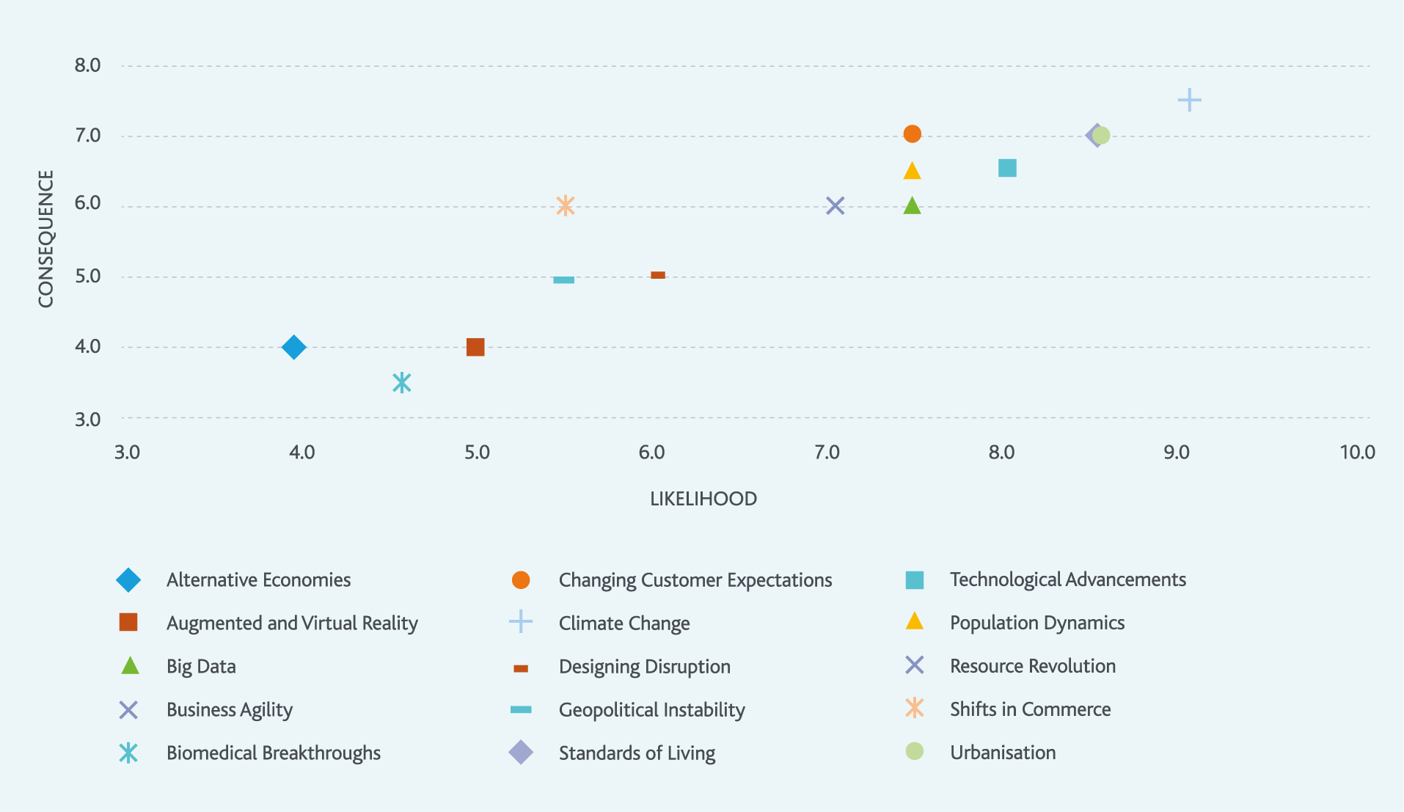
Reviewing our Operating Environment Scan, we grouped the key challenges into two categories, which we explore in the next two chapters:
Chapter 2: Our growing and changing region
Chapter 3: Our changing and variable climate.

2. Our growing and changing region
Melbourne and the surrounding region will continue to grow in the future. Delivering safe, affordable water to a growing city requires an integrated approach that considers the whole water cycle – one that meets the needs of the region as it grows.
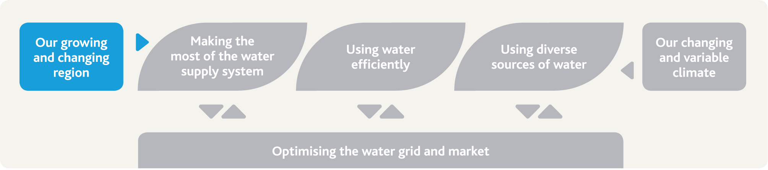

The challenge and our strategic response
Melbourne is a vibrant city of more than four million people. The population of Melbourne and the surrounding region is expected to almost double in size by 2065 – perhaps even more – increasing the demand for water.
The city will become denser as the population grows, generating even more stormwater and sewage, and presenting challenges to our infrastructure, and opportunities to harvest new resources.
All Melburnians, and those living nearby, will have access to safe, affordable, high quality water, regardless of the population of Melbourne and the surrounding region. Melbourne Water will work in close collaboration with our customers to meet the needs of our growing city and region.

Our actions and their benefits
Action number | Actions in chapter 2 related to our changing and growing region | Healthy People | Healthy Places | Healthy Environment
2.1 | Explore opportunities to use our land to deliver improved green spaces for shade and cooling | • | •
2.2 | Ensure our core service strategies are linked across the water cycle | • | • | •
2.3 | Enable the community to use our land assets to enhance liveability | • | •
2.4 | Work to improve demand forecasts to enhance consistency and accuracy | •

Our region is changing
Victoria in Future 2016, the official state government projections of population and households, shows that Victoria’s population is likely to continue growing over the coming decades – and Melbourne’s population will continue to grow faster than the rest of the state.
The latest projections from Victoria in Future suggest that from a base of about 4.5 million people in mid-2015, Melbourne’s population could grow to 8 million people by 2051 (endnote 9), and according to the water industry’s extrapolation of this projection, potentially as large as 10 million by 2065.
Data from the Australian Bureau of Statistics shows that in 2014/15, seven of the top ten growth areas in Australia (based on local government areas) were in Melbourne’s outer metropolitan region (endnote 10).
The projections also tell us that regional areas closest to greater Melbourne will also experience strong growth, placing even greater demands on the city’s infrastructure, including the water supply system.

Melbourne is becoming an increasingly dense city
Plan Melbourne, Victoria’s metropolitan planning strategy, describes an increasingly dense city – with the growing population housed within a permanent urban growth boundary (endnote 11). This means that while some of the population growth in Melbourne will be accommodated in the growth areas on the edge of the metropolitan area, the existing metropolitan Melbourne area will also need to change, with some lower density housing being replaced with higher density housing like apartments and townhouses.
A more populous, denser city brings a number of challenges to meeting the community’s needs across a range of areas: transport, community and health services, and resource management, including water. All of these challenges will put pressure on the liveability of our city.
Having access to safe, affordable water for households and businesses is essential for Melbourne as a vibrant, growing city. Supplying safe water for drinking, washing and hygiene is Melbourne Water’s highest priority. Businesses rely on affordable access to water every day to drive a prosperous economy and to create good jobs for Melburnians.
We need to understand how our city is changing physically so we can deliver the water and the infrastructure the city requires, but we also need to understand the role of water in supporting liveability and environmental values in our city as it changes – because water enables and underpins almost all aspects of urban life.

Water for a healthy environment, healthy open spaces and a cool city
With increasing housing density, high-quality open spaces play a vital role in making Melbourne such an attractive place to live for an active community. Open public spaces connect communities with each other and the environment. They also provide places for recreation and sport, enhancing the health and wellbeing of our communities. Over 30% of respondents to our most recent Community Perceptions of Waterways survey told us they visit waterways for exercise, with another 25% using them as spaces for relaxation, and nearly 20% using them for social gatherings like picnics and barbecues (endnote 12).
Reliable water supply is vital to building and maintaining these green open spaces for the community and for the protection of biodiversity in urban areas. A recent study suggests that the community values open spaces much more highly when the environment is improved along with amenity rather than just the amenity alone (endnote 13).
There is an emerging area of research on the urban heat island effect – the capture of heat in the unshaded buildings and roads of the city – and the role of water in providing local cooling.
The urban heat island can cause problems ranging from increases in peak energy use on hot days, to increased mortality in the community. Making sure public spaces like parks and streetscapes are shaded means they can still be used and enjoyed on hotter days, providing liveability benefits for the community.
The severe water restrictions needed during the Millennium Drought showed the impact that a lack of water can have on our open spaces such as parks, sporting grounds, nature reserves and streetscapes. Many green spaces couldn’t be irrigated and weren’t useable, and many trees died, losing their shade when it was needed most. Melbourne Water is committed to exploring how we can contribute to managing the impacts of the urban heat island effect.

Action 2.1
Explore opportunities to use our land assets and water services to enhance liveability by delivering 30 hectares of improved green spaces for shade and cooling across Melbourne by 2021. Initial stakeholder engagement and the principles that will be used to identify specific contributing projects will be complete by December 2017.
Delivered by
Melbourne Water
Contributes to the following Sustainable Development Goals
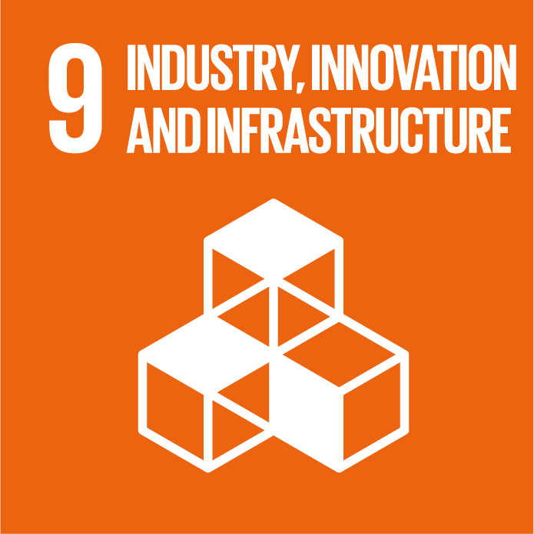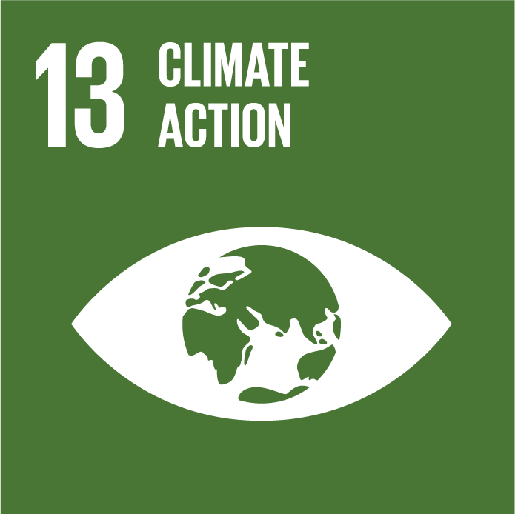

Growth means more stormwater and sewage
Hard surfaces like roofs and roads are impervious (non-absorbent) and generate much more stormwater than the natural surfaces they replace. This can cause flooding where stormwater cannot drain away quickly enough when it rains. It can also wash pollutants into waterways as well as cause erosion and other problems.
Households generate sewage through showers, toilets, dishwashing, clothes washing, and other uses of water. Businesses generate sewage in the same ways, as well as generating sewage in industrial processes. As the number of households and businesses grows, so too does the volume of sewage we will need to manage.

More stormwater
Urban growth and higher population density will result in more stormwater entering creeks and rivers every time it rains. In some cases, increasing a catchment’s imperviousness (by constructing roads, paths and buildings) by only 2% is enough to cause significant environmental impacts in local streams (endnote 14). An indicative water balance for Melbourne is included in Chapter 3 to illustrate the current scale of stormwater resources in Melbourne, relative to other water resources.
Managing the volume of stormwater from increased urbanisation is only one part of the challenge. Stormwater also washes litter and other pollution into waterways, impacting on water quality and the health of the rivers and creeks. Further downstream, these impacts flow into Port Philip Bay and Westernport, impacting on the plants and animals that live there, as well as our beaches.
The full range of issues related to future growth of stormwater will be considered in the Healthy Waterways Strategy (which is currently under review), however the MWSS considers stormwater as a potential water resource.

More sewage
More people means the city will generate more sewage. The treatment of sewage requires major infrastructure, considerable energy and generates greenhouse emissions.
Our sewerage system already removes and treats more than 320 GL of sewage each year, including trade waste from industry. Melbourne Water removes and treats most of Melbourne’s sewage via a network of over 400 kilometres of sewers, nine pumping stations and two treatment plants. An indicative water balance for Melbourne is included in Chapter 3 to illustrate the scale of current sewage generation in Melbourne, relative to other water resources.
Most of the sewage generated in Melbourne is transferred to one of Melbourne Water’s two sewage treatment plants: the Eastern Treatment Plant in Bangholme or the Western Treatment Plant in Werribee.
Our two treatment plants process sewage, which can then be supplied as recycled water or safely released into Port Phillip Bay (Western Treatment Plant) or Bass Strait (Eastern Treatment Plant).
The full range of issues related to future growth of sewage will be considered in the forthcoming Sewerage Strategy, however the MWSS considers recycled water as a potential water resource.

Highlight box - Stormwater and Port Phillip Bay
Over four million people live within the Port Phillip Bay catchment, which includes most of the Greater Melbourne region. When it rains, the resulting stormwater carries litter and pollutants from built-up areas of the catchment and transports them long distances.
Rainfall can cause stormwater to pollute the Bay, and heavy falls mean much more rainwater than usual infiltrates the soil and enters the sewerage system. During extremely heavy storms, this infiltration can push the local sewerage system to its limit, and sometimes diluted sewage overflows through emergency release valves into creeks and rivers.
In summer, even moderate rain can cause poor water quality in the Bay, leading to beach closures. While we expect less rainfall overall as the climate changes, it is likely that storms will become more intense and more frequent in summer, exacerbating these problems.
As the population living in the Port Phillip Bay catchment grows, the increase in hard surfaces like roofs and roads means more stormwater and sewage. Without ongoing active management, even more nutrients, litter and other pollutants will be washed into the Bay. This will increase the risk of problems like algal blooms and poor water quality after storms.
The recently released draft Environmental Management Plan for Port Phillip Bay provides a framework for government, industry and community to work together to manage the Bay and its catchment. The draft plan includes actions to manage the impacts of stormwater and sewage on the Bay.
The MWSS is one of several strategies to contribute to these actions by taking an integrated approach, considering the use of stormwater and sewage to diversify sources within the Melbourne water system to deliver benefits across the whole water cycle.
End highlight box.

All water is a potential resource
Sewage and stormwater are no longer considered waste products. In the face of climate change and enabled by new technology, Melbourne Water is using sewage to generate valuable resources such as recycled water, biosolids, and biogas (renewable energy). This is part of the integrated water management approach, considering all water as a potential resource. Water for Victoria highlights integrated water management as an efficient way of maximising economic, social and ecological benefits to the community.
The Victorian Government, in collaboration with the water sector, is producing the Integrated Water Management Framework for Victoria, which will provide clear guidance on roles and responsibilities for delivering integrated water management in a way that provides shared benefits across the sector.
Melbourne Water’s Healthy Waterways Strategy and Stormwater Strategy (both currently under review), Flood Management Strategy, and Sewerage Strategy (due in 2018) explore in detail the challenges and opportunities for managing increased volumes of stormwater and sewage as the region grows. It is important that this strategy is linked with other Melbourne Water strategies to deliver an integrated perspective on water management issues across Melbourne and the surrounding region.

Action 2.2
Ensure all of Melbourne Water’s core service strategies are linked, developed in the context of the broader water cycle, and support implementation of the Integrated Water Management Framework for Victoria.
Delivered by
Melbourne Water
Contributes to the following Sustainable Development Goals
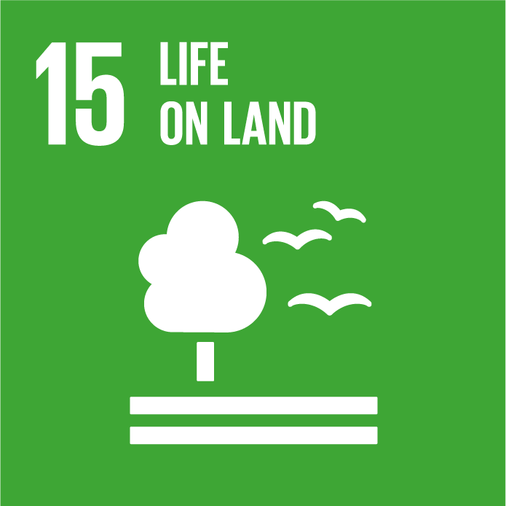

Providing for communities and recreation in a built-up city
Having an increasingly dense city means less private outdoor space, increasing the value and importance of public outdoor spaces. Excluding our water supply catchments, Melbourne Water manages approximately 33,000 hectares of land across the Greater Melbourne region to support delivery of our services. This includes land around aqueducts and pipeline routes, service reservoirs, flood retarding basins, sewage treatment plants, and other assets.
We also help to manage over 290,000 hectares of water supply catchments, including the mid-Yarra catchment upstream of Sugarloaf Reservoir. More than 60% of our water supply catchments are state forests or national parks, with the remainder comprised of land owned by Melbourne Water or privately owned land.
In some cases, the land we manage along pipeline routes is unique because it has the potential to provide linear connections within otherwise heavily urbanised areas of the city.
Where strategic, operational, safety and security needs can be met, Melbourne Water offers its land resources to the community for beneficial uses. We work with the community to develop high-amenity community assets and active transport links like cycling and walking paths on our land, providing attractive and safe options for alternative modes of transport. This is an aspect of our business that we plan to continue growing in the future.

Action 2.3
Enable the community to use our land assets to enhance life and liveability through initiatives including:
Establish partnerships with social enterprises to deliver community activities on Melbourne Water land on an ongoing basis.
Investigate the risks and controls associated with different types of activities the community undertakes on or around water supply infrastructure by December 2018.
Develop guidelines for multiple use opportunities for retarding basins by December 2019.
Undertake a visitation study to understand the use of water storage reservoir parks by December 2018.
Develop a social values conceptual framework to support the review of the Healthy Waterways Strategy which will provide further insights into activities we should be encouraging on our land by December 2018.
Use the Our Space Your Place portal to enable the community to engage directly with Melbourne Water on an ongoing basis.
Delivered by
Melbourne Water (in partnership with others as required)
Contributes to the following Sustainable Development Goals

Highlight box - Our Space Your Place
To encourage the use of our land for community projects, we have created a web app that streamlines the process of finding land and expressing interest in using it for community benefit.
Our Space Your Place is a map-based application that holds details of the availability, size and potential use of our land. People use the application to search for an appropriate space for their community concept and then send us an expression of interest. A search function to find grants is also available to source funding from a range of grant providers.
End highlight box.

Highlight box - The Carrum to Warburton shared path
Melbourne Water has been working closely with VicRoads and local councils on a new shared path which will link the existing Warburton and Eastlink trails. Almost three kilometres of the new shared path will be built on land above a buried Melbourne Water pipeline in Croydon. Once the connecting path is complete in early 2017 the entire trail will extend 90 kilometres from Carrum to Warburton, enabling active recreation from Port Phillip Bay to the upper reaches of the Yarra River.
End highlight box.

Determining the future demand for water
As the population of Greater Melbourne grows, the demand for water in Melbourne will increase. We need to understand what these demands might be.
Melbourne Water worked closely with the retail and regional water corporations to understand how water is used currently, and to develop a number of different future scenarios of the demand for water across Melbourne and the surrounding region. When the water businesses developed these demand scenarios, they considered water use trends for all the residential and non-residential uses of water, as well as non-revenue water related to fire-fighting, leaks, and operational uses of water (for example, to flush sediments out of water mains).

Drivers of demand
The factors that will shape our future demands for water – the ‘drivers’ we need to consider – include:
how we use water
our changing and growing city and region
climate change
diverse sources of water.

How water is used
Residential water use is currently the largest proportion of the total demand, and we expect this will remain the case over the next 50 years, as shown in Figure 10, which illustrates the demand associated with different categories of users in Melbourne, now and in 2065. Although residential water use accounts for the majority of the water demand in Melbourne, non-residential water use accounts for around a quarter of total water use. As an essential input to commercial, institutional and industrial activities, water is an enabler of economic development and jobs growth in Melbourne and the surrounding region.
Over the next 50 years, the split between residential, non-residential, and non-revenue water is not expected to change substantially. Similarly, over time, the relative split between different uses of water in households is not expected to change a great deal over the next 50 years, as illustrated in Figure 10.
This does not mean that the volume of water used across all categories of users and uses of water will stay the same – it just means we expect the volume of water used for each category and use will change at similar rates.
Figure 10. Different urban demand categories (left) and how Melburnians use water at home (right) now and in 2065
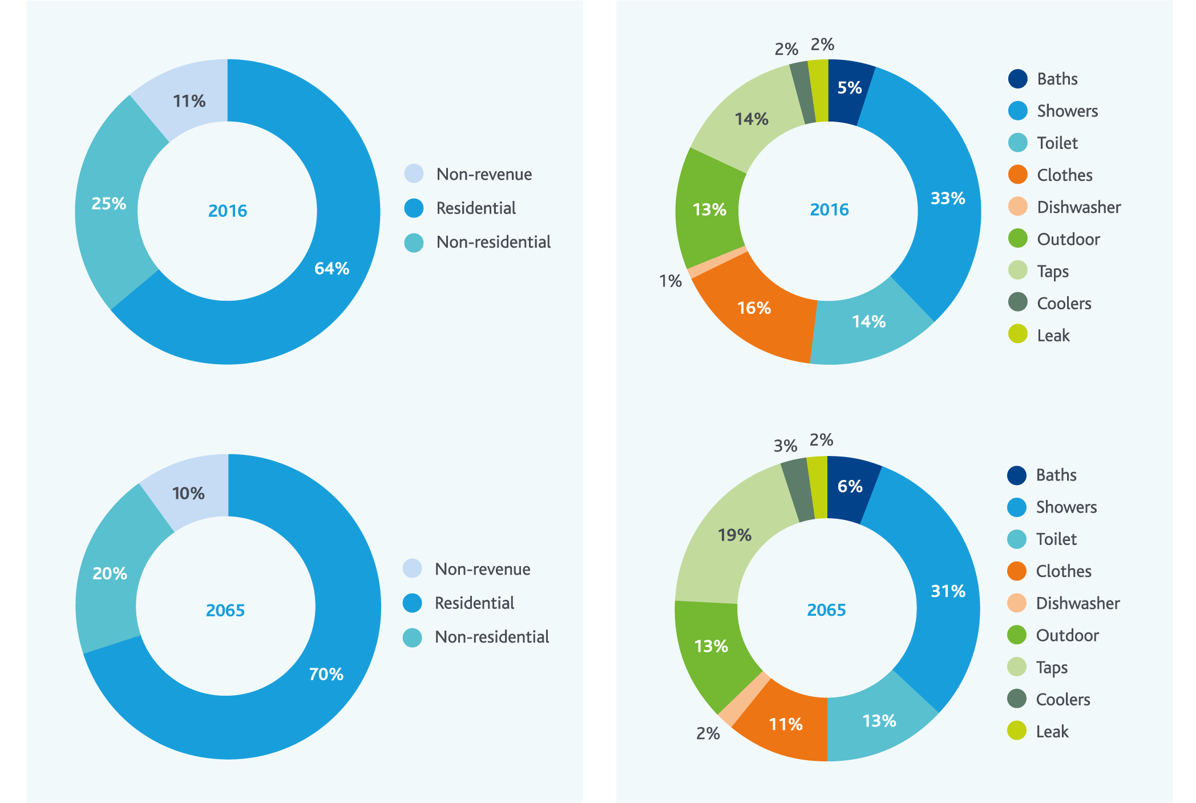
These projections of how we will use water 50 years from now are based on information available today. However, how water will be used in the future, in terms of both appliance efficiency and water-using behaviours, is difficult to predict because it relates to so many different uncertain factors. Consider the difficulty, in 1967, of predicting many of the things that have occurred over the last 50 years.
There is some potential that disruptive technologies and cultural shifts could change the way we use water. For example, waterless washing machines are already available for commercial applications; if they become widely available for household applications, the volume of water used for washing clothes could decline much faster than we currently anticipate. Potential future water efficiency initiatives driven by the water industry could influence the rate at which these changes occur – this is discussed further in Chapter 5.

Our growing city and changing region
Population growth is a key driver of the future demand for water. To understand this, the retail water corporations used the population projection outlined in Victoria in Future 2015 as the baseline scenario. The retail water corporations also considered higher and lower population growth scenarios by drawing on the broader range of population growth scenarios available from the Australian Bureau of Statistics (endnote 15). The population projections for Melbourne developed by the retail water corporations and used in this strategy are illustrated in Figure 11.
Figure 11. Population projections for Melbourne
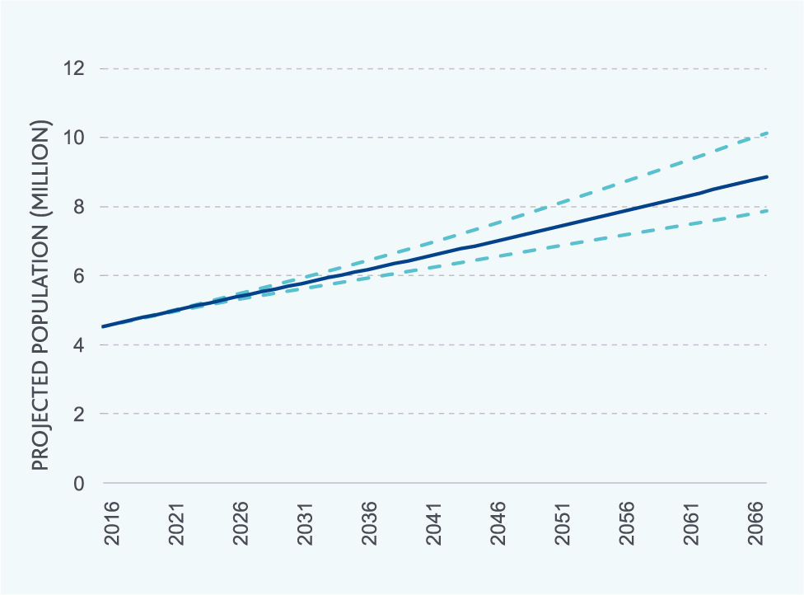
The regional water corporations took a number of different approaches to developing population growth scenarios, including using Victoria in Future 2015, Victoria in Future 2016, Australian Bureau of Statistics data, and information from local government. The broader range of approaches taken by the regional water corporations reflects the greater diversity of their customers and the differences in data availability across the regions they work in.
The densification of our city that is expected to happen to accommodate our growing population will also affect the demand for water, as apartments and semi-detached houses replace detached houses with large backyards and large landscape irrigation requirements. This has been taken into account in the demand forecasts.
The demand forecasts also consider the expected increase in water use efficiency that we expect as housing density increases (meaning smaller gardens and backyards that require less irrigation), old appliances like clothes washing machines and dishwashers wear out and are replaced with more efficient models, and technology continues to deliver even more efficient toilets, showers and other fixtures.
Given the uncertainty surrounding how water will be used in the future, the retail water corporations also considered two alternative scenarios of per person use. They developed these scenarios by increasing or decreasing the rate at which per person use changed by 50% more and 50% less each year. These scenarios could reflect any combination of different trends in the efficiency of water-using appliances and fixtures, or different trends in water-using behaviours.

Climate change
Climate change will affect the demand for water from the Melbourne water system in different ways for the retail and regional water corporations.
For the retail water corporations, the hotter and drier conditions associated with climate change could result in slightly higher demands for water, mainly for landscape irrigation, but also for other uses like evaporative air conditioners. Analysis undertaken by the retail water corporations suggests that total demands could increase by approximately 3% across Melbourne due to climate change.
Climate change is a more significant driver of demand on the Melbourne water system for the regional water corporations. This is because climate change will impact on their own local water resources, reducing local supplies and driving them to take more water from our water supply system through the water grid.

Diverse sources of water
Using sources of water like rainwater, stormwater and recycled water can reduce the demand for water from the water supply system.
To develop demand forecasts, our customers took into account the anticipated contribution of rainwater, stormwater and recycled water, based on existing projects and projects for which planning is well progressed. Accordingly, by 2065, these demand forecasts already reflect approximately 30 GL/yr to be sourced from rainwater, stormwater and recycled water.
Other projects will be developed that further reduce the demand for water from the water supply system; however, until further planning work is undertaken it is difficult to reflect them in the demand forecasts. The processes we will use to identify these opportunities are outlined further in Chapter 6 of this strategy.

Demand scenarios
The uncertainty in the drivers outlined earlier means that it is difficult to identify a single demand forecast for which we should plan. This strategy considers a range of different demand scenarios that explore the uncertainty in the underlying drivers of demand.
Figure 12 outlines the demand scenarios used to develop this strategy. This illustrates that by 2065 demands are expected to be between around 500 GL/yr and, if demands grow more quickly, around 800 GL/yr, almost double the current demand on the system.
Figure 12. Scenarios of demand for water from the water supply system
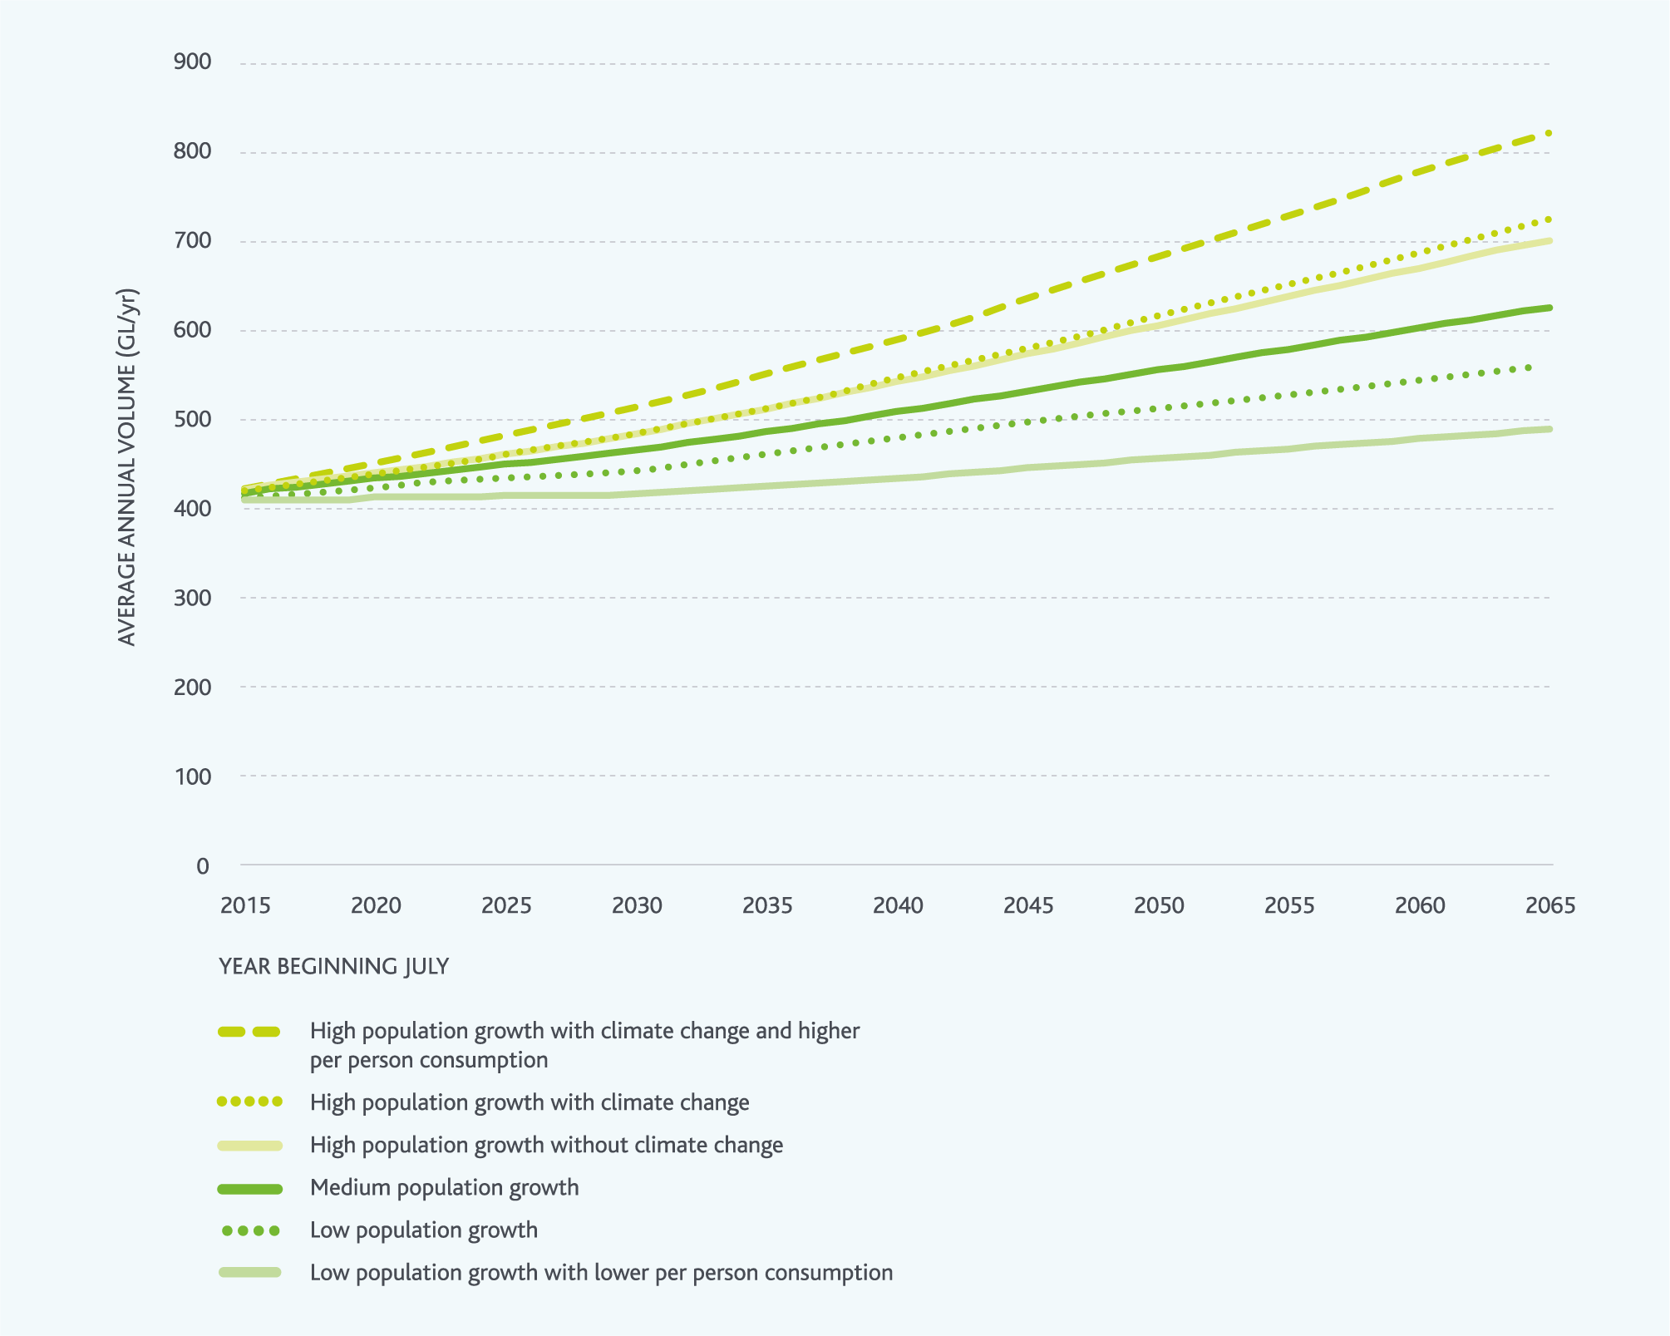
In developing this strategy, we considered all of these demand scenarios. Melbourne Water and the retail water corporations will continue to monitor demand, and ensure actions are in place to maintain future water use efficiency as discussed in Chapter 5. This will help to manage the risk of the higher per person consumption reflected in the highest demand scenario shown in Figure 12.

Peak day demands
Forecasts of future annual demands are used to support long-term water resource planning; they establish how much water is needed by all of our customers across the whole year. In planning the water supply transfer system (the network of pipelines, pump stations and service tanks that link our storage reservoirs to our customers), constraints tend to be driven primarily by peak day demands – typically observed on hot, dry days in summer. Further to this, the spatial distribution of peak day demands across the city is important for planning the water supply transfer system. The distribution of high and low density housing, and the location of businesses and activity centres across the city means that in some areas of the city, peak day demands are higher than in other parts of the city. Lower density areas tend to have higher peak day demands, since gardens are larger and tend to be watered more during summer months.
We have worked closely with the retail water corporations and Western Water to establish the peak day demands that we should be planning for in the future. We considered the distribution of high, medium, low, and apartment density housing across Melbourne, as well as the location of businesses. We also considered the potential peak day demands we may need to supply to Western Water, depending on the extent to which they can manage peak days in their service area from their own water supply system. Based on this analysis, Melbourne Water is currently planning for peak day demands of 3.9 GL/day in 2050. The application of this peak day demand forecast is discussed further in Chapter 4.

The future of demand forecasting
Demand projections, while subject to changes in underlying assumptions, are essential to our planning processes. To build our collective understanding of the uncertainty surrounding future demands, Melbourne Water will continue to work with the retail and regional water corporations to enhance demand forecasting capabilities across the water industry. New data sources and information technologies are emerging which we will integrate into our demand forecasting methods and tools.

Action 2.4
Convene a water industry working group by September 2017 to continue the development and improvement of demand forecasting methods and tools, to support the development of consistent water and sewage demand forecasts at hourly, daily, seasonal and annual scales.
Delivered by
Melbourne Water, retail water corporations, Western Water
Contributes to the following Sustainable Development Goals

3. Our changing and variable climate
Melbourne’s climate has always been variable, with wetter periods leading to floods, and drier periods leading to droughts. Managing climate change and variability will be an ongoing challenge.
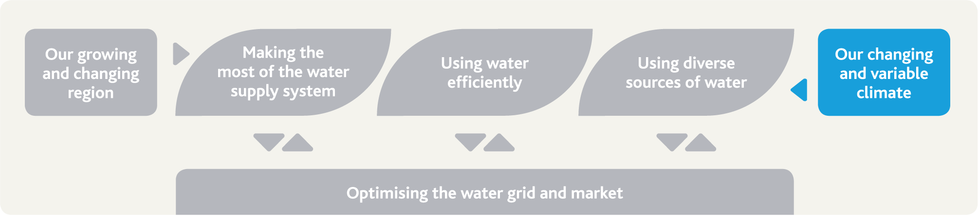

The challenge and our strategic response
Climate change means we need to be prepared for more frequent and severe droughts in the future, and a long-term decreasing trend in rainfall and streamflow.
Changes in rainfall and streamflow will impact not only on water supply for the retail and regional water corporations, but also on irrigators and the environment.
Melbourne Water will plan for a range of climate scenarios to make sure Melbourne Water, our customers, and the community are prepared and resilient to climate change, whatever the future holds.

Our actions and their benefits
Action number | Actions in chapter 3 related to our changing and variable climate | Healthy People | Healthy Places | Healthy Environment
3.1 | Invest in climate research and operationalise outcomes to build resilience | • | • | •
3.2 | Become a net-zero greenhouse emissions business |  |  | •
3.3 | Define climate risks to environmental values of waterways and wetlands |  | • | •

Understanding climate variability
Melbourne’s weather and climate has always been variable, with extended periods of low rainfall causing droughts and with periods of high rainfall causing floods.
Complex interactions drive this variability in weather and climate. The atmospheric circulation patterns and changes in sea surface temperature, wind speeds, and barometric pressure over the oceans around Australia affect the amount of rainfall across southeast Australia, including Melbourne and our water supply catchments. Since rainfall across Melbourne’s water supply catchments drives the amount of water flowing into our water storage reservoirs, understanding weather and climate is important to water resource planning.

Rainfall and streamflow in a variable climate
Rainfall over Melbourne’s water supply catchments is not uniform – neither between different catchments nor within individual catchments. At the bottom of each catchment near our storage reservoirs, rainfall is often lower than it is higher up in the same catchment. For example, average annual rainfall (1987–2016) at Maroondah Reservoir is approximately 1,045 mm/yr, but at Mount Donna Buang, which is higher up in the Maroondah Reservoir catchment it is approximately 2,196 mm/yr.
Some of the rain that falls on our water supply catchments is used by vegetation, evaporated into the atmosphere or stored in the soil as groundwater. The remaining rainfall runs off the catchment and flows into waterways. How much of the rain ends up in the waterways depends on a range of factors but, on average, around 30% to 50% of the rain that falls on our catchments each year ends up in the waterways. This changes from season to season depending on how wet the soil in the catchment is. For example, only about 10% of rainfall during summer turns into runoff because the dry soil acts like a sponge, soaking up the rain before it can flow into streams.
In addition to varying spatially across our catchments, and seasonally through the year, rainfall and the resulting streamflow varies from year to year. Figure 13 shows annual streamflow into Melbourne’s four major harvesting storages (Thomson, Upper Yarra, O’Shannassy and Maroondah Reservoirs) since records started in 1913. The black line shows the moving average over a five-year period. Where this line dips below the longer-term historical average, it shows that our catchments have produced less-than-average water for an extended period of time – a sign of drought impacts. This is particularly evident during the Millennium Drought in 1997–2009.

Droughts in Melbourne
Research suggests that droughts have occurred on a regular basis in Australia for thousands of years (endnote 15). Within the last century there have been five notable droughts, including the recent Millennium Drought from 1997 to 2009, which have all had an influence on water supply operations and planning for the future.
No drought is the same; each was caused by a unique set of climate influences resulting in different impacts. What they have in common is that every drought presented water resource management challenges.

The Millennium Drought
Analysis of paleo-climate records such as ocean corals, tree rings, ice cores, mineral deposits in caves and lake and marine sediments suggests that the Millennium Drought was probably the most significant drought in south eastern Australia since European settlement. The analysis suggests that droughts like the Millennium Drought occur on average approximately once in every 560 years (endnote 16).
In the future, with climate change, droughts like the Millennium Drought may occur more frequently than they have in the past.
The South Eastern Australia Climate Initiative researched the causes of the Millennium Drought and the associated observed change in autumn rainfall. They partly attributed the drought to human-induced impacts on the climate system (endnote 17).
Given what we know about our variable climate, we need to be prepared for climate change and droughts – even droughts more significant than the Millennium Drought. Being prepared is a key part of ensuring safe and reliable supplies that will provide for the liveability of Melbourne.

Figure 13. Historical streamflows into Melbourne’s four major harvesting storages
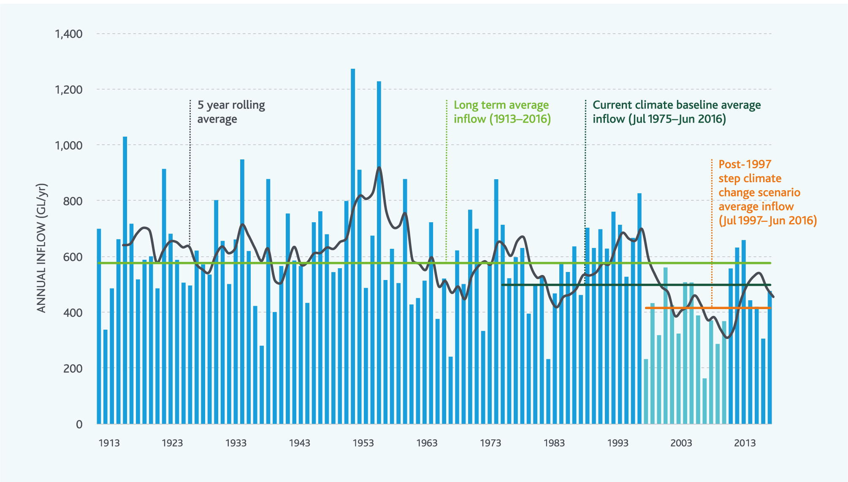

Our changing climate
Greenhouse gases like carbon dioxide in Earth’s atmosphere play a key role in making our planet warm enough to support animal and plant life. However, greenhouse gas concentrations in the atmosphere have been trending upwards since the mid-1800s, driving changes in our climate.
Victoria’s climate is changing and will continue to change in the future. Figure 14 on the next page shows how Victoria’s mean temperature has been increasing over the past century in line with global trends.
Figure 14. Annual mean temperature anomalies for Victoria have followed global trends (based on data sourced from the Bureau of Meteorology and CSIRO)
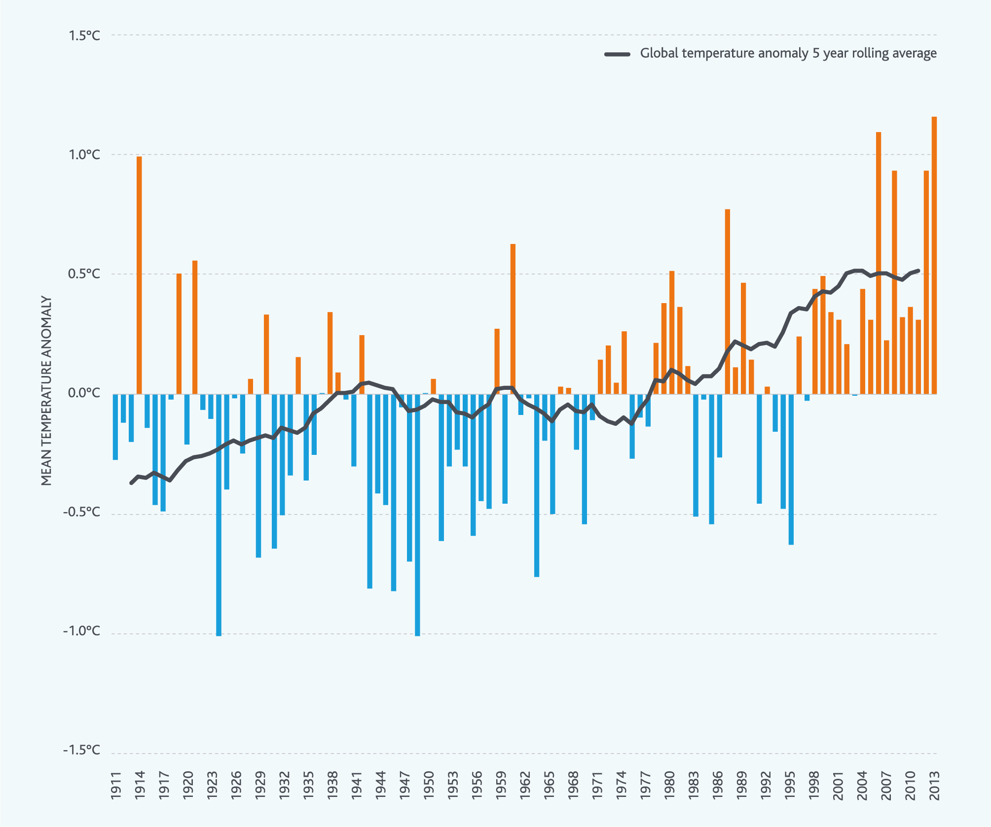
Climate change is a significant issue for the water sector. Together with climate variability, climate change is expected to drive these potential impacts:
more frequent and intense droughts
seasonal shifts and decreases in rainfall changing catchment behaviour
reduced average streamflows in waterways
higher average and minimum temperatures
increased frequency and severity of storms, bushfires and heatwaves
rising sea levels.
Melbourne Water was among the first water agencies in the world to examine the implications of climate change on water, sewerage and drainage systems. We collaborated with CSIRO in 2005 to produce the Melbourne Water Climate Change Study: Implications of Potential Climate Change for Melbourne’s Water Resources (endnote 18).
Climate change research to understand the potential impacts of climate change and develop adaptation plans is an ongoing focus for Melbourne Water.
We work with the retail water corporations through the Melbourne Water Industry Climate Change Committee to develop a shared understanding of potential climate change impacts, and we include the impacts of climate change in our corporate risk register. We are also developing a Climate Adaptation and Resilience Plan to manage the risks.

Highlight box - Supporting climate research
Melbourne’s water resources are highly influenced by our variable climate and the potential impacts of climate change. It is vital that we continually build our knowledge through innovative research to enhance climate resilience in our planning and deliver valued customer services.
Melbourne Water partners and engages with a range of research organisations to advance knowledge of climate change and how it can impact the water system.
We participated as a key stakeholder in the Victorian Climate Initiative, a partnership between DELWP, the Bureau of Meteorology and CSIRO. The research focussed on the drivers and projections of climate change in Victoria and was the key input into the Guidelines for Assessing the Impact of Climate Change on Water Supplies in Victoria prepared by DELWP, which underpin the climate scenarios considered in this strategy.
We also worked with Melbourne University and a range of industry and research partners on an Australian Research Council funded project to extend our 100 years of instrumental records using paleo-reconstruction techniques. These techniques use tree rings, ice cores, coral records, and other materials to derive insights into our climate from the time before humans started keeping records. The research indicates that droughts like the 1997–2009 Millennium Drought are likely to occur around once in every 500 years on average in the region surrounding Melbourne.
Melbourne Water continues to partner with DELWP and work with researchers to assess the future risks of ‘megadroughts’ by characterising the full range of past natural climate variability and incorporating the latest climate change projections.
End highlight box.

Action 3.1
Continue to invest in climate research to build our understanding of how climate change and variability could affect all of our business activities in the future, and develop a Climate Change and Resilience Plan by December 2017 to operationalise research outcomes and ensure Melbourne Water is prepared for climate change.
Delivered by
Melbourne Water
Contributes to the following Sustainable Development Goals

Highlight box - Reducing our greenhouse emissions
The water sector produces greenhouse emissions through two key pathways:
indirect emissions through its use of electricity to transport, treat and discharge sewage, and, to pump, treat and supply water
direct emissions, emitted from our sewage treatment plants as a result of the sewage treatment process.
Melbourne Water has a role to play in reducing greenhouse emissions in Victoria. We have been taking action to reduce greenhouse emissions for many years through initiatives such as:
capturing biogas for electricity generation at our sewage treatment plants
installing hydroelectric plants across the water supply system
upgrading and optimising aeration and pumping systems for improved energy efficiency
installing our first solar photovoltaic system to generate electricity from sunlight at one of our smaller water treatment plants.
The Victorian Government has committed to legislating a long-term target of net-zero greenhouse emissions from Victoria by 2050.
In Water for Victoria, the Victorian Government announced that Melbourne Water would investigate an early path to achieve net-zero greenhouse emissions by 2030. We are considering the following types of initiatives:
energy efficiency projects; e.g. further operational optimisation of aeration and pumping systems
waste utilisation projects; e.g. capturing additional biogas from sewage treatment plants and using it to generate electricity
renewable energy generation projects; e.g. installing solar photovoltaic systems at our sewage/water treatment plants and/or pump stations
carbon sequestration projects; e.g. planting trees
self-generating and/or purchasing carbon offsets.
End highlight box.

Highlight box - Renewable energy generation across the water supply system
Across our water supply system Melbourne Water has installed hydroelectricity plants to capture water pressure energy that would otherwise be wasted. There are currently nine hydroelectricity plants installed across the water supply system, with a total generating capacity of 22.3 megawatts. In 2015/16 these hydroelectricity plants generated 47,600 megawatt-hours of electricity and reduced Melbourne Water’s total electricity bill by $6.5 million.
An additional five hydroelectricity plants are currently being commissioned across our water supply system, which will add a total of 1.0 megawatt of electricity generation capacity. We are also currently investigating a further ten hydroelectricity plants, potentially adding a further 1.7 megawatts of electricity generation capacity (these ten sites are still subject to approval).
We have recently installed our first solar photovoltaic system at one of our water treatment plants to offset our electricity consumption, and we are currently monitoring the performance of the solar panels at this site. The results will help inform future solar photovoltaic projects at other water treatment and water pump station locations.
End highlight box.

Action 3.2
Ensure Melbourne Water is a net-zero greenhouse emissions business by 2050, and explore an early path to achieve this by 2030.
Delivered by
Melbourne Water
Contributes to the following Sustainable Development Goals
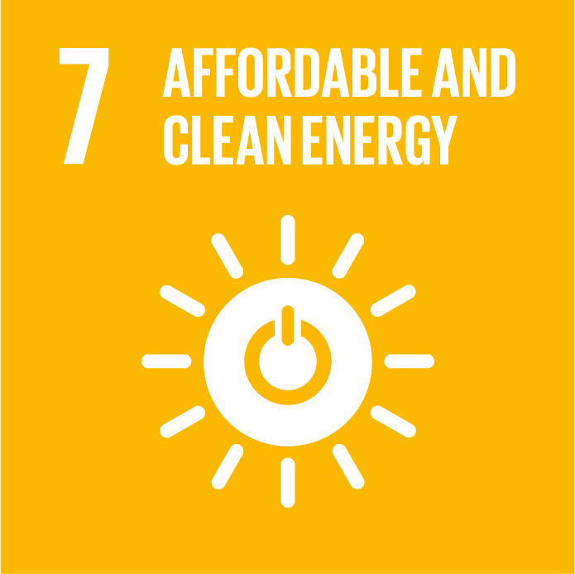

Planning for the future
To support this strategy, DELWP prepared Guidelines for Assessing the Impact of Climate Change on Water Supplies in Victoria. The guidelines describe four climate change scenarios that we have considered:
- high climate change
- medium climate change
- low climate change
- post-1997 step climate change.
CSIRO developed the high, medium and low climate change scenarios based on the outputs of the 42 different global circulation models used to develop the Intergovernmental Panel on Climate Change’s Fifth Assessment Report. These scenarios provide insight into how water availability from our water supply catchments could change in the future under a range of plausible future climate conditions.
Included as one of the climate scenarios is the post-1997 step climate change scenario. This scenario is different to the other three scenarios; it provides insight into how water availability from our water supply catchment may already have changed since 1997.
The Guidelines for Assessing the Impact of Climate Change on Water Supplies in Victoria prepared by DELWP state there is no ‘most likely’ scenario for future climate in Victoria, and that ‘future planning needs to be built around consideration of a range of plausible climate futures’. This strategy considers all of the four climate change scenarios.

Water availability from the water supply system
To plan our water needs, we need to understand how much water might be available from our water supply system and compare that with the demand scenarios outlined earlier in Chapter 2. Melbourne Water has prepared water supply system yield estimates for the four climate change scenarios. Yield estimates are the expected volumes that can be reliably supplied from the water supply system over the long-term.
The yield estimates assume that, among other factors:
We will aim to avoid having storage levels fall into the water outlook low zone described in the retail water corporations’ revised drought preparedness plans (discussed in Chapter 5). This represents a base level of service, and in general our customers and the community will experience higher levels of service than this.
The existing environmental water reserve will remain in place in the future, including the additional 8 GL/yr committed to the Thomson River.
The Victorian Desalination Project could potentially be operated at higher rates in the future – up to 150 GL/yr – to ensure we make the most of the water available from our existing water supply system to meet growing demands.
Melbourne Water has prepared yield estimates for the four climate change scenarios outlined in the Guidelines for Assessing the Impact of Climate Change on Water Supplies in Victoria, as shown in Figure 15.

Figure 15. Long-term water supply outlooks for the high, medium, low and post-1997 step climate change scenarios
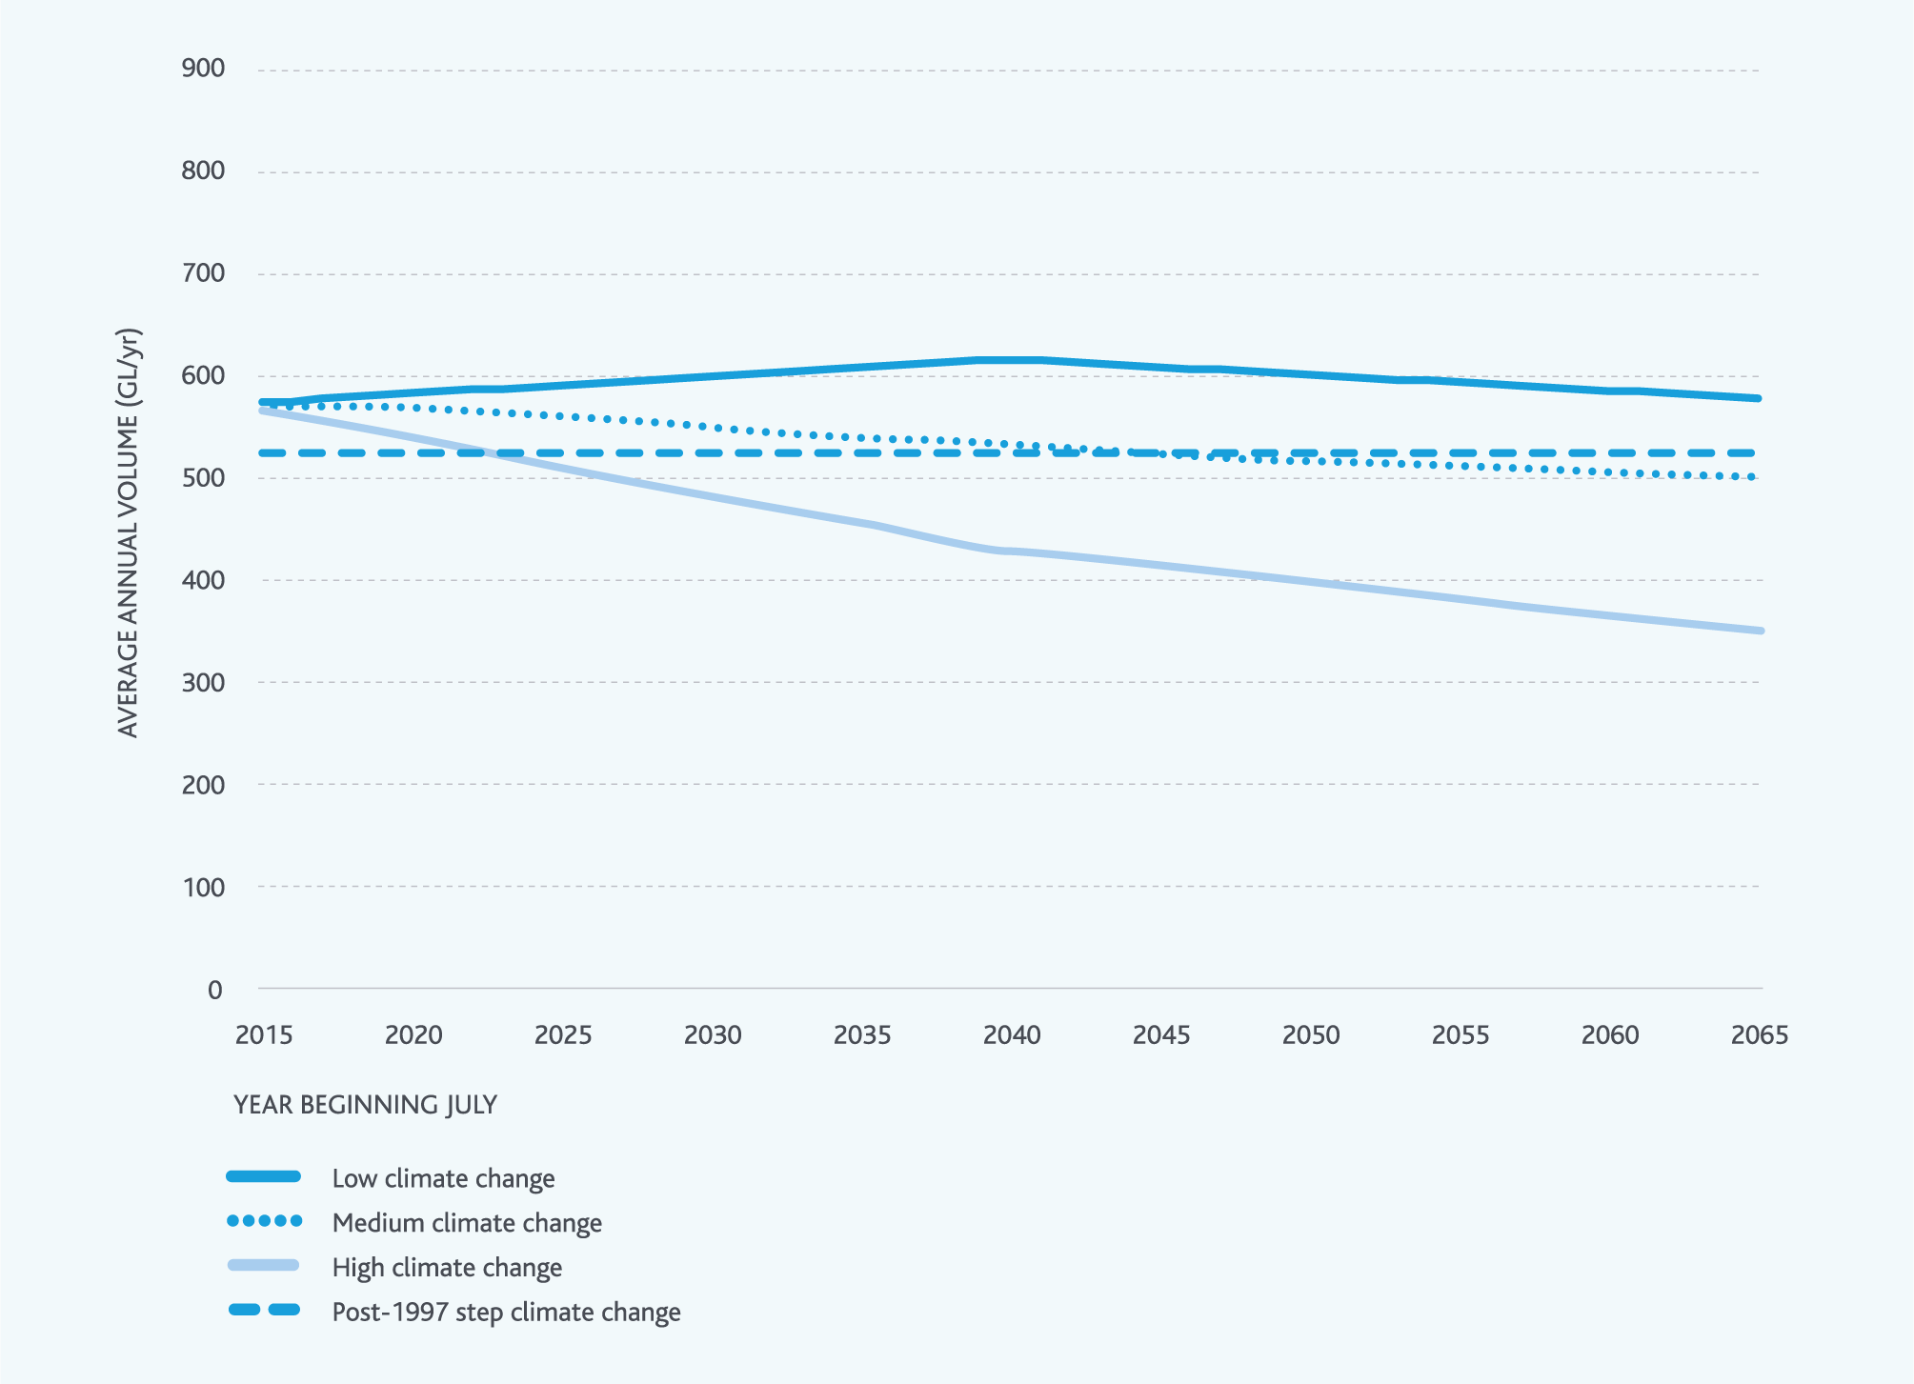

Creating scenarios of supply and demand
When we combine yield estimates with the long-term demand forecasts provided by the retail and regional water corporations, we gain insight into how the water supply system will cope with future droughts, and the expected timing and magnitude of potential water resource shortfalls that could emerge in the future. When demand exceeds supply, we use the term ‘water resource shortfalls’ to describe the risk that existing sources of supply may not be able to continue to deliver the base level of service we aim to deliver (aiming to keep storages above the water outlook low zone).
For this strategy, we considered three key strategic scenarios of supply and demand:
- low change scenario: lower growth in water demands and low climate change
- incremental change scenario: medium growth in water demands and medium climate change
- rapid change scenario: higher growth in water demands and high climate change.
Figure 16. Three key scenarios of supply and demand used during the development of this strategy: low change scenario (top), incremental change scenario (middle), and rapid change scenario (bottom)
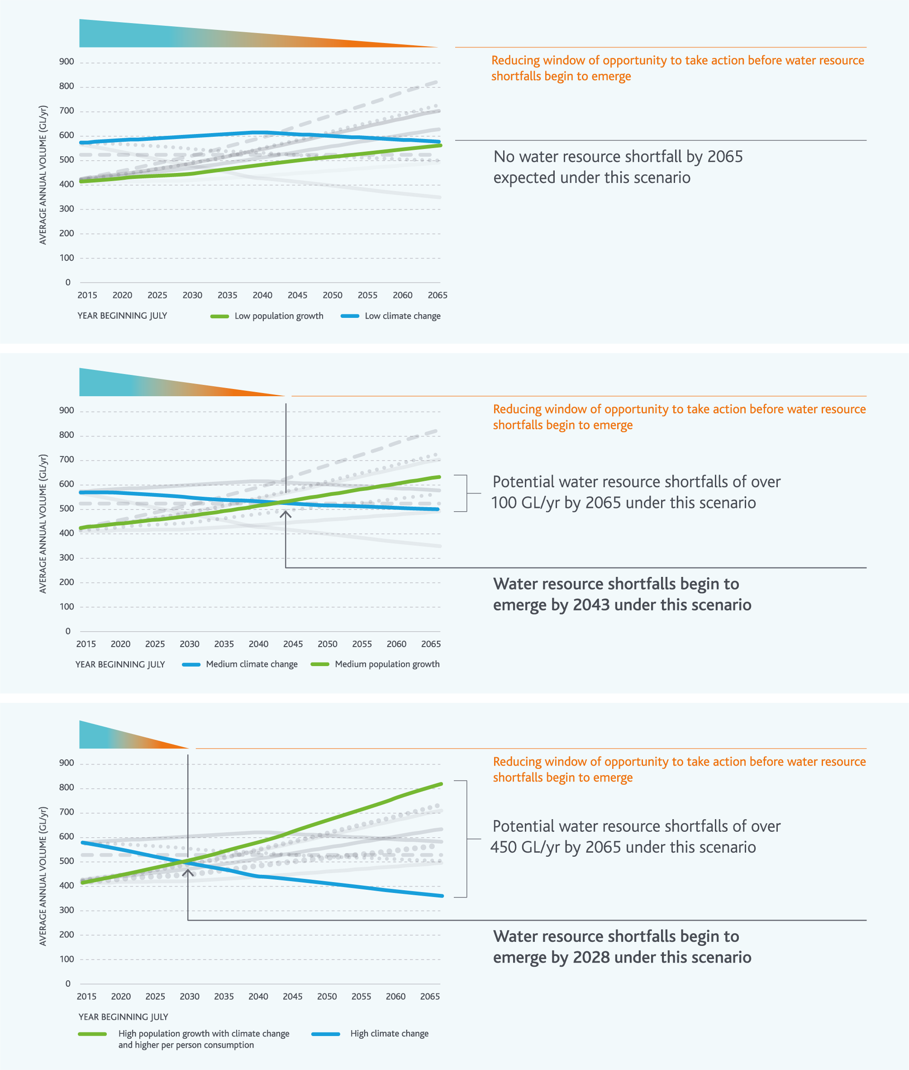
These scenarios were selected to reflect a range of timing of demand exceeding supply. Although there were other scenarios, these three key scenarios highlighted a broad range of possible futures to guide the development of an adaptable strategy.
The long-term yield estimates and demand forecasts illustrated in Figure 16 reflect some of the key sources of uncertainty that we need to consider. Other sources of uncertainty exist, but given the significant uncertainty already captured in the three key scenarios above, further increasing this is unlikely to change the strategy.
The three key scenarios of supply and demand illustrated in Figure 16 highlight that this strategy needs to be adaptable to a range of potential futures. However, potential water resource shortfalls of over 450 GL/yr by 2065 are possible if we experience high population growth and high levels of climate change together, so we need to have flexible plans in place.
Under all three scenarios, action is required well before water resource shortfalls begin to emerge. The adaptive portfolio approach outlined in this strategy requires ongoing investment in making the most of the water supply system, using water efficiently and using diverse sources of water, to deliver a large number of smaller projects that can collectively have a significant impact on supply and demand (refer to Chapters 4, 5 and 6).
This investment is needed under all three scenarios on an ongoing basis. Under the rapid and incremental change scenarios, it is also possible that major infrastructure projects to add capacity to the water grid could be needed (refer to Chapter 7). These types of projects can take many years to implement after decisions are made to implement them – the time needed for planning, design and construction needs to be considered in the evaluation and scheduling of these options.
Further discussion of these three scenarios and how this strategy would be implemented under each of them is included in Appendix A.

Highlight box - Potential future water storage levels under the incremental change scenario
As illustrated earlier in Figure 16, under the incremental change scenario, water resource shortfalls could begin to emerge by 2043. If a severe drought occurs after 2043, we might not be able to continue to deliver our planned base level of service (to keep water storage levels above the water outlook low zone). This concept is illustrated in Figure 17 for the incremental change scenario and shows the impact of a repeat of the Millennium Drought at 2038, 2043 and 2048 levels of demand and climate change with the Victorian Desalination Project operating at 150 GL/yr.
Figure 17 shows that at 2043 levels of climate change and demand, it is possible that water storage levels could fall very slightly into the water outlook low zone if the Millennium Drought occurred at that time. At 2038 levels of climate change and demand, water storage levels would not even fall into the water outlook medium zone, while at 2048 levels of climate change and demand, water storage levels could fall well into the water outlook low zone and could remain there for some years.
This highlights the sensitivity of our water supply system, with its large storage capacity, to climate change and demand growth. During long droughts, even small annual reductions in inflows or increases in demand result in impacts on water storage levels that continue to accumulate for as long as the drought lasts.
The water resource modelling illustrated in Figure 17 was started before the Millennium Drought, so the wetter years in the mid-1990s resulted in water storages filling to near capacity just before the beginning of the Millennium Drought. If storage levels were not full at the beginning of the Millennium Drought, storages could have fallen into the water outlook low zone at lower levels of demand and climate change, potentially earlier than 2043. This highlights the importance of operating the water supply system to keep a buffer of water in storage, subject to cost, for maintaining supply throughout future severe droughts and extreme events.
Figure 17. Potential water storage levels if the Millennium Drought occurred at 2038, 2043, 2048 levels of climate change and demand from the incremental change scenario
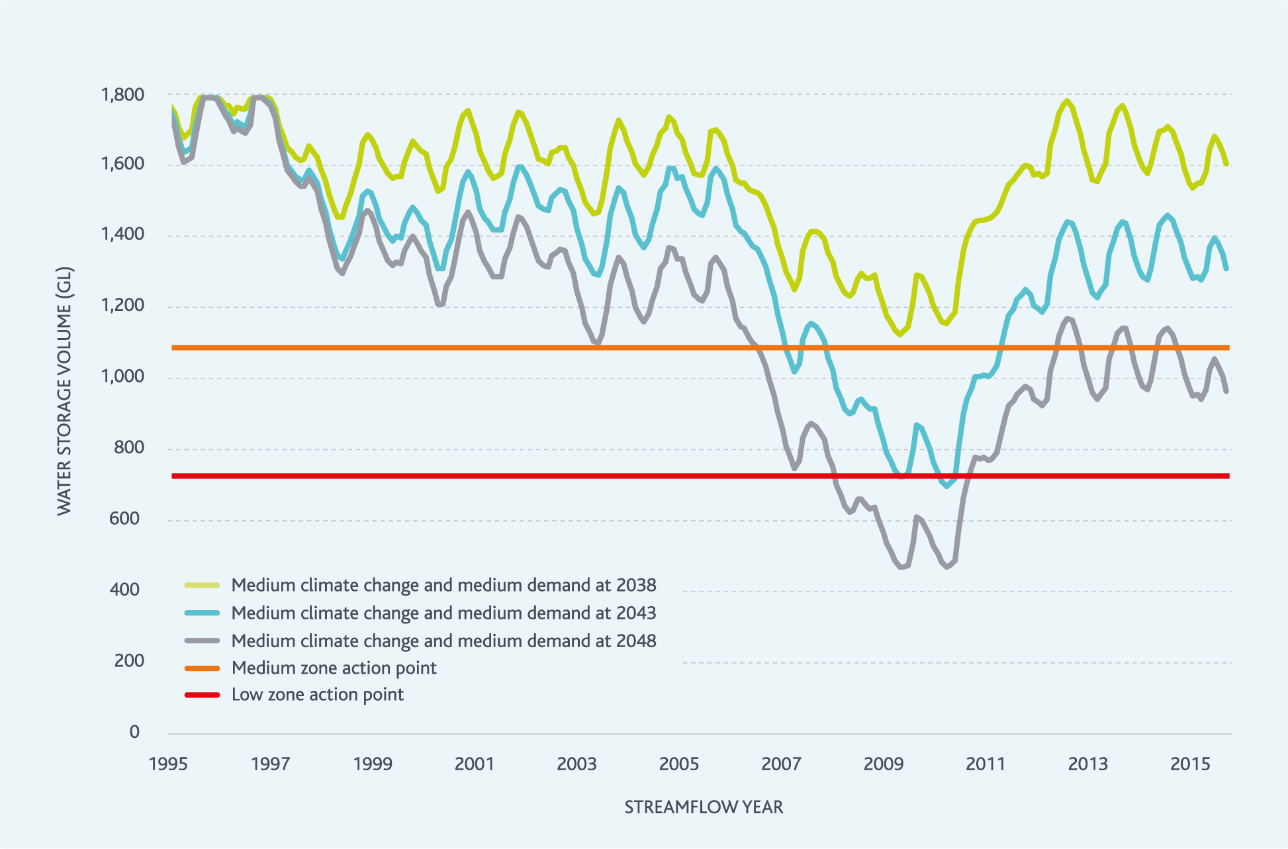
End highlight box.

Highlight box - The Black Saturday bushfires
Parts of our water supply catchments were burnt to varying extents during the Black Saturday bushfires in February 2009.
Bushfires can have both immediate and long-term impacts on the water supply system.
In the short term, damage to infrastructure and water quality issues caused by ash entering storages can impact on water supply. The Black Saturday bushfires did not impact water supply in this way, but did highlight the importance of having procedures in place that ensure the community experiences minimal disruption to water supply services. Melbourne Water’s approach to managing extreme events like bushfires is discussed more in Chapter 4.
In the longer term, bushfires can impact the quantity of water produced by water supply catchments, especially when they burn the Mountain Ash forests that cover many of our water supply catchments.
When Mountain Ash forest renews itself after a bushfire, the young trees initially grow together very densely – up to more than 100,000 stems per hectare. Typically, all of these young trees soak up a lot of soil moisture so that less water runs off into our water storage reservoirs.
As the forest matures, the trees thin out through natural competition – down to as few as 10 stems per hectare – and start to soak up less water. Around 100 years after a bushfire, the quantity of water produced by the catchment starts to stabilise.
To assess the potential impact of the Black Saturday bushfires on our water supply system, we commissioned the development of the Rapid Assessment of Forest Impacts on Streamflow tool. Application of this tool suggests that the Black Saturday bushfires could further reduce water availability from our water supply system over the next 50 years by 2–5%, before eventually returning to normal.
As a result of climate change, bushfires may occur more frequently, and the impacts of future bushfires could be more significant.
End highlight box.

The impact of climate change on environmental water
The water supply system yield estimates presented earlier in this chapter assume that the existing Environmental Water Reserve – which is used to deliver environmental water releases from reservoirs to support key environmental values – will not change in the future.
However, climate change could have implications for the environmental values of waterways and wetlands.
The environmental water reserve was established by the Victorian Government to ensure that enough water is available to protect environmental values of waterways. However, with climate change, future streamflows may be lower than the historically observed streamflows that were used to guide the original assessments of environmental water needs. This means that, in the future, more environmental water may be needed to maintain environmental values.

Potential shortfalls in environmental flows under climate change
Melbourne Water worked with DELWP and the West Gippsland Catchment Management Authority to undertake preliminary studies to understand the magnitude of the potential future challenge of shortfalls in environmental flows. These studies considered each waterway, using various approaches to ensure we were able to utilise the best available streamflow data and hydrologic models.
For the Yarra River, Thomson River and Tarago River, enough streamflow data was available to support the use of both the medium climate change and post-1997 step climate change scenarios. For the Werribee and Maribyrnong Rivers, there was only enough streamflow data to support consideration of the post-1997 step climate change scenario. Given the different approaches that were taken, the potential environmental flow shortfalls illustrated in Figure 18 could emerge at different times over the next 50 years in the different rivers.
Figure 18 shows that climate change may present challenges to ensuring sufficient water is available to maintain the environmental values of waterways. For example, the preliminary studies suggest that in the Yarra River, shortfalls of around 15–25 GL/yr could occur in the future – these volumes, and the exact timing of when they will start to emerge, are uncertain, but the volumes are high enough to give us confidence that shortfalls can be expected under some climate change scenarios.

Figure 18. Preliminary estimates of the potential gap between the existing environmental water reserve and what would be needed to continue to deliver the periods of higher flows required to support existing environmental values
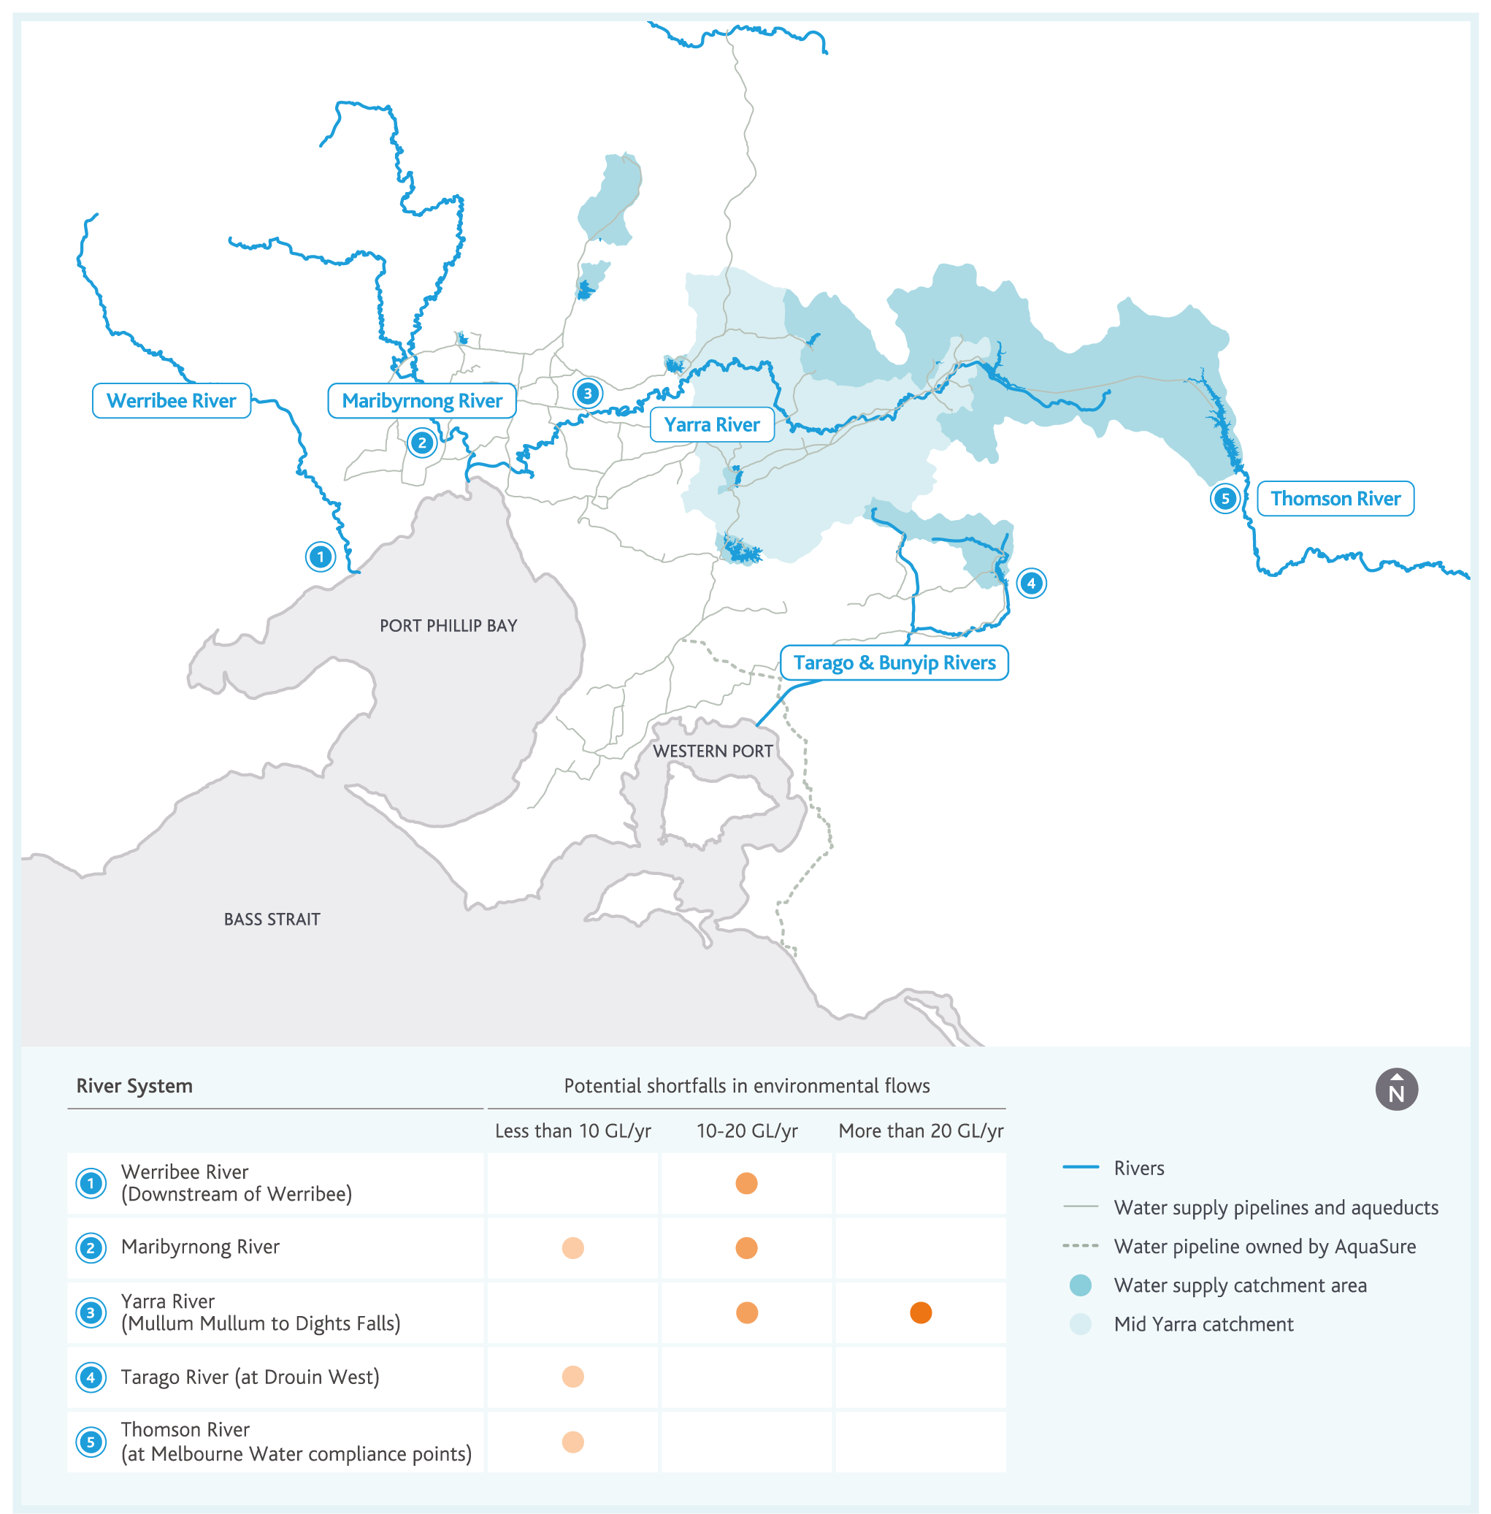
Further work is needed to build our understanding of the volumes of environmental water that may be needed in the future to support environmental values of waterways under climate change. For example, some waterways and wetlands across Melbourne and the surrounding region depend on inflows from groundwater, which require more detailed, locally focussed consideration.
This strategy considers a range of measures (discussed in later chapters), which aim to increase the volume of water available within the whole system, some of which could potentially be used to meet environmental flow shortfalls arising from climate change. The balance between environmental and consumptive uses of water is considered through state government processes, such as sustainable water strategies and long-term water resource assessments. The south central market trial, discussed further in Chapter 7 of this strategy, may also provide opportunities for optimising the balance between environmental and consumptive uses of water in the future. To support these processes, Melbourne Water is currently working with the University of South Australia to build our understanding of the economic value of environmental water in the Port Phillip and Westernport region.

Climate change could affect the quality of water in our waterways
The quantity of water in waterways is key to supporting environmental values, but the quality of water in waterways is also important.
Climate change could affect the quality of water in waterways by modifying:
water temperature
nutrient loads
turbidity.
With climate change, it is possible that more environmental water will need to be delivered to manage water quality, as well as water quantity.
Further work is needed to improve our understanding of climate change impacts on both the quantity of water and quality of water relating to environmental water to start identifying potential management strategies.

Highlight box - Environmental water flushes out Werribee bloom
Environmental water is already used to manage water quality in waterways. In March 2016, 160 ML of environmental water was released into the Werribee River to lower water temperatures and raise the level of dissolved oxygen for aquatic fauna in the lower reaches of the river. The release flushed out a bloom of blue–green algae near Werribee Zoo that was caused by the high water temperatures and high nutrient loads. If climate change increases water temperature, releases like this may need to be larger or more frequent to maintain the current ecological and amenity values of our waterways.
End highlight box.
Figure 19. Werribee River before and after environmental water was delivered
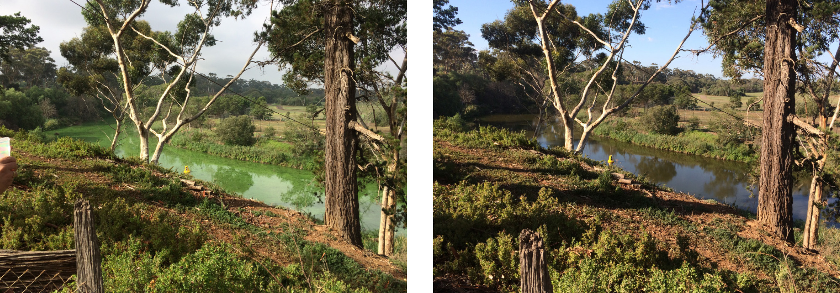

Action 3.3
Develop a strategic understanding of the climate change risks to the environmental values of waterways and wetlands across the Port Phillip and Westernport region or those that are linked to the water supply system by June 2021.
Delivered by
Melbourne Water, West Gippsland Catchment Management Authority, VEWH, DELWP
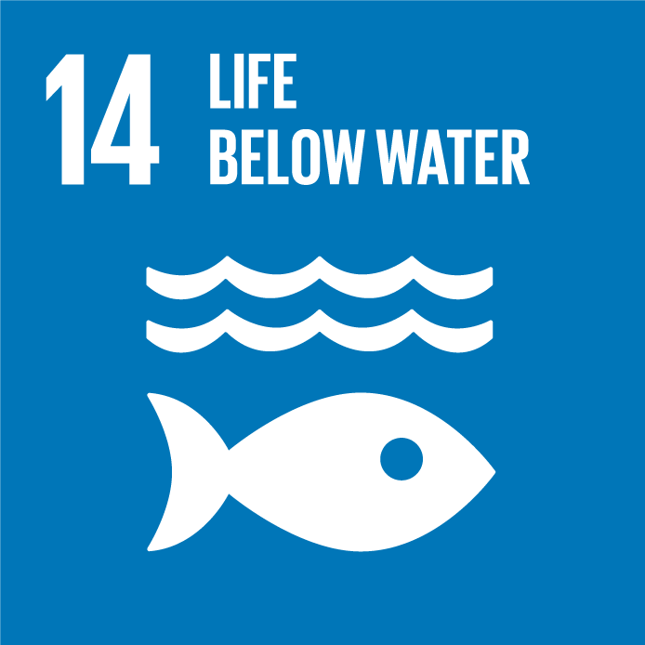

The impact of climate change on water for agriculture
The agricultural sector in the region surrounding Melbourne will also need to adapt to lower water availability with climate change. For example, streamflows in the Werribee and Lerderderg Rivers – key sources of water for the Werribee Irrigation District – could be reduced by up to 45% (endnote 2). In the Werribee River in particular, when streamflows are low, the water tends to become increasingly saline, which could further impact on the extent to which it can be used to support irrigated agriculture.
Irrigators that take water from unregulated streams are often forced to switch to other sources, like groundwater, during droughts.
Water for Victoria outlines some of the ways the agricultural sector is already responding to climate change, including:
modernisation or retirement of irrigation districts
consolidation or retirement of farming operations
shifting farming operations to higher value products
strategically planning any future farming operations to ensure any proposed activities are appropriate to the site and available water resources.
The three major agricultural centres around Melbourne managed by Southern Rural Water – Macalister Irrigation District, Werribee Irrigation District and Bacchus Marsh Irrigation District – are being modernised to reduce water losses and improve the capacity of the system to deliver water when and where it is needed.
In the longer term, the three agricultural centres are all connected to the water grid and directly or indirectly connected to the Melbourne water supply system. The development of water markets and the water grid (discussed in Chapter 7) may offer opportunities to examine future supply options for both agricultural and urban water uses.
The impacts of climate change on the farms that divert water from waterways under farm dam and diversion licences granted by Melbourne Water are to be considered further through the Healthy Waterways Strategy (which is currently under review) as well as associated streamflow management plans.

Rainwater, stormwater and recycled water resources
Rainwater, stormwater and recycled water resources are used to a limited, but growing, extent by households and businesses, and for agricultural purposes across Melbourne and the surrounding region.
Figure 20 provides an indicative snapshot of the water balance across the urban water cycle in Melbourne in 2015/16, showing the significant rainwater, stormwater and recycled water resources available, and how they are comparable to the total volume of water used in Melbourne. For simplicity, stormwater and rainwater resources have been combined in this diagram. Detailed explanatory notes related to Figure 20 are included in Appendix C.
Rainwater, stormwater, and recycled water resources present opportunities to adapt to climate change and population growth. Increasing our use of these diverse sources of water is a key element of the portfolio approach outlined in this strategy, discussed further in Chapter 6.
Figure 20 highlights that in 2015/16, there was more than 600 GL of rainwater, stormwater and recycled water resources available. This volume was higher than total water consumption in 2015/16, and only a small proportion was used. While this presents an opportunity, there are also challenges in using rainwater, stormwater and recycled water. Both the challenges and the opportunities are discussed further in Chapter 6.

Highlight box - Recycled water for agriculture
In a drying climate, recycled water is a potential resource that can be used to support irrigated agriculture and other purposes. In the region surrounding Melbourne, recycled water is already used to support irrigated agriculture, both in major irrigation districts and other areas.
Before 2004, the Werribee Irrigation District was supplied exclusively with water sourced from the Werribee and Lerderderg Rivers. Following several years of extreme drought conditions in the early stages of the Millennium Drought, the Werribee Irrigation District recycled water scheme was implemented in 2004 to supply recycled water from Melbourne Water’s Western Treatment Plant to the Werribee Irrigation District. During the later stages of the Millennium Drought, water availability from the Werribee and Lerderderg Rivers was so low that the Werribee Irrigation District had to be supplied almost exclusively with recycled water in some years.
With climate change expected to impact on streamflows in the Werribee and Lerderderg Rivers, it is likely that recycled water from our Western Treatment Plant will continue to be needed as a source of water for the Werribee Irrigation District – underpinning jobs and economic growth in the area.
End highlight box.

Figure 20. Water balance for Melbourne in 2015/16 (explanatory notes can be found in Appendix C)
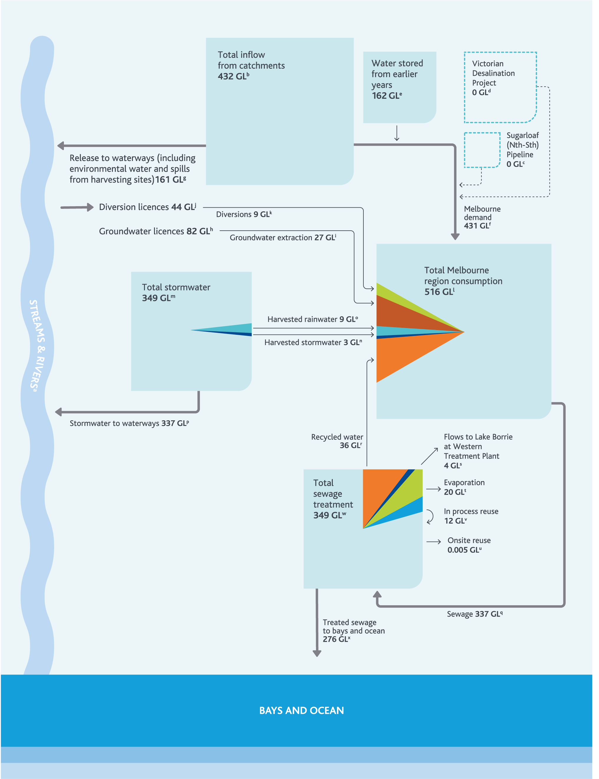

Meeting the Challenges
The challenges presented in the previous two chapters are complex; there is no single solution that can meet the needs of all of Melbourne Water’s customers. In this section we outline a portfolio approach to managing the challenges.
The following four chapters explore the elements of Melbourne Water’s portfolio approach and the strategic directions we will work with our customers to deliver:
Chapter 4: Making the most of the water supply system
Chapter 5: Using water efficiently
Chapter 6: Using diverse sources of water
Chapter 7: Optimising the water grid and market.
Given the uncertainty surrounding the future, we need to ensure that we implement our portfolio approach adaptively, in response to the latest observations and projections available.
This strategy forms one element of the broader adaptive management framework used by Melbourne Water and our customers and stakeholders to ensure that our planning, capital works delivery and operational activities are matched to our operating environment, as illustrated in Figure 21.
Through all of these processes, Melbourne Water will regularly review our actions across our portfolio approach to ensure they are always appropriate to the current situation and reflect the latest available projections of the future.

Figure 21. Adaptive management framework used by Melbourne Water and our customers and stakeholders
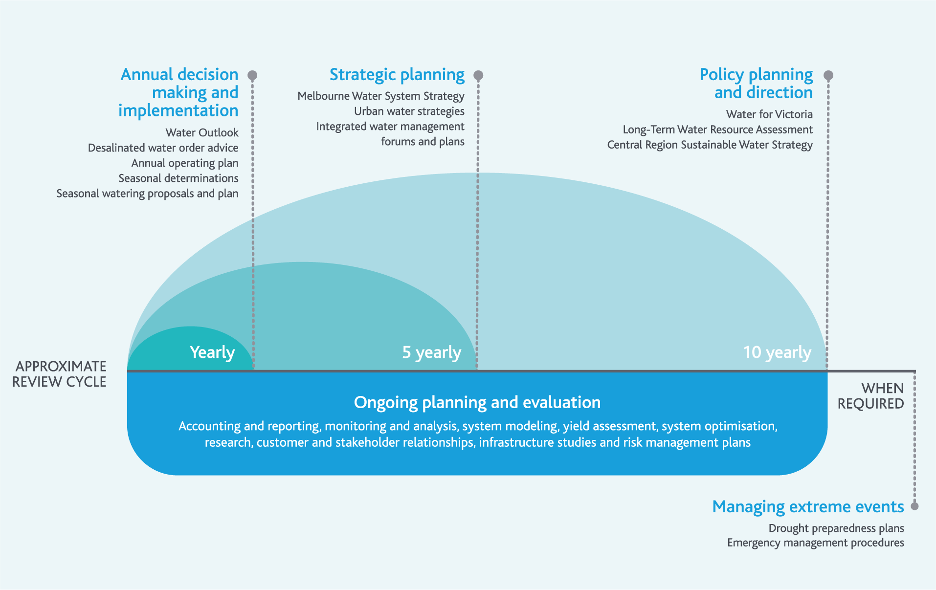

4. Making the most of the water supply system
The water supply system is currently the primary and, in most cases, the only source of supply for many people and businesses across Melbourne. The large storage capacity of the water supply system has been designed to provide Melbourne with water through droughts, enabling us to build a buffer of water in storage during wetter periods.
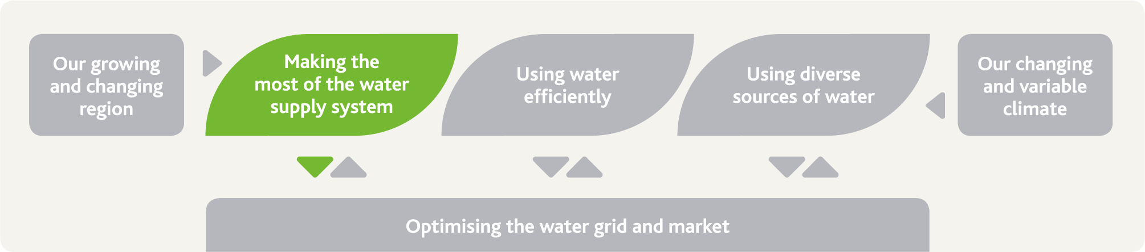

The challenge and our strategic response
To make the most of the water supply system, we operate it to keep a buffer of water in storage, subject to cost, for maintaining supply through future severe droughts and extreme events. Melbourne Water also needs to actively manage our water supply catchments, which underpin the quality and affordability of water for our customers, and maximise the utilisation of our existing entitlements to water.
The water supply system also delivers environmental water – we need to ensure we consider this as part of our ongoing optimisation of the water supply system.

Our actions and their benefits
Action number | Actions in chapter 4 related to making the most of our water supply system | Healthy People | Healthy Places | Healthy Environment
4.1 | Update annual operational planning to continue to meet customer needs, improve transparency and address climate change impacts | •
4.2 | Review arrangements for operation of the Thomson Reservoir hydroelectric plant to prepare for future opportunities | •
4.3 | Review desalinated water order advice development process | •
4.4 | Identify potential improvements to the way we deliver environmental water |  |  | •
4.5 | Continue to develop asset management and information systems and reports, and improve integration with other processes to support optimal asset management | • | • | •
4.6 | Establish clear roles, responsibilities, strategic objectives and management plans for our forested water supply catchments | • |  | •
4.7 | Continue to identify efficient and innovative approaches to managing emerging water quality risks in our water supply catchments | • |  | •
4.8 | Review system performance analysis at least every three years | •
4.9 | Drive integration between water supply system models used by Melbourne Water and our customers | •
4.10 | Explore options to make the most of existing water entitlements and water supply assets | • |  | •
4.11 | Undertake study to understand the trade-off between water quantity, quality and affordability of water from catchments under climate change | •

The water supply system: underpinning water availability
Over four million people in Melbourne and the surrounding region are currently connected to the water supply system – and we expect that by 2065, more than 10 million people could potentially be connected to the water supply system. The water supply system underpins water availability across the region, reliably able to provide high-quality water for the retail and regional water corporations, the environment, and irrigators downstream of Thomson Reservoir and Tarago Reservoir. Across Melbourne, the water supply system is the primary and, in most cases, the only source of supply for many people and businesses.
The water supply system has developed and evolved over more than 150 years. Completed in 1857, Yan Yean Reservoir was the first element of the water supply system, which has since developed into a network of 10 major reservoirs that supply water into the transfer system – the pipelines, pump stations and tanks that interface with our customers’ assets across Melbourne and into the surrounding water grid. The water supply system is discussed in more detail in Appendix B.
Figure 22 illustrates the development of the water supply system over the past century. Figure 23 illustrates the water supply system we have today.
The construction of Thomson Reservoir in the 1980s more than doubled the total storage capacity across our water supply system, as shown in Figure 22. Thomson Reservoir filled before 1997, and we were able to draw on water stored in Thomson Reservoir throughout the Millennium Drought from 1997 to 2009. Storages descended to a low of 25.6% full in June 2009 near the end of the Millennium Drought and since then, they have still not fully recovered. It is now more than 20 years since Thomson Reservoir was last full.
Thomson Reservoir is our main drought reserve that enables us to manage severe, long-duration droughts. In this context, we need to enable Thomson Reservoir to refill after droughts so that we are prepared for the next one. Although we can’t physically transfer more water directly into Thomson Reservoir, we can strategically manage Thomson Reservoir by using diverse sources of water, using water efficiently, and using up to 150 GL/yr from the Victorian Desalination Project to reduce the volume of water that needs to be taken from Thomson Reservoir each year, enabling it to refill more quickly.
Figure 22. Development of storage capacity within the water supply system
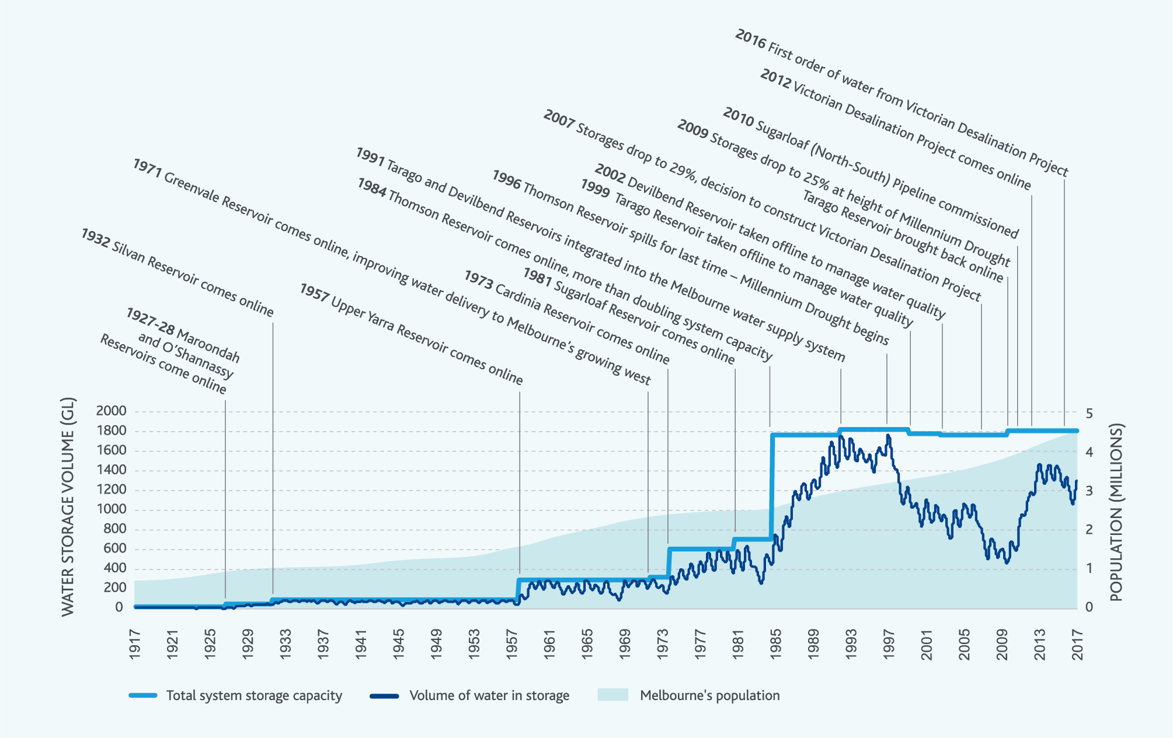

Highlight box - The Victorian Desalination Project
The Victorian Desalination Project, commissioned in 2012, is a rainfall-independent source of water capable of supplying up to 150 GL/yr of high-quality water. This is around one third of Melbourne’s current annual water consumption.
The plant uses reverse osmosis, the most energy-efficient method of desalinating water, and includes energy recovery devices to reduce power consumption. All operational energy is covered by renewable energy certificates.
The project includes an 84-kilometre underground transfer pipeline to connect the plant to the Melbourne network through a transfer main to Cardinia Reservoir. There are a number of water grid connections along this pipeline that enable water to be supplied to the regional water corporations in that area. More broadly, the Victorian Desalination Project underpins water availability for all of our customers, helping us to manage short-term droughts, and the longer-term challenges related to population growth and climate change.
The marine intake and outlet tunnels, transfer pipeline, and the power supply have been built to accommodate up to 200 GL/yr. This means that if this additional capacity is ever needed, only some elements of the plant would need to be upgraded.
End highlight box.

Highlight Box – Yan Yean Reservoir
Built in 1857, Yan Yean Reservoir is Melbourne’s oldest water supply reservoir. The location of Yan Yean Reservoir in Melbourne’s north makes it a key strategic source of water for supplying the northern and western areas of Melbourne, which will experience significant population growth over the coming decades.
The water sourced from Yan Yean Reservoir occasionally has colour, taste and odour issues which have resulted in complaints to the retail water corporations. To ensure water from Yan Yean Reservoir can be better used in the future, Melbourne Water is currently working closely with the retail water corporations to review options to manage this source of water.
We anticipate that water from Yan Yean Reservoir will be more fully utilised within the next 2–3 years after the water treatment plant is upgraded.
End highlight box.
Figure 23. Map of the water supply system

Optimising the water supply system
As discussed in Chapters 2 and 3, climate change will place increasing strain on our water resources in the future, and the demand for those water resources will continue to grow.
On the other hand, our customers and the community have told us that affordability is a key concern for them.
In this constrained environment, we need to get as much value for our customers as possible from the water resources we already have access to through the existing water supply system – we aim to continue delivering water services to our customers at the lowest practicable cost.

Adaptively planning and delivering water supply operations
Every year, Melbourne Water works with our customers to prepare our annual operating plan, which outlines how we will operate the system each year under a range of different climate scenarios. In the annual operating plan we take into account:
forecast urban demands from our customers
planned asset outages for maintenance purposes
projected volumes of water generated by our water supply catchments
planned major transfers between storage reservoirs
any forecast environmental water deliveries, which could result in some assets being temporarily unavailable for water supply purposes while environmental water is being delivered.
The annual operating plan provides our customers with confidence that we will be able to meet their needs and provides an opportunity for them to provide input to ensure our operations reflect the needs of their customers.
We implement the annual operating plan adaptively through each year, to reflect actual consumption, observed climate conditions, any unanticipated outages, environmental water releases, and to make the most of opportunities that emerge during the year to harvest lower-cost water.

Action 4.1
Review the annual operating plan development, the models that underpin it and implementation processes by June 2018 so it continues to meet the needs of our customers, and reflects the latest climate change information from the Guidelines for Assessing the Impact of Climate Change on Water Supplies in Victoria.
Delivered by
Melbourne Water

Contributes to the following Sustainable Development Goals
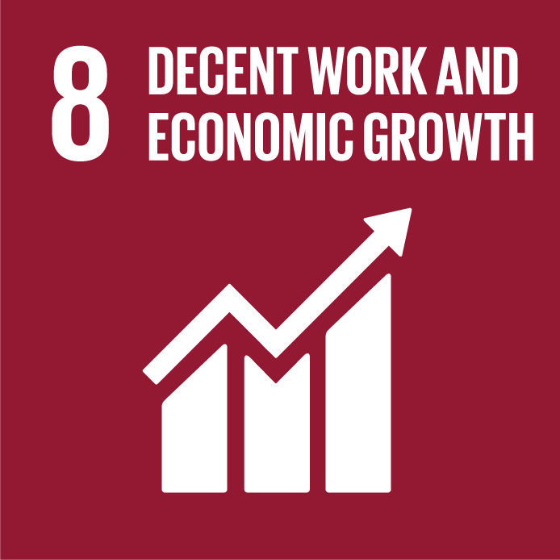

Highlight box - The economic value of water in storage
The water supply system is operated to keep a buffer of water in storage, subject to cost, for maintaining supply throughout future severe droughts, which could last for more than a decade, and to manage the impact of other extreme events like bushfires. Diversifying the sources of water available also helps to manage this risk by providing a range of independent sources that can be used to supply water.
Managing a water supply system with diverse sources of water available that can be called on in any given year requires a detailed understanding of the costs and benefits associated with each source. Melbourne Water, along with the retail water corporations and DELWP, has partnered with the University of Melbourne to research innovative approaches to valuing the water held in storage. This research will provide insights into how the economic value of water in the Melbourne system changes as volumes in storage fall during droughts, informing the optimal use of all available water sources at any given point in time.
End highlight box.

Highlight box - Thomson hydroelectric plant
Water is routinely released from Thomson Reservoir to support downstream environmental values and for Southern Rural Water’s customers in the Macalister Irrigation District. These releases are made through the Thomson Reservoir hydroelectric plant. This practice helps to offset energy costs elsewhere in the water supply system, improving affordability for our customers.
Although Thomson Reservoir hasn’t been full to capacity for 20 years, it may reach full capacity again in the future. When Thomson Reservoir is nearing full capacity, an opportunity emerges to increase flows through the hydroelectric plant to regulate the storage volume and to reduce the chance of unregulated flows from the spillway.
Since Melbourne Water does not own the water stored in Thomson Reservoir, any discretionary releases made through the Thomson Reservoir hydroelectric plant would need the approval of the entitlement holders that own the water.
End highlight box.

Action 4.2
Review arrangements for the future operation of the Thomson Reservoir hydroelectric plant by June 2020.
Delivered by
Melbourne Water, retail water corporations, regional water corporations, West Gippsland Catchment Management Authority, VEWH, Southern Rural Water
Contributes to the following Sustainable Development Goals

Preparing the desalinated water order advice
Melbourne Water, together with the retail water corporations, helps to inform the state government’s desalinated water order decision by providing technical and operational advice about the desalinated water order volumes needed each year to maintain the levels of service our customers need.
Population growth and a changing climate will result in desalinated water being ordered increasingly frequently. Recent assessments by Melbourne Water suggest that we may already be approaching the point where smaller volumes of desalinated water could need to be ordered regularly to keep a buffer of water in storage, subject to cost, for maintaining supply through future severe droughts which could last for more than a decade.
When we prepare the desalinated water order advice each year, we consider information related to current and forecast storage levels, including Bureau of Meteorology outlooks, against five key principles:
- the need to avoid storage levels falling into the water outlook low zone
- the need to avoid storage levels falling into the water outlook medium zone most of the time
- the need for storage recovery following dry periods
- the risk of desalinated water causing avoidable foregone harvest or spills
- affordability considerations.
During the development of this strategy, Melbourne Water worked closely with the retail water corporations to update the water outlook zones to reflect recent growth in demand, the new climate change streamflow scenarios in the Guidelines for Assessing the Impact of Climate Change on Water Supplies in Victoria prepared by DELWP, and other factors that have changed since the zones were last reviewed in 2011. This is discussed further in Chapter 5.
Many of the same factors that recently changed our water outlook zones also underpin the desalinated water order advice. We will review the desalinated water order advice development process with the retail water corporations to make sure it is based on the latest available information, and delivers transparent advice that provides our customers, stakeholders and the community with certainty and confidence.

Action 4.3
Review the desalinated water order advice development process with the retail water corporations and other stakeholders by September 2017, drawing on expertise from economists, engineers and environmental scientists, to ensure it:
reflects customer and community preferences
optimises short and long-term water availability
underpins water availability across the water grid
incorporates operational and asset management considerations
relates to the updated water outlook zones
discharges existing contractual obligations
aligns with the Guidelines for Assessing the Impact of Climate Change on Water Supplies in Victoria.
Delivered by
Melbourne Water, retail water corporations
Contributes to the following Sustainable Development Goals

Adaptively planning and delivering environmental water
In parallel with the development of the annual operating plan, Melbourne Water prepares seasonal watering proposals for the rivers we manage (Werribee, Maribyrnong, Yarra and Tarago Rivers) in consultation with our community advisory groups. The West Gippsland Catchment Management Authority prepares the seasonal watering proposal for the Thomson River. These proposals outline the environmental water releases needed to support environmental values throughout the year.
The proposals are submitted to the VEWH to support their preparation of the seasonal watering plan for Victoria, which sets the priorities for where, when, how and why environmental water will be used annually in rivers and wetlands under wet, dry and average climate scenarios. The seasonal watering plan is implemented adaptively in response to the climate conditions actually observed through the year.
Melbourne Water plays a number of roles in its implementation once the VEWH finalises the seasonal watering plan.
For the Yarra and Tarago Rivers, we plan and deliver environmental water releases through the year.
In the Werribee and Maribyrnong Rivers, we plan environmental water releases, and then we work with Southern Rural Water to deliver the releases from the storage reservoirs on those rivers which they manage.
In the Thomson River, the West Gippsland Catchment Management Authority plans environmental water releases, and then our operators deliver the releases from Thomson Reservoir.

Improving how we deliver environmental water
Many of the water supply assets that deliver environmental water from water supply reservoirs, pipelines, and aqueducts, were designed and built decades before we understood the importance of the environmental values of waterways, and before we started delivering environmental water to support them.
As a result, some of the water supply assets Melbourne Water uses to deliver environmental water are not currently able to effectively and efficiently deliver water to some reaches of some waterways and wetlands. We have made improvements or modifications to our water supply assets to overcome some of these challenges. There may be more opportunities, but these require further evaluation.
As well as infrastructure limitations, operational challenges have also emerged where water supply assets are needed for both water supply purposes and to deliver environmental water. Improvements to our water supply assets may help to overcome some of these types of operational challenges. Melbourne Water will work closely with the retail and regional water corporations, the West Gippsland Catchment Management Authority, the VEWH and DELWP to continue to develop transparent and optimised approaches to sharing water supply assets.

Action 4.4
Identify potential operational and infrastructure solutions that could improve our ability to efficiently deliver environmental water when and where it is needed from the water supply system, including:
a review of constraints in the Yarra River system to be finalised in June 2017
a trial of flexible passing flows and associated water accounting in the Thomson River system commencing in July 2017.
Delivered by
Melbourne Water, retail water corporations, regional water corporations, Southern Rural Water, West Gippsland Catchment Management Authority, VEWH, DELWP
Contributes to the following Sustainable Development Goals

Highlight box - Delivering environmental water into billabongs and wetlands
In river systems, overbank flows naturally fill adjacent billabongs and wetlands that support ecologically valuable flora and fauna. In regulated river systems where there are large water storage reservoirs upstream, small and medium sized floods that naturally fill wetlands occur less regularly than they did before the reservoirs were built.
Melbourne Water has recently undertaken works to deliver environmental water directly to three wetlands along the Yarra River to mimic the effects of overbank flows: Spadoni’s Billabong, Banyule Billabong, and Yering Backswamp. In this way environmental water is used safely and efficiently to support environmental values and also to provide a secondary shared benefit of pleasant places for recreation.
End highlight box.

Highlight box - Recreation on our waterways
Waterways across Melbourne and the surrounding region support a diverse range of recreational activities such as fishing, kayaking and swimming in waterways, and walking, running and cycling on shared paths along waterways.
Environmental water releases are planned primarily to meet environmental needs. However, they can also play a role in supporting recreational activities, because many of the types of flow events required to support ecological values can also support recreational values. These types of shared benefits are very important.
For example, environmental watering over the last five years has initiated migration of the Australian grayling to spawn in the lower Thomson River. This is a significant accomplishment in the population recovery of Australian grayling, which are listed as a vulnerable species.
The releases of environmental water for Australian grayling also provide shared benefits to kayakers and canoers. Many kayakers and outdoor education clubs have registered with West Gippsland Catchment Management Authority to be notified of these releases and choose to take advantage of these conditions. Both Melbourne Water and the West Gippsland Catchment Management Authority take shared recreational benefits into account during the planning and delivery of environmental water, to maximise the value we deliver to the community when releasing environmental water.
End highlight box.

Maintaining and renewing the water supply system
The water supply system is comprised of hundreds of kilometres of linked assets that have been built over a long period of time including reservoirs, pipelines, pump stations and water treatment plants. Some of our water supply assets are over 100 years old, while others are new.
To ensure Melbourne Water’s assets continue to provide the services our customers need, we invest resources into monitoring their condition, maintaining, and renewing them.

Monitoring the condition of our assets
To drive Melbourne Water’s maintenance and renewal activities, we review the condition of each of our assets on an ongoing, prioritised basis. We have asset management and information systems which enable us to report on the condition of each asset, and the extent to which the condition could impact on the specific services supported by those assets. These systems can highlight assets particularly critical to delivering our services. This means we can then focus maintenance and renewal efforts on these critical assets.

Action 4.5
Continue to develop more dynamic and interactive asset management and information systems and reports, expanding use of business intelligence tools, and improve integration with other risk management procedures and systems and growth planning activities across Melbourne Water.
Delivered by
Melbourne Water
Contributes to the following Sustainable Development Goals

Maintaining and renewing our assets
Driven by our asset management and information systems and other planning activities, Melbourne Water generally has a significant maintenance and renewals program. Assets are maintained to extend their lifespan and improve their performance; when assets have reached the end of their service life, they are renewed, replaced, or retired.
As our region grows in population and density, it is even more likely people will be living or doing business near our assets. We work hard to minimise any impacts on the community whenever we undertake any construction works, but as our city and region become more and more densely populated, this may become increasingly challenging. We will continue to work closely with our customers and the community to minimise any adverse impacts of future construction works.

Highlight box - The Maroondah Aqueduct
The Maroondah Aqueduct is an open aqueduct that links Maroondah Reservoir and Sugarloaf Reservoir, which has been in service for over 100 years. During this period, it has been repaired and upgraded many times.
The Maroondah Aqueduct is now reaching the end of its service life and is going to be progressively replaced with a new pipeline over the next 10–15 years. This solution will also improve water quality, resolve safety issues related to operating an open aqueduct, and manage a source of leakage from our water supply system. The new pipeline may also present improved opportunities to deliver environmental water to key locations in the Yarra River.
Melbourne Water is currently working with our customers and stakeholders to plan for the decommissioning of the Maroondah Aqueduct and associated assets. Even when it is decommissioned, the Maroondah Aqueduct will have cultural heritage values which will need to be preserved. We are also working with relevant stakeholders to investigate opportunities to construct a shared path on any land that will no longer be needed for water supply purposes.
End highlight box.

Managing drinking water quality
More than 75% of Melburnians consider the quality of our drinking water to be very good or good (endnote 19). How we manage our water supply catchments is a key driver of drinking water quality.
We apply a preventative risk management framework to manage drinking water quality. We use the hierarchy of controls to guide our risk management, with a major focus on prevention.

Forested water supply catchments
The majority of Melbourne’s water comes from forested catchments to the east of Melbourne. These catchments are largely closed to public access, including commercial and recreational activities, to minimise water quality risks at their source. This approach to managing drinking water quality has a long history in Melbourne, dating back to the late 1800s when it was recognised that public access to water supply catchments (which was allowed at the time) was a key contributor to the observed poor drinking water quality.
The Australian Drinking Water Guidelines recognise catchment management and source water protection as a key element of a multiple barrier approach to managing drinking water quality, and recommend that ‘wherever possible, the focus of these measures should be to prevent contamination in the catchment rather than rely on downstream control’ (endnote 20).
Water from our forested water supply catchments is currently subjected to minimal water treatment – disinfection and fluoridation only. Extensive water treatment can be costly and energy intensive. This means that restricted access to our forested water supply catchments not only contributes to maintaining water quality, but also to keeping water from our water supply system affordable and helping to manage our greenhouse emissions. This is important as nearly 80% of Melburnians think that water is the most basic of essentials, and should be offered at a low cost (endnote 19).
Bottled water is often marketed on the basis of its pristine origins. Melbourne Water sources the majority of Melbourne’s water from remote, forested mountain streams - for a very small fraction of the cost of bottled water.
Our forested water supply catchments help us deliver safe, affordable water and we expect they will continue to be a major source of water for Melbourne and the surrounding region over the next 50 years. Melbourne Water shares catchment management responsibilities with Parks Victoria and DELWP and, together, we will continue to manage and protect our forested water supply catchments for current and future generations.

Action 4.6
Clarify roles and responsibilities in managing our forested water supply catchments and establish clear strategic objectives and associated joint management plans to optimise water quality and quantity from our water supply catchments.
Delivered by
Melbourne Water, DELWP, Parks Victoria
Contributes to the following Sustainable Development Goals

Open water supply catchments
Some of Melbourne’s water is also sourced from open water supply catchments upstream of Tarago Reservoir and Sugarloaf Reservoir. These are partially forested, but also support agricultural and recreational activities, and some urban development. Over the last ten years, approximately 15% to 44% of the total volume of water supplied from the water supply system each year has come from Tarago Reservoir and Sugarloaf Reservoir.
Water from open water supply catchments is fully treated before it is supplied to our customers, which makes water from Sugarloaf Reservoir and Tarago Reservoir more costly to supply than water sourced from our forested water supply catchments.
In the future, additional development is expected in the mid-Yarra catchment upstream of Sugarloaf Reservoir, which could create additional water quality risks that would need to be managed through additional water treatment unless those risks can be managed within the catchment.
Currently, Melbourne Water has limited input to development approvals in the mid-Yarra catchment, despite its strategic importance as the key source of water for Sugarloaf Reservoir. This presents challenges for managing emerging risks, including those associated with inappropriate development, other than through additional water treatment that could impact on the affordability of water. We are currently exploring potential statutory planning mechanisms that could provide Melbourne Water with greater influence over future development and land use change.
We will also continue to work with our customers and stakeholders on an ongoing basis to identify other efficient and innovative risk management approaches, such as optimising traditional river health programs for both environmental and public health outcomes, and investing in a robust monitoring and research program to support evidence based decision making.

Action 4.7
Continue to identify efficient and innovative approaches to managing emerging water quality risks in our water supply catchments, including exploring potential statutory planning mechanisms that could provide Melbourne Water with greater influence over future development and land use change in the mid-Yarra catchment by June 2018.
Delivered by
Melbourne Water, Yarra Valley Water, DELWP, Parks Victoria, local government
Contributes to the following Sustainable Development Goals

Our water supply system in droughts
Our water supply system has been designed to help manage climate variability, with large storage reservoirs that can capture water during wetter periods, to deliver it during drier periods. It is normal for water storage levels in our water supply system to rise during wetter years, and to fall during drought years.
With climate change, wetter periods will likely still occur, but possibly not at the same frequency or to the same extent. Our water storages may not naturally refill as quickly between droughts – and it is critical that we go into droughts with a buffer of water in storage. Since the end of the Millennium Drought, our water storages have still not fully recovered - Thomson Reservoir has not been full since 1996.

The Victorian Desalination Project during droughts
The significant reductions in water consumption and environmental water releases during the Millennium Drought helped us to avoid running out of water in 2009 (as discussed further in Chapter 5), but only because our water storages were full at the beginning of the drought in 1997.
Figure 24 shows how our water storage levels would track if climate conditions for the next 13 years were similar to those in the Millennium Drought, depending on how the Victorian Desalination Project is used. (Figure 24 assumes demands would follow the medium demand scenario presented earlier in Figure 16.)
Figure 24. Potential future water storage levels if the Millennium Drought occurred now
Having sufficient water in storage at the beginning of droughts is critical to ensuring we have enough water to last through to the end of droughts. This is because even the Victorian Desalination Project – able to provide up to 150 GL/yr – can only supply up to around one third of the current demand for water, meaning that the remaining two thirds need to be sourced from our storages. The Victorian Desalination Project was not built to be turned on only when our water storages reached critically low levels; instead we need to use it to make sure that our water storages don’t fall to those levels in the first place.
Figure 24 shows that current storage levels could be high enough to deliver water throughout a repeat of the Millennium Drought under the levels of demand anticipated over the next 13 years, provided water drawn from storages is regularly supplemented with water from the Victorian Desalination Project, potentially including orders of up to 150 GL in some dry years. However, even this with use of the Victorian Desalination Project, it is likely water storage levels would fall into the water outlook medium zone where mild water restrictions could potentially be implemented. This highlights the need to operate the water supply system to keep a buffer of water in storage, subject to cost, for maintaining supply throughout future severe droughts, which could last for more than a decade.
Figure 24 shows that in this simple example if 50 GL is ordered in years when storages are above the water outlook medium zone, and 150 GL is ordered in years when storages are in the water outlook medium zone, storage levels can be maintained above the water outlook low zone, where severe water restrictions would need to be implemented. To manage higher demand scenarios, we would need to enter the Millennium Drought with more water in storage, and use even more water from the Victorian Desalination Project.

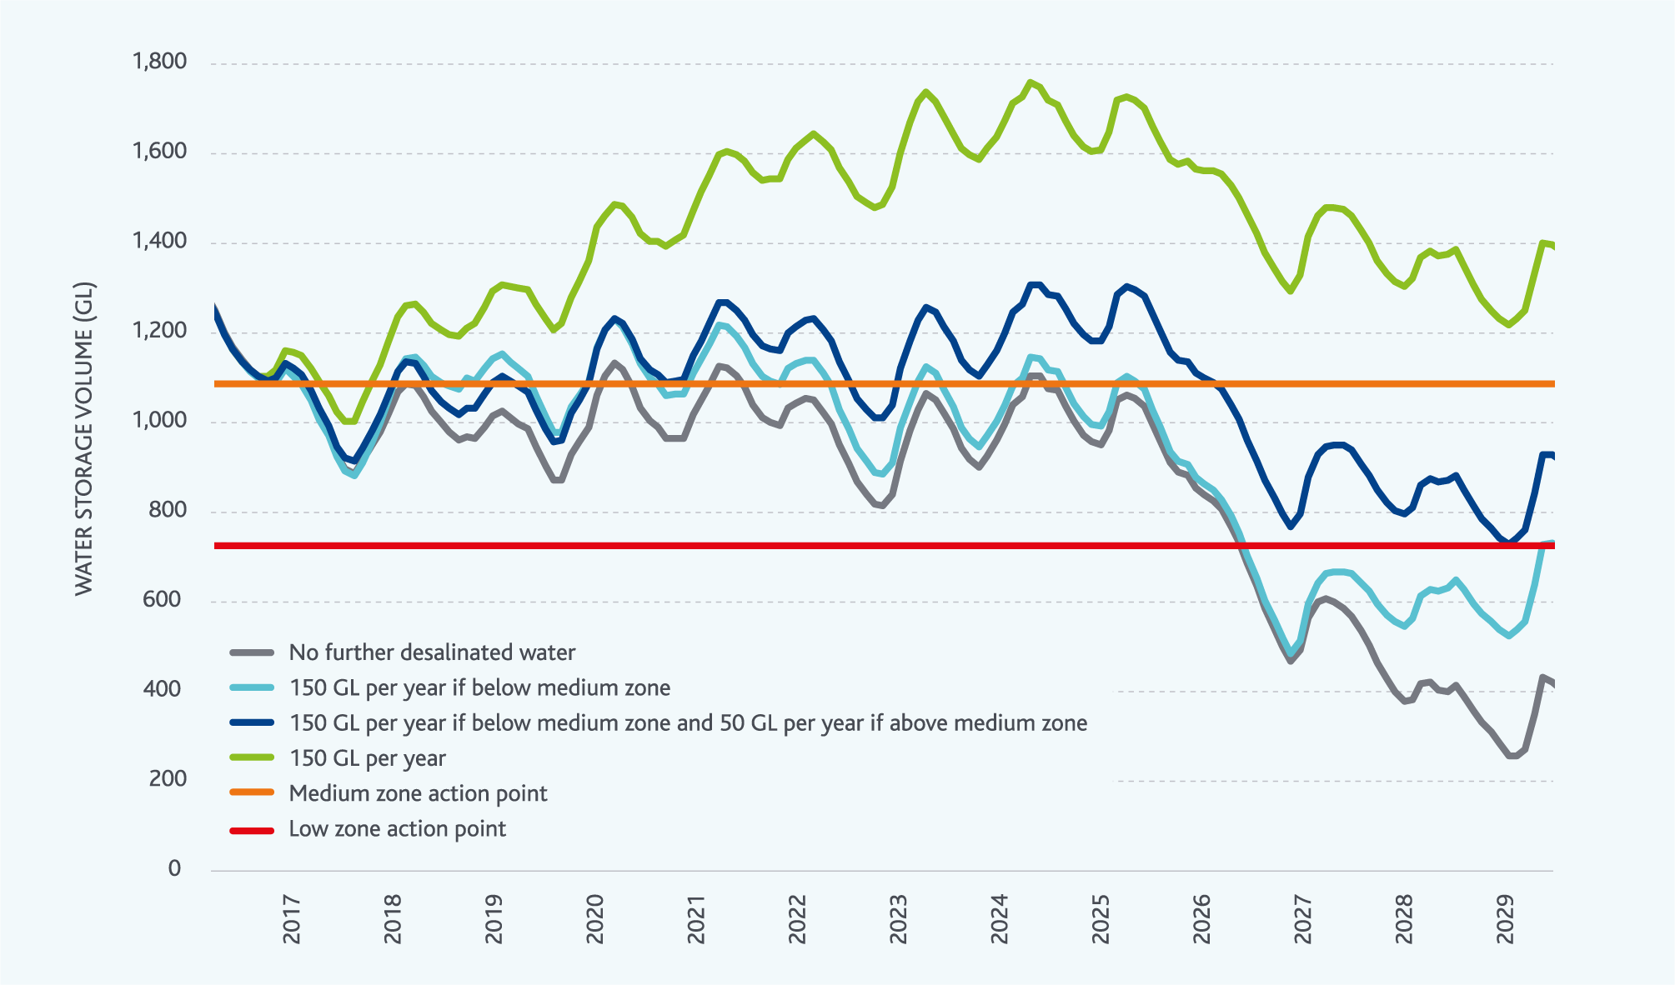

Balancing affordability and risks
Water from the Victorian Desalination Project becomes more expensive if higher volumes are ordered. On a per unit volume basis, it is less expensive to order 50 GL/yr than it is to order 150 GL/yr. This means that a strategy of ordering 50 GL/yr more frequently to keep water storage levels higher could be a more affordable approach than ordering larger volumes of water from the Victorian Desalination Project after water storage levels fall to lower levels.
We need to balance risks of storages falling to low levels with affordability, and the risk of our storages reaching capacity and spilling if future climate conditions are wetter than those during the Millennium Drought.
We take these affordability and risk considerations into account in our annual desalinated water order advice as discussed earlier in this chapter.

Helping our waterways through droughts
During droughts, our rivers and creeks can become stressed, and environmental water needs to be used to support key environmental values.
Assessments made after the Millennium Drought suggest that environmental values in our key waterways were impacted by the Millennium Drought, but began to recover with good rainfall in the second half of 2010 and in 2011 providing significant flows throughout our waterways.
During the Millennium Drought Melbourne Water identified a number of sites throughout Melbourne’s waterways that contained high-value aquatic ecosystems and species. These ‘drought refuges’ play a key role in supporting environmental values through dry periods and recovery afterwards.
Working with a wide range of stakeholders and building on the lessons we learned during the Millennium Drought, we have developed a Drought Refuge Management Plan. This plan catalogues locations, values, hydrology and other characteristics of drought refuges across the Melbourne region, and outlines key drought management actions for each drought refuge.
The Drought Refuge Management Plan will help to maintain environmental values throughout future droughts, making the most of available environmental water. Other actions related to managing waterways during droughts are included in the Healthy Waterways Strategy and associated streamflow management plans.

Our water supply system in extreme events
There is a range of extreme events, aside from drought, that can impact on the water supply system and threaten our ability to deliver the services the community expects. The system is potentially exposed to a range of hazards including:
natural disasters such as bushfires, severe storms and earthquakes
physical and cyber security threats
operational outages linked to asset or control system failures.

Identifying and monitoring threats
Identifying and monitoring potential threats early is a key aspect of managing extreme events. Melbourne Water has a series of processes in place to continually monitor emerging and ongoing risks to all our systems, including the water system. This is part of our obligation under the Water Industry Act 1994 and the Emergency Management Act 2013 and is built into our business through:
a robust structure of accountability and governance
risk management systems
risk-specific working groups responsible for developing and implementing our risk management plans.
Melbourne Water monitors risks to the system using our integrated risk management and incident reporting system. Using this, we can track all incidents and use them to identify where risks to system operation exists, and how they might be minimised to avoid major incidents.
Where possible, we proactively intervene to reduce the risk of extreme events; for example, catchment management activities and active fire monitoring reduce the risk that bushfires pose to the water system.

Responding to extreme events or emergency situations
Not all risks posed by extreme events can be fully mitigated, so we ensure that Melbourne Water is able to respond decisively and effectively should an extreme event or emergency situation arise.
Melbourne Water has adopted an all-hazards incident management approach, which means that regardless of the type of incident, the impacts are managed using an adaptable framework that aims to deliver continuity of service while minimising the physical risks to people, infrastructure and property.
Melbourne Water’s emergency management system is an incident response framework aimed at providing a clear and concise set of responsibilities to minimise the impacts of any extreme or emergency event. The structure of our system is aligned with those in place across emergency management and other government agencies in Victoria.
This enables coordination of incident responses across multiple agencies and allows responsibility for an incident to transfer between agencies such as the Country Fire Authority or Victoria Police.
High-impact events, like extreme bushfires or major earthquakes, could impact on normal operations of the water supply system. Our incident management framework recognises the significance of Melbourne Water’s role in providing essential services to the community and provides a framework for minimising the impact on our customers and the community, regardless of the cause or severity of the event.
The Victorian Desalination Project provides the water supply system with an additional source of water that is available to manage system storage levels as part of the response to any extreme event that reduces water availability from our catchments and reservoirs.

Highlight box - Managing bushfire risks
Our forested catchments act as natural filters, meaning we can minimise costly water treatment processes and still deliver a world class product to our customers.
The attributes of our forested catchments that make them so valuable – their well-established vegetation, restricted access, remote location and often steep terrain – means that they are also potentially susceptible to bushfire. Bushfires can result in nutrient rich, silty water being washed into reservoirs. The silt that is mobilised after bushfires is very fine, and can stay suspended in the water for years. Bushfires can also have long-term impacts on the volume of water produced by water supply catchments, as discussed in Chapter 3. Fires also pose a threat to water supply infrastructure and surrounding community assets.
While we have a range of operational contingency options for managing the impacts of bushfire, potentially including increased use of the Victorian Desalination Project, it is even better if bushfires can be avoided or managed to minimise impacts on the water supply system.
Melbourne Water works with DELWP and Parks Victoria to manage our forested catchments, including a range of bushfire risk management activities intended to minimise the risk of major bushfires spreading out of control. We maintain a network of fire access tracks and firebreaks to improve firefighting effectiveness, and perform fuel reduction burns where appropriate and possible to minimise the risk of fires taking hold. Under climate change, bushfire risks are likely to continue to grow, and these bushfire risk management activities will become increasingly important.
We also employ firefighting crews over the fire season each year to maintain an in house capability to work with the fire agencies, including first attack fire suppression in our water supply catchments. The crews are strategically located to monitor our catchments and for quick response to fires as they happen, providing a critical first response capability in an effort to reduce their severity and extent of any fires that do break out. We invest about $4m a year to provide this quick response capability, as well as to build and maintain assets that assist bushfire risk management and firefighting activities.
End highlight box.

Transferring water to our customers
While having enough water available in storages is essential, it is equally important we have the right infrastructure in place to ensure water can be transferred from our water storages to our customers. This is especially critical during summer when more water is used, both across the whole season and on peak days during particularly hot and dry periods.
As Melbourne continues to grow, both through densification of existing suburbs and new suburbs around the edges of the city and in the surrounding region, a challenge will be to continue to transfer enough water across Melbourne and the surrounding region to meet the needs of our customers.
Transferring water to the growth areas around the western and northern fringe of Melbourne is an example of this, since these areas are some distance from existing sources of water.
Figure 25 illustrates the water supply transfer system, highlighting the growth areas outlined in Plan Melbourne (endnote 11).
Figure 25 also highlights the proximity and growing importance of the main sources of water for the northern and western areas of Melbourne: Greenvale Reservoir, Sugarloaf Reservoir and Yan Yean Reservoir. Greenvale Reservoir is the closest source of water to the northern and western growth areas and will play an important role in supplying water into these areas. Greenvale Reservoir has no catchment of its own, but stores water transferred across Melbourne from Silvan Reservoir during the cooler months of the year when the demand for water is lower.
To support the development of appropriate servicing solutions for growth areas, Melbourne Water regularly undertakes detailed system performance analysis of the water supply transfer system, and plans and delivers any necessary upgrades.

Figure 25. The water supply system and growth areas outlined in Plan Melbourne
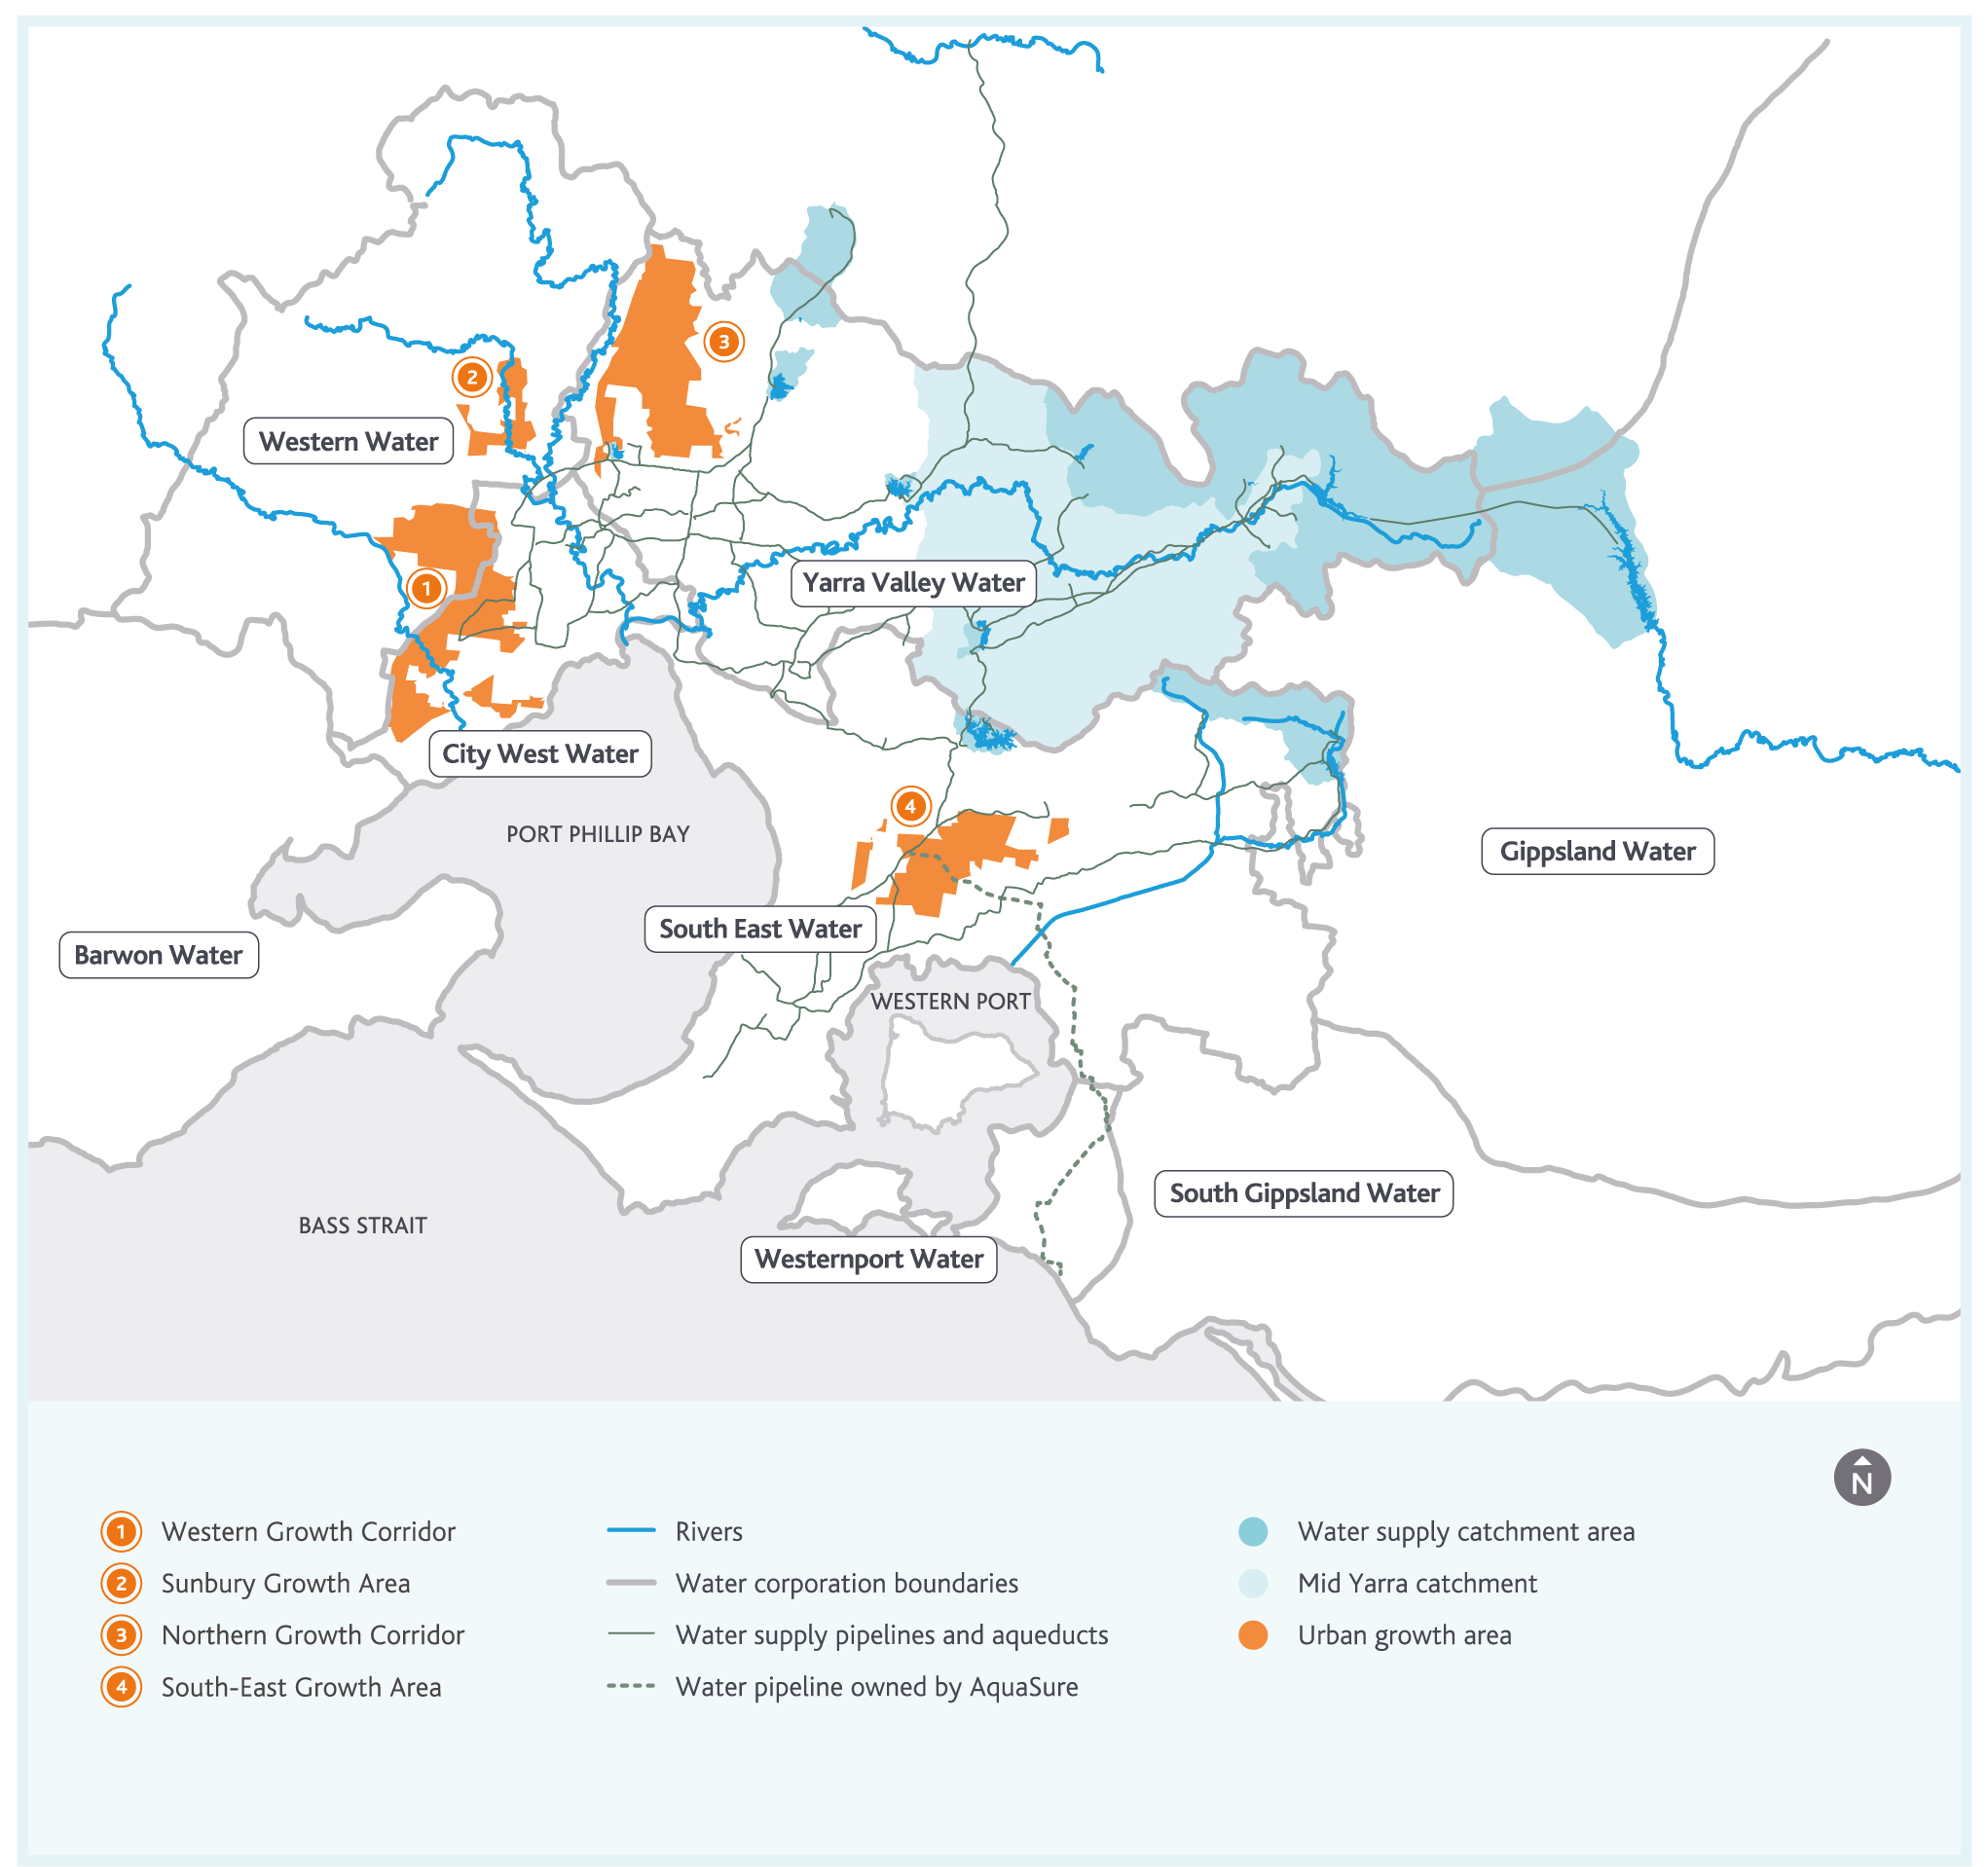

Analysing the performance of the transfer system
During the development of this strategy, Melbourne Water undertook system performance analysis to understand how the transfer system would perform under the level of demand expected in 2050 based on current population projections and demand assumptions provided by the retail water corporations. This analysis took into account upgrades of the transfer system that are already planned for the next 20 years – so it was aimed at identifying longer term challenges that could emerge further into the future.
Through this process, we assessed the performance of the transfer system against a number of key criteria, including:
minimum predicted water pressure relative to our existing service standards
recovery of service reservoir levels following peak demand periods, which is needed to ensure water is available in subsequent days
capacity to supply water from our water supply system to Western Water (who are supplied from the north-west edge of our water supply system) during peak demand periods.
Our system performance analysis indicates that the transfer system will need further investigations and upgrades beyond those planned for the next 20 years to ensure the criteria above can be satisfied until 2050 and beyond. The analysis suggests that by 2050 and without further upgrades to the transfer system beyond those already planned:
Water treatment plants at major storage reservoirs, including the Winneke and Tarago water treatment plants, may need to be upgraded or may require additional treated water storage capacity to ensure they can deliver enough water during peak demand periods.
During peak demand periods, minimum water pressure at approximately 17 locations across the transfer system may fall below the minimum water pressure service standard.
Following peak demand periods, the water levels in 12 of our service reservoirs may not fully recover, which could make it challenging to meet demands on the following days, at least at an acceptable water pressure.
Delivering enough water to Western Water during peak periods at full pressure may present challenges.
Upgrades of the water supply transfer system to address these challenges could also help to manage operational risks that may emerge in the future. Developing the transfer system to include capacity beyond what is immediately needed, and to include alternative transfer pathways can help to ensure continuity of supply during unplanned asset outages.
As part of our system performance analysis, we also undertake sensitivity analysis, to understand the extent to which the challenges across our transfer system could be influenced by lower demands. Through this sensitivity analysis, we found that if the forecast peak day demand for 2050 could be reduced by about 20%, from the currently expected 3.9 GL/day to around 3.1 GL/day, some of the projected challenges would not emerge until beyond 2050, and the magnitude of others would be reduced. This key finding highlights the importance of ongoing investment in both water efficiency initiatives and diverse sources of water as discussed in the following two chapters of this strategy. We will continue to work with our customers and stakeholders to plan and deliver selective augmentations at key sites across the water supply transfer system to manage any challenges that remain after investment in water efficiency initiatives and diverse sources of water.

Action 4.8
Establish a shared understanding with the retail and regional water corporations of the relationship between the demand for water and the long-term costs of servicing those demands through the transfer system by:
reviewing system performance analysis at least every three years (and at other times as needed)
investigating potential future upgrades of the transfer system that may be required in the future.
Delivered by
Melbourne Water, retail water corporations, regional water corporations
Contributes to the following Sustainable Development Goals
Our system performance analysis also highlighted an opportunity to enhance our understanding of the retail and regional water corporations’ water distribution systems, and to work with them to explore more integrated approaches to managing our systems together. This could help to optimise augmentations of our transfer system, and their distribution systems. Increasing the level of integration between models used by Melbourne Water and the retail and regional water corporations is one way of further developing our shared understanding of how our systems can work optimally together.

Action 4.9
Drive increasing integration between resource models of Melbourne Water’s headworks system, hydraulic models of Melbourne Water’s transfer system and hydraulic models of the transfer and distribution assets operated by the retail and regional water corporations. This will help to support increasingly optimised and integrated transfer system upgrades.
Delivered by
Melbourne Water, retail water corporations, regional water corporations
Contributes to the following Sustainable Development Goals
Future development of the water grid and the south central market, in addition to the development already anticipated and taken into account in our system performance analysis, may also create new demands on the water supply system. Any new demands could drive consideration of further upgrades of the transfer system in the broader context of opportunities to efficiently service growing demands for water across the region through the water grid.
Efficient and timely investment planning for future water (and sewage) transfer infrastructure needs to be supported by good demand forecasts. The growing contributions from rainwater, stormwater and recycled water and the emerging roles of the water grid and south central market will create new challenges and uncertainties in forecasting demands over the coming years. Action 2.4 in this strategy will enhance demand forecasting capabilities across the Melbourne water industry.

Fully utilising water entitlements and assets
As discussed earlier in this chapter, we need to optimise the operation of the water supply system and take opportunities to enhance the capacity, flexibility and efficiency whenever we maintain and renew our assets.
There may also be opportunities to make relatively minor investments in new infrastructure to make our water supply system work harder and enable us to maximise the use of existing water entitlements. We will continue to work with our customers and stakeholders to identify and investigate these opportunities on an ongoing basis.

Minor enhancements of our water supply system
While developing this strategy, we identified some potential opportunities to more fully utilise existing water entitlements.
Cement Creek is a tributary of the Yarra River, from which we used to take water until the 1990s when the O’Shannassy Aqueduct was decommissioned to manage asset condition and water quality risks. The aqueduct previously connected O’Shannassy Reservoir, Cement Creek and a number of other smaller creeks to our water supply system at Silvan Reservoir. Melbourne Water still has an entitlement to divert water from Cement Creek, and recent reviews suggest that modest volumes of water could potentially be diverted from Cement Creek, if new connecting infrastructure was built.
Bunyip River flows from the southern slopes of the Yarra Ranges into Western Port. Small volumes of water are currently diverted from Bunyip River to supply some of South East Water’s customers. Melbourne Water is currently working with South East Water to identify different ways of supplying water to these customers, which could mean that in the future we will no longer need to divert water from Bunyip River to supply them. Like Cement Creek, Melbourne Water will still have an entitlement to divert water from Bunyip River and recent reviews suggest that modest volumes of water could potentially be diverted from Bunyip River into our water supply system, if new connecting infrastructure was built.
Further evaluation of the environmental, social and financial costs associated with using these sources of water is required, including consideration of alternative approaches to using the entitlements, such as for sources of environmental water.

Action 4.10
Identify and evaluate options for making the most of existing water entitlements and water supply assets, taking into account environmental, social, financial and technical considerations. Initially, this will include reviewing options to fully utilise the existing Cement Creek and Bunyip River water entitlements by December 2019.
Delivered by
Melbourne Water, retail water corporations, regional water corporations, DELWP

Contributes to the following Sustainable Development Goals

Balancing water quality, quantity and affordability
In some of our catchments, major storms can wash sediments into waterways, causing water quality to deteriorate. During such events, harvesting water from some of our catchments may be reduced to ensure none of this lower quality water makes its way into our water supply system.
This practice provides additional water to the environment and helps to manage water quality in our water supply system, but it does mean that we are unable to fully utilise these water supply catchments.
With increasing demand for water and with climate change, implementing additional water treatment so that we can fully utilise our existing catchments may become more feasible. The challenge will be to balance water quantity, water quality, and affordability – so that we can continue to deliver water services to our customers at the lowest practicable cost.

Action 4.11
Undertake an optimisation study to understand the trade-off between water quantity, water quality, and affordability of water from our existing catchments by June 2020.
Delivered by
Melbourne Water
Contributes to the following Sustainable Development Goals

Highlight box - O’Shannassy Outlet Main
To make the most of our entitlement to use water from O’Shannassy Reservoir, Melbourne Water recently cleaned sediment deposits from the water pipeline that transfers water from O’Shannassy Reservoir into the water supply system. This resulted in an improvement of the capacity of the pipeline. To make it easier and safer to clean the pipeline again in the future, we have recently upgraded the access point to the pipeline. These types of projects help to ensure we are making the most of the water entitlements and assets we already have.
End highlight box.

5. Using water efficiently
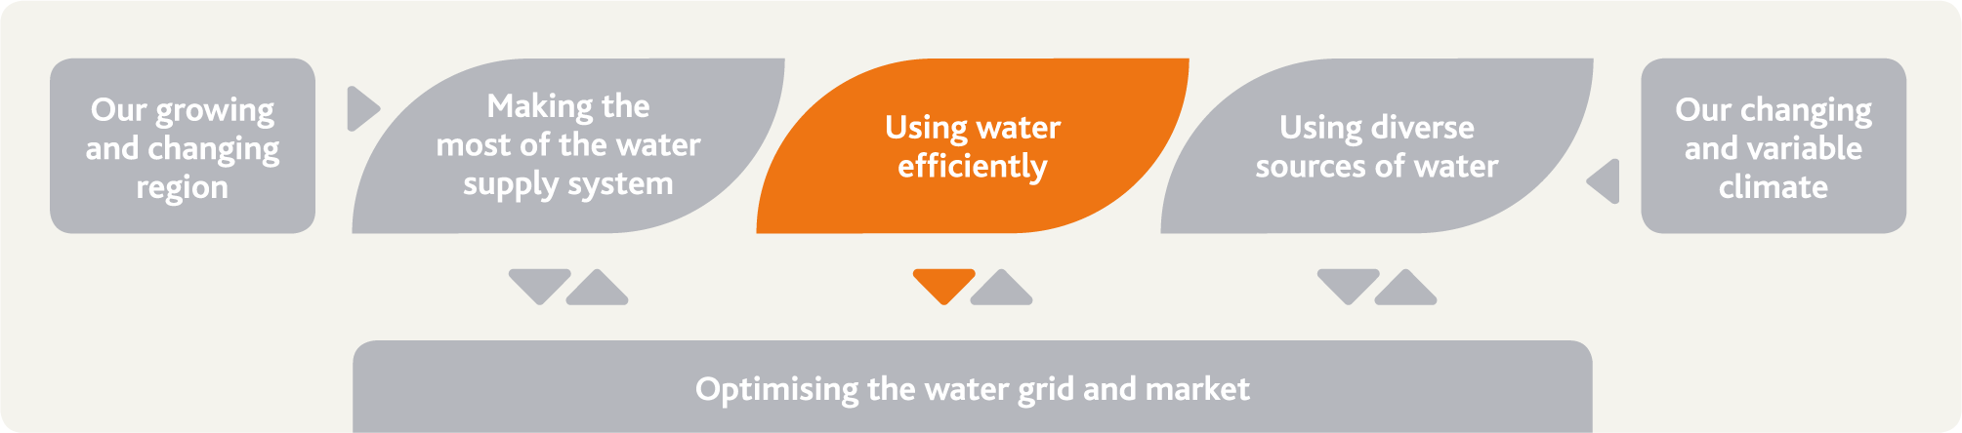
Water is used much more efficiently in Melbourne today than it was 20 years ago. Using water efficiently has many benefits, including helping to delay the need to augment the water supply system over the longer term.

The challenge and our strategic response
Melbourne has become a much more water efficient city since the Millennium Drought. Melburnians use significantly less water per person now compared to 20 years ago.
Melbourne Water will continue working with the retail water corporations and DELWP to ensure water continues to be used efficiently while enhancing liveability for the community, maximising affordability, and supporting drought preparedness.

Our actions and their benefits
Action number | Actions in chapter 5 relating to using water efficiently | Healthy People | Healthy Places | Healthy Environment
5.1 | Support delivery of the Target 155 program | •
5.2 | Collaborate to deliver research on water efficiency into the future | •
5.3 | Periodically review the drought preparedness plans for Melbourne | • | •
5.4 | Build a shared understanding of the costs and benefits of water restrictions | • | •
5.5 | Review the Water Outlook to ensure it meets community needs | •

Achievements in water efficiency
Water is a valuable resource. Using water efficiently means using the minimum amount possible to support an activity without compromising the desired outcome or the liveability of our city and region.
Water is used much more efficiently today than it was in the past. In response to the water restrictions and voluntary water efficiency programs implemented during the Millennium Drought, the demand for water declined by over 30% between 1997 and 2009, despite population growth of around 500,000 people in Melbourne during that time.
On a per person basis, water consumption has declined to levels not seen since the 1930s, as shown in Figure 26.
Peak day demands have also declined, from a high of over 3 GL/day in 1996/97 to less than 2 GL/day in recent years.
These reductions in water consumption, in combination with reduced environmental water releases, were the main reasons we were able to maintain supplies throughout the Millennium Drought.
Figure 26. Historical water use per person and total Melbourne water use based on residential, commercial, industrial and all other demands
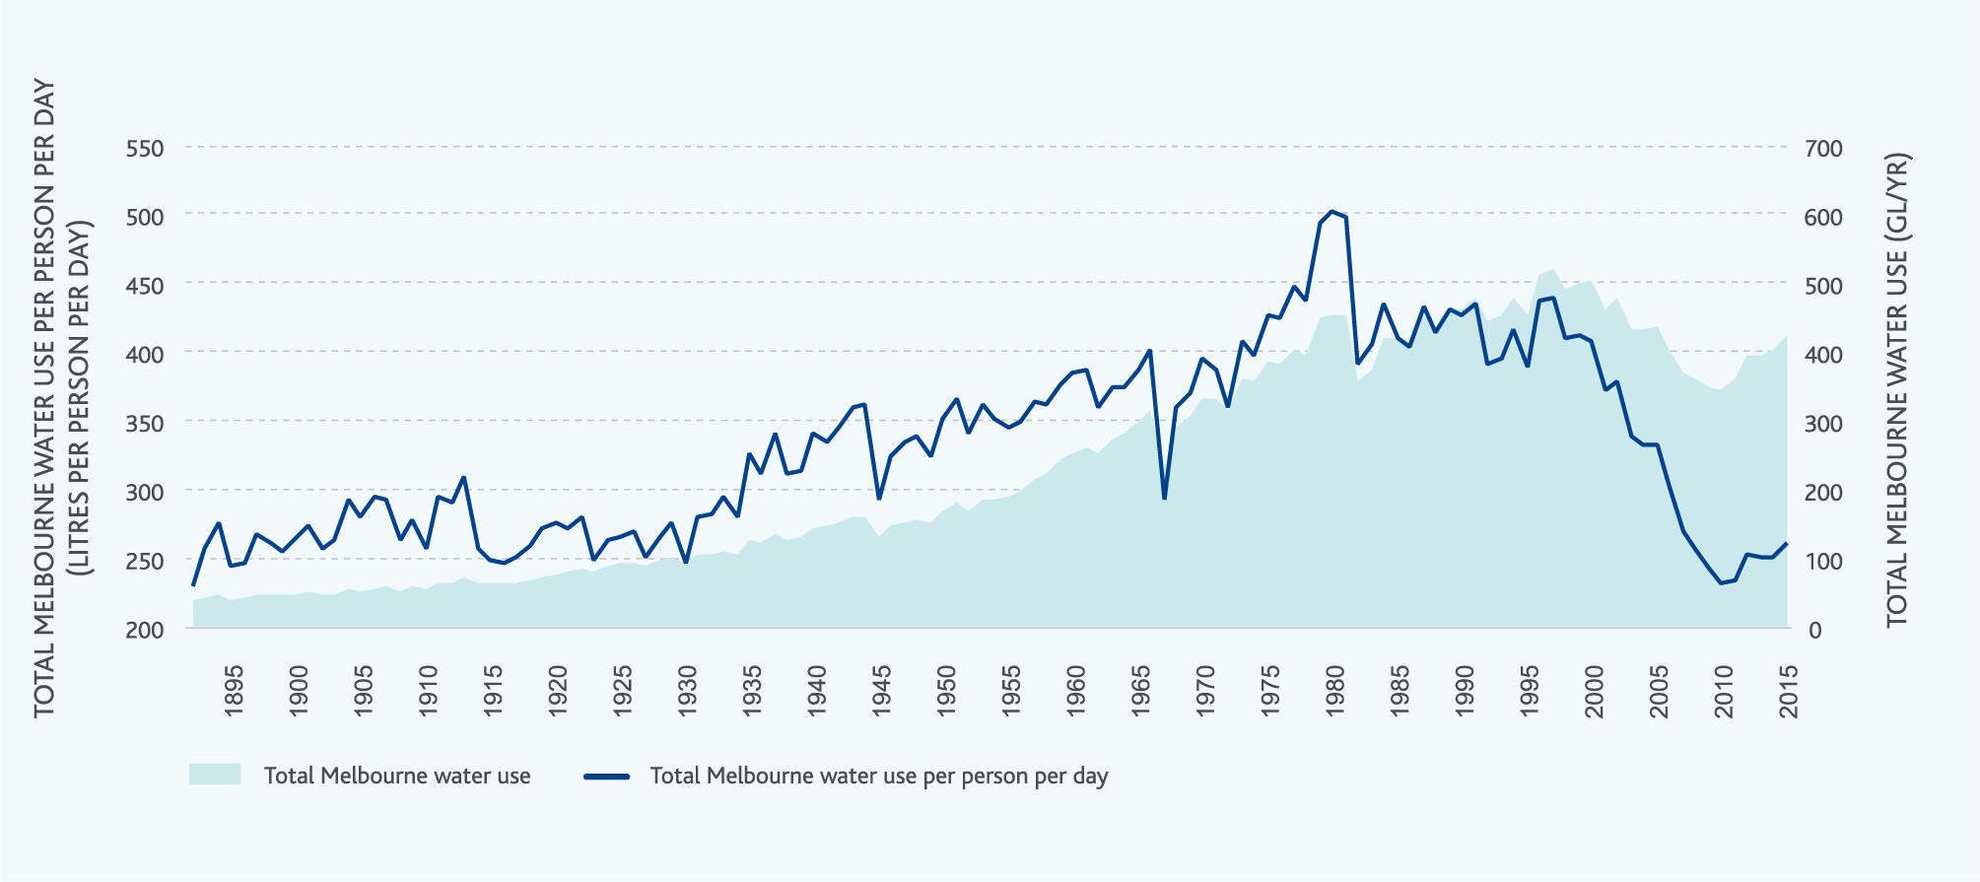

Reducing water use during the Millennium Drought
Figure 27 shows the impact of reduced water consumption on storage levels throughout the Millennium Drought. By July 2011, the reductions in water consumption saved around 780 GL of water – almost three quarters of the capacity of Thomson Reservoir. During the Millennium Drought, environmental water releases were also reduced. This had a positive impact on water storage levels, but also increased the risks of the Millennium Drought impacting on environmental values. Reduced environmental water releases increased water storage levels by almost 150 GL by late 2010 when environmental water releases returned to normal.
Figure 27. Melbourne’s recorded water storage volumes from 2002 to 2011, and what they could have been without reductions in water use
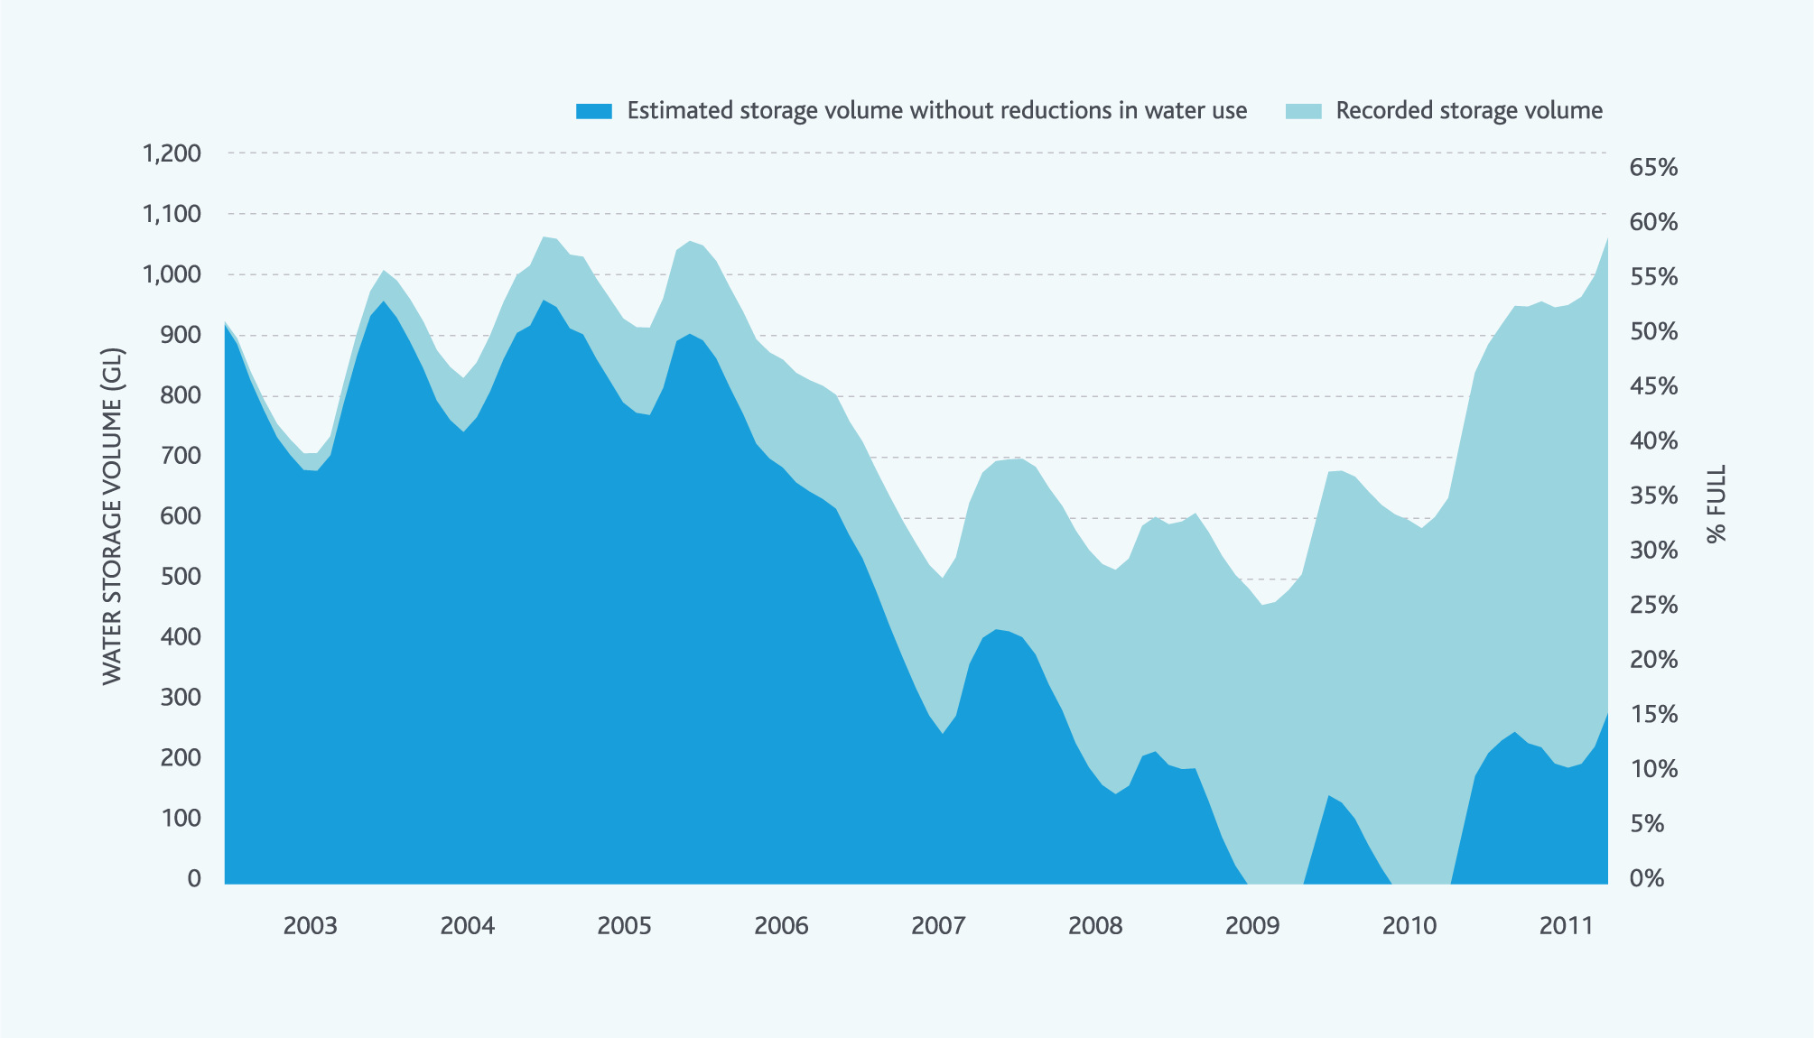
During the Millennium Drought, with a range of water efficiency and conservation programs implemented, including severe water restrictions, water use declined to such low levels that it started to affect the liveability of our city and region. Among other impacts on businesses and the community, a large number of sports fields became unsuitable for use during the Millennium Drought – impacting on the health and wellbeing of the community. However, the community research undertaken during the development of this strategy suggests that many people generally still regard water restrictions as an important mechanism that can be used to provide guidance to the community regarding the efficient use of water (endnote 4).
Since the end of the Millennium Drought, water use has increased slightly (as shown in Figure 28, Figure 29, Figure 30 and Figure 31). However, water use has still not increased to the levels we were seeing before the Millennium Drought.
Permanent water use rules remain in place, and these have helped maintain efficient water use practices. However, when we asked the community, we found that many people are unaware of permanent water use rules, but water efficiency has nevertheless become part of their way of life, and is something they intend to continue, regardless of whether it is wet or dry (endnote 4). Only 6% of people in Melbourne don’t go out of their way to save water (endnote 19).
Figure 28. Total water use in Melbourne
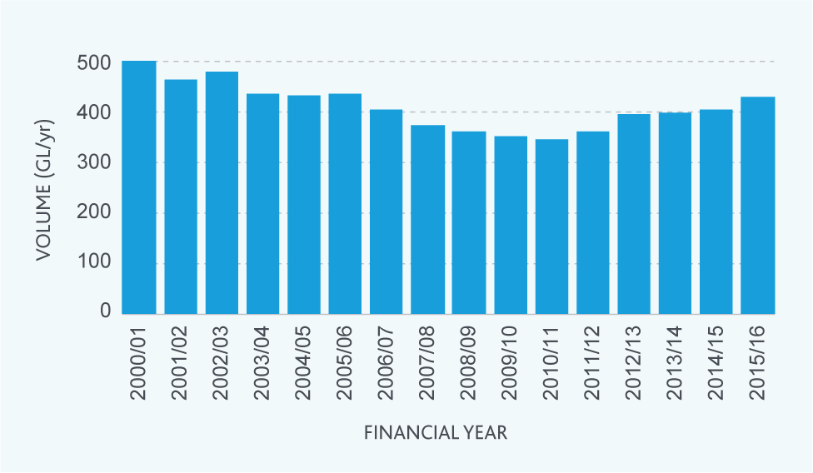
Figure 29. Residential water use per person in Melbourne
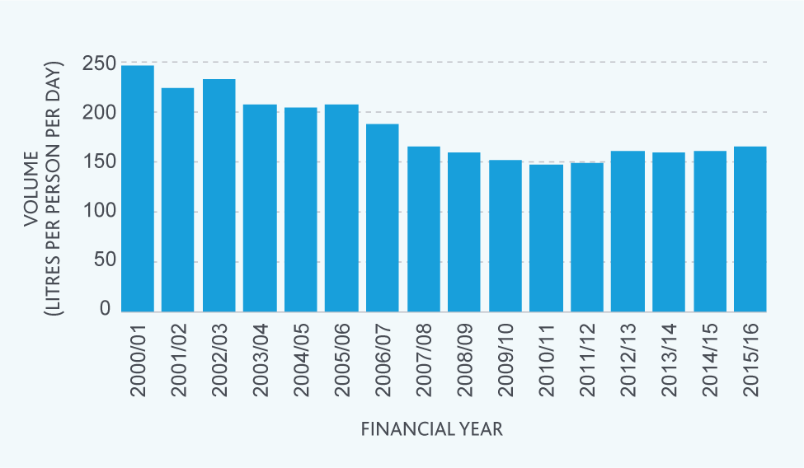

Figure 30. Non-residential water use in Melbourne
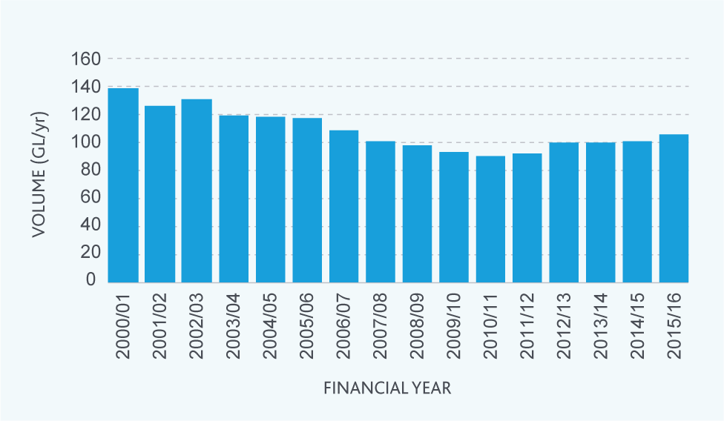
Figure 31. Non-revenue water use in Melbourne
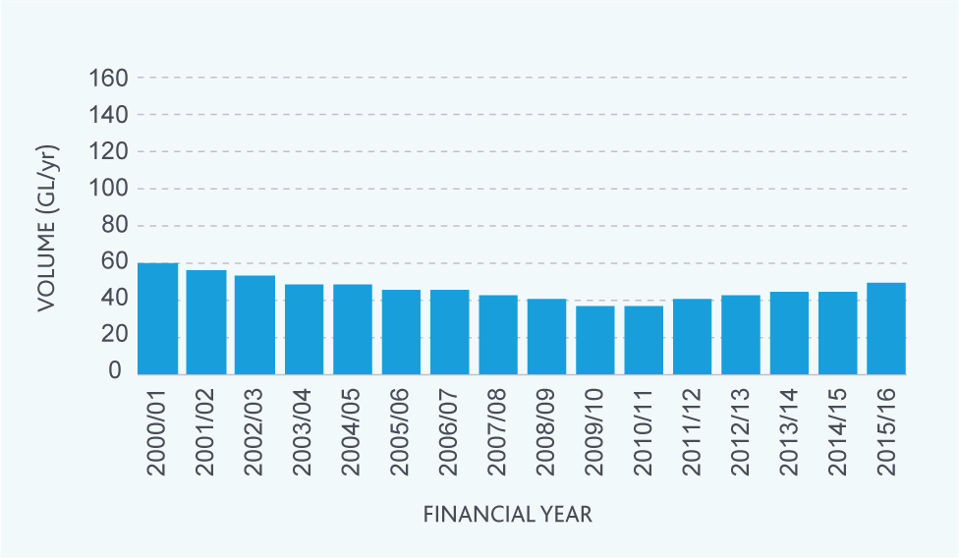

Highlight box - Saving water during the Millennium Drought
During the Millennium Drought, the retail water corporations and the Victorian Government, supported by Melbourne Water, delivered a range of complementary water efficiency and conservation programs to help the community save water. Among many others, these programs included:
replacing over 460,000 inefficient showerheads by 2010/11
replacing over 4500 inefficient toilets by 2010/11
various stages of water restrictions
providing over 300,000 water efficiency rebates across Victoria from 2003 to 2011
the Target 155 program
working with large business water users to develop more than 1,190 Water Management Action Plans by 2010/11.
In addition to these specific programs, the community made independent efforts to save water. Many people replaced their top-loading clothes washing machines with more efficient front-loading models, put buckets in their showers and kitchen sinks, replaced European-style gardens with well-mulched native gardens, installed rainwater tanks, washed their cars at commercial car washes – and many other even more innovative solutions to save water.
End highlight box.

The benefits of water efficiency
Using water efficiently can potentially provide a range of benefits:
The community expects a continued focus on water efficiency, and it can help to keep water affordable, and if hot water consumption is reduced, it can help to keep energy affordable too.
It reduces energy consumption and greenhouse emissions linked to treating and pumping water around the water supply system.
It can delay the need to augment the water supply system and increase the capacity of the water supply transfer system.
It can help to control some of the many uncertain factors that drive future water consumption, making it easier to plan future investments in the water supply system with greater certainty.
It could enable water resources to be redirected for other purposes, such as through the water grid and south central market, including environmental flows.
It can help to progressively accumulate water in Melbourne’s large storage reservoirs, both before and during future drought periods.

Future opportunities to use water more efficiently
Water efficiency is a key element of Melbourne Water’s portfolio approach to meeting the challenges presented by our growing and changing city, and by climate change and variability. A lot has been achieved over the past 20 years, but there is still further potential to use water even more efficiently.
Melbourne Water is working with the retail water corporations and DELWP to support the Target 155 program, which the Victorian Government recently reintroduced to complement permanent water use rules.
We will work with the retail water corporations to regularly review residential and total per person water use to ensure water continues to be used efficiently, relative to the demand forecasts prepared by the retail water corporations.

Action 5.1
Support the delivery of the Victorian Government’s Target 155 program, and participate in any future reviews as required.
Work with the retail water corporations to support the efficient use of water across the community. By 2022, the retail water corporations are forecasting water demands of:
230 litres per person per day for total water use from the water supply system
150 litres per person per day for residential water use from the water supply system.
Performance against these forecasts and any actions needed to keep observed demands consistent with these forecasts will be published each year in the Water Outlook.

Delivered by
Melbourne Water, retail water corporations, DELWP
Contributes to the following Sustainable Development Goals
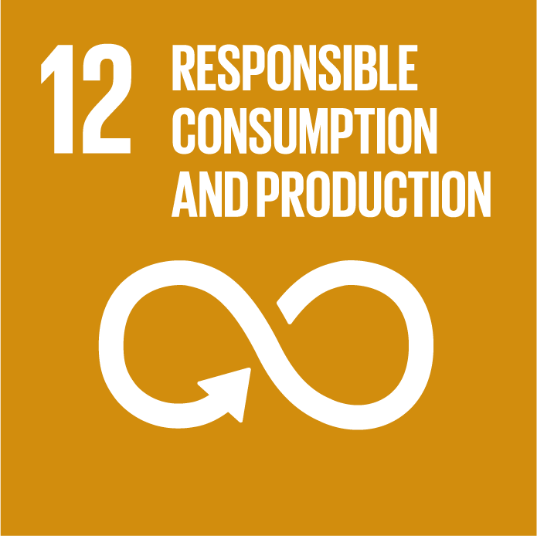

Highlight box - Target 155
Target 155 was introduced in the late stage of the Millennium Drought (December 2008) to encourage households to keep their water use below 155 litres per person per day.
The program was implemented as part of a very broad suite of water efficiency initiatives and it was supported by significant communication efforts across print, radio, television and websites, and even on one of Melbourne’s trams.
Analysis by the retail water corporations suggests the original Target 155 program saved over 53 GL of water. The original Target 155 program was discontinued in February 2011.
As part of a broader reinvigoration of water efficiency programs announced in Water for Victoria, the Victorian Government has recently reintroduced the Target 155 program.
As shown in Figure 32, for the medium demand scenario, we expect household water use to naturally decline to below 155 litres per person per day within the next few years, and the Target 155 program is likely to make this happen even sooner. When household water use declines to levels below 155 litres, the target may need to be reviewed and reset at a new aspirational level.

Figure 32. Projected per person demands for Melbourne
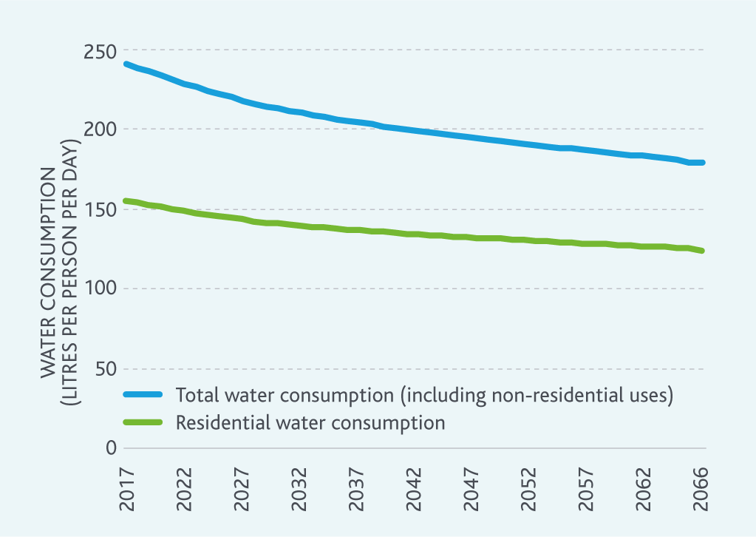
End highlight box.
The community has told us that they support using water efficiently and want programs like Target 155 to continue. People have a strong expectation that Melbourne Water and the retail water corporations will be working with and supporting the state government to deliver programs to encourage and support water efficiency (endnote 4).
A recent review commissioned by Melbourne Water, the retail water corporations and other stakeholders highlights some emerging issues related to using water efficiently in the future such as:
The need to consider the potential implications of increased water efficiency on related systems, including the water supply system, diverse sources of water, household plumbing, and the sewerage system. For example, toilet paper composition and household plumbing configuration may become increasingly important considerations as appliances and fixtures become increasingly water efficient.
Community preferences and attitudes will continue to change, potentially driving increases or decreases in the demand for water that may be difficult to anticipate. This could be linked to changes in existing uses of water, or the emergence of new uses of water.
Through the growing connectivity of devices through the internet, it may become increasingly common for households and businesses to receive real time feedback on water and energy consumption, and to be able to control appliances associated with water and energy consumption remotely to reflect the most up-to-date information. These types of innovations could enable new, tailored approaches to encourage and support individuals and households to use water more efficiently.
Appropriate regulation will continue to be needed to ensure the community is kept informed of how much water appliances and fixtures use (including new types of appliances and fixtures), and to prevent poor quality products entering the market. Some issues are already emerging that may require consideration soon. For example, in an increasingly dense city, laundry space will be limited, potentially driving more people to purchase combined clothes washing and drying machines rather than separate units. Some of the newer combined machines use water as part of the drying cycle as well as the washing cycle, but only the washing cycle is subject to regulation by the Commonwealth Government Water Efficiency Labelling and Standards scheme (endnote 21).
These emerging issues highlight the need for us to work with our customers and stakeholders to identify challenges and risks, and make the most of opportunities to encourage efficient use of water on an ongoing basis.

Action 5.2
Convene a working group by December 2017 to support an ongoing water efficiency research program, and the development of innovative water efficiency programs and regulations to operationalise research outcomes.
Delivered by
Melbourne Water, retail water corporations, Western Water, DELWP
Contributes to the following Sustainable Development Goals

Reducing water use during droughts
Reducing water use during droughts is needed because our water supply system relies on water in storage to maintain supply throughout any drought. Even relatively modest reductions in water use during drought years can deliver significant cumulative benefits in terms of water in storage, which help us to continue to supply affordable water.
In Melbourne, each of the retail water corporations have their own drought preparedness plan, but the three plans have been developed through a highly collaborative process and include common objectives to make sure a consistent approach to preparing for and managing droughts is adopted across Melbourne.
We work with the retail water corporations to review the drought preparedness plans for Melbourne at least every five years, and they were reviewed during the development of this strategy. The drought preparedness plans are a key element of the adaptive management approach used by the Melbourne water industry.
The drought preparedness plans include the specification of three water outlook zones. These zones define the volumes of water we need to maintain reliable water supplies that meet agreed levels of service for our customers throughout future droughts. The drought preparedness plans also guide the implementation of actions that could be required to reduce demand or increase supply as storages descend through the high, medium and low zones.

Reviewing the water outlook zones
Melbourne Water and the retail water corporations have reviewed the water storage levels used to define the water outlook zones. We took into account what has changed since the water outlook zones were reviewed in 2011, including the:
growth in demand in Melbourne and the surrounding region
emerging role of the Melbourne water supply system in underpinning supply across the grid during droughts
new scenarios of streamflow under climate change developed by DELWP
Sugarloaf (North-South) Pipeline policy and carryover rules in northern Victoria.
The analysis showed that the water outlook zones need to be set at a higher level than they were in the past to ensure the same level of water supply reliability during future droughts.
Figure 33 is a table that summarises the water storage levels that define each water outlook zone, and what it means when storage levels are in each zone. The new water outlook zones will be used for the first time in December 2017 when the next Water Outlook for Melbourne will be prepared.
The drought preparedness plans and associated water outlook zones will be reviewed regularly as population continues to grow new climate information becomes available.
Figure 33. Table describing previous and new water outlook zones
Water outlook zone name | What it means if storage levels are in each water outlook zone on 1 December of any given year | Previous water storage levels defining zone | New water storage levels defining zone
High zone | The water supply system can continue to supply water for at least the next five years without storage levels descending into the low zone, even if we have a drought of the severity we might expect once in every 100 years.  We work with our customers to keep storages in the high zone, including through using the Victorian Desalination Project, encouraging water efficiency, and using rainwater, stormwater and recycled water. | Above 54.1% | Above 60%
Medium zone | The water supply system cannot continue to supply water for the next five years without storage levels descending into the low zone if we have a drought of the severity we might expect once in every 100 years.  If storage levels descend into the medium zone, we would work with our customers, stakeholders and the community to recover storage levels back into the high zone, including potentially using the Victorian Desalination Project at its full capacity, and encouraging additional water efficiency and use of rainwater, stormwater and recycled water. In the medium zone, advance planning of water supply system augmentations would also need to be undertaken. | Between 31.7% and 54.1% | Between 40% and 60%
Low zone | The water supply system cannot continue to supply water for the next two years without storage levels descending below minimum operating levels if we have a drought of the severity we might expect once in every 200 years.  If storage levels descend into the low zone, we would work with our customers, stakeholders and the community to recover storage levels back into the high zone, including through using the Victorian Desalination Project at its full capacity, encouraging additional water efficiency, and using rainwater, stormwater and recycled water. Severe water restrictions would need to be implemented if storage levels descend into the low zone, and augmentations of the water supply system would need to be delivered. | Below 31.7% | Below 40%

Action 5.3
Continue to review the drought preparedness plans for Melbourne every five years.
Delivered by
Melbourne Water, retail water corporations
Contributes to the following Sustainable Development Goals

Water restrictions
Severe water restrictions can impact on the liveability and economy of our city and region. When we asked the community during the development of this strategy, more than 60% of people felt that some form of mandatory water restrictions should be implemented again in the future as a means of managing drought (endnote 4).
If they are required, water restrictions are overseen by the retail and regional water corporations. Water restrictions largely target more discretionary external uses of water such as watering parks and gardens, refilling swimming pools, washing cars, and other similar uses.

The complexities of water restrictions
The drought preparedness plans include the option of introducing mandatory water restrictions, should other initiatives not achieve desired water use reductions during drought periods.
Water restrictions can be implemented by the retail water corporations when water storages descend into the water outlook medium zone.
A minimum of Stage 3 water restrictions must be implemented by the retail water corporations when water storages descend into the water outlook low zone.
The anticipated impact of Stage 3 or 4 restrictions on the liveability of our city, and the potential broader associated economic impacts, are why we aim to avoid storages falling into the water outlook low zone.
We do this through a range of planning and operational activities, including our desalinated water order advice that we prepare each year as discussed in Chapter 4.
To minimise these impacts, Water for Victoria outlines a range of approaches, including the requirement for the retail water corporations to work with local government, catchment management authorities, and community leaders to identify priority parks, gardens, public open spaces and playing fields to look after during future droughts. Melbourne Water will continue to work closely with our customers to support drought preparedness activities.

Challenge: determining potential future roles for water restrictions
Following the significant and sustained reductions in water use during the Millennium Drought, water restrictions might not deliver the extent of water savings achieved during the Millennium Drought in the future.
When water is already used efficiently, it becomes more difficult to find ways of using even less water – this is known as demand hardening. For example, some of the warm season lawns that have become more popular since the Millennium Drought require very limited watering once they are established. For households that have installed these types of lawns, future water restrictions that limit lawn watering may result in much less water being saved. Similarly, over the longer term, the ongoing densification of Melbourne will lead to less external water use as gardens diminish in size, further reducing the effectiveness of water restrictions.
Early in the Millennium Drought it was estimated that severe water restrictions could potentially drive water consumption down by more than 25% (endnote 22). Current estimates suggest that:
Stage 1 or 2 water restrictions might drive water consumption down by 2–7%.
Stage 3 or 4 restrictions might drive water consumption down by 8–16%.
Although these savings are modest in percentage terms, they still reflect quite large volumes of water. For example, 5% of our current total demand of around 430 GL/yr is more than 20 GL/yr.
Water restrictions may also influence the effectiveness of other initiatives to encourage efficient water use; for example, the community might be more motivated to use more efficient appliances like showerheads and washing machines, or install rainwater tanks to water gardens and wash cars. This broader influence of water restrictions is difficult to quantify, since it depends on what other initiatives are implemented at the time, but allowances for this effect were included in the estimated consumption reductions above.
Water for Victoria recognises that the costs and benefits of water restrictions are complex and need to be understood better, and includes an action to build a shared understanding of the costs of water restrictions in particular.

Action 5.4
Support research directions emerging from Water for Victoria, including through a study into the economic costs of water restrictions to build a shared understanding of:
potential liveability impacts
economic costs
community perspectives
potentially modest water savings.
Delivered by
Melbourne Water, retail water corporations, regional water corporations, DELWP
Contributes to the following Sustainable Development Goals

Engaging the community
Water efficiency is valued by the community, and they have a clear expectation that the water industry will engage them in water efficiency as well as water resource management more generally. For example, more than 50% of people in the community want more information about the water industry’s plans to cope with future population growth (endnote 19).
Melbourne Water will continue to work with the retail and regional water corporations and our stakeholders to engage the community through specific water efficiency initiatives, such as the Target 155 program, and through our ongoing schools and community education programs.
More broadly, the Water Outlook is one of our key modes of communicating with the community about water resource management issues each year. When we asked the community, they liked the intent behind the Water Outlook, but felt that opportunities may exist to improve its content and accessibility (endnote 4). We need to work with the retail water corporations to respond to this feedback, and provide the community with the information they need.

Action 5.5
Review the Water Outlook format and content by November 2017 to:
make it more relevant to and accessible by the community
incorporate the outcomes of a broader review of alternative metrics that could potentially be used to more clearly convey water availability messages to the community.
Delivered by
Melbourne Water, retail water corporations
Contributes to the following Sustainable Development Goals

6. Using diverse sources of water
Rainwater, stormwater and recycled water, with the appropriate level of treatment, can diversify our portfolio of water sources, delivering benefits across the water cycle.
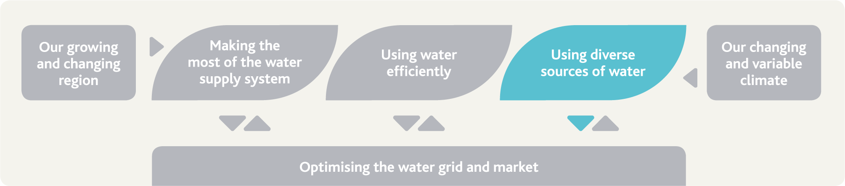

The challenge and our strategic response
Using diverse sources of water like rainwater, stormwater and recycled water can help to delay the need for major augmentations of the water supply system and water grid, and can also contribute to keeping parks and gardens cool and green during dry periods, reducing flooding, and reducing the environmental impacts of urbanisation. Collectively, these benefits can be significant.
Melbourne Water and the retail and regional water corporations have been investing in projects that utilise diverse water sources for some time, and will continue to do so where it meets the community’s needs, delivering shared benefits across the water cycle.

Our actions and their benefits
Action number | Actions in chapter 6 related to using diverse sources of water | Healthy People | Healthy Places | Healthy Environment
6.1 | Collaborate through integrated water management forums and plans to deliver up to 80 GL/yr (subject to further investigation) from diverse sources of water instead of the water supply system by 2065 | • | • | •
6.2 | Investigate use of diverse sources to deliver environmental water |  |  | •
6.3 | Enhance capabilities to model diverse sources of water to support investment decisions | •
6.4 | Monitor applications of diverse sources and associated community views | • | • | •
6.5 | Support the development of a comprehensive and transparent investment evaluation framework | • | • | •

What are diverse sources of water?
This strategy takes a broad view of available water for use in the Melbourne water system – including rainwater, stormwater and recycled water.
There are opportunities to develop a more integrated water supply system incorporating diverse water sources. By using resources like rainwater, stormwater and recycled water, we can reduce the demand on the existing water supply system, and deliver a range of other benefits across the water cycle and throughout communities.
In the future, these sources of water will play an increasingly key role in enhancing life and liveability in Melbourne and the surrounding region. When we asked the community, the majority of people indicated that they favour using rainwater, stormwater and recycled water for non-drinking purposes, and expect water corporations to invest over the long term in projects that utilise these sources of water (endnote 4).

The benefits of diversifying our portfolio of water sources
Using diverse sources of water can provide a range of benefits:
meeting community expectations to use more rainwater, stormwater and recycled water
reducing the dependence on the water supply system, and delaying the need to augment the water supply system and the water supply transfer system
keeping stormwater out of our rivers and creeks, preventing erosion, pollution and impacts on environmental values of waterways
reducing the environmental impacts of discharging treated sewage to waterways, Port Phillip Bay and Bass Strait
reducing the impact of some flood events by capturing and storing rainwater and stormwater
providing a source of water to enhance liveability of the city during droughts by keeping open spaces green
retaining water in the urban environment to help manage the impacts of the urban heat island effect.

What we’ve achieved so far
Through partnerships with the community, retail and regional water corporations, local government, DELWP, and other stakeholders, we have helped to deliver projects that capture and use rainwater, stormwater and recycled water.
For example, most of Melbourne’s sewage is treated at Melbourne Water’s Western Treatment Plant at Werribee and Eastern Treatment Plant at Bangholme. Both plants produce recycled water that is supplied to households, businesses and agricultural customers. In 2015/16, Melbourne Water supplied:
more than 5.5 GL of recycled water from the Western Treatment Plant to the Werribee Irrigation District, a major vegetable growing region for Victoria
more than 6.0 GL of recycled water from the Eastern Treatment Plant to the Eastern Irrigation Scheme, through which recycled water is distributed for recreational, agricultural, industrial and residential purposes.

Building a water sensitive city
Melbourne Water, along with our customers and stakeholders, recently participated in an exercise to assess Melbourne’s rating as a water sensitive city. The Water Sensitive Cities Index was developed by the Cooperative Research Centre for Water Sensitive Cities as a tool to help planners understand how cities perform in relation to a range of criteria related to water cycle services – from critical public health needs of a safe water supply and robust sewerage system, through to achievements in minimising the impact of the built environment on the environment and water cycle.
A water sensitive city is one that is resilient, liveable, productive and sustainable. Increasing the diversity of water sources contributes to making a city water sensitive.
As shown in Figure 34, the process showed that Melbourne performed well in most areas, but that opportunities exist to become a more water sensitive city by further integrating the whole water cycle into urban planning and further diversifying sources of water. The actions included in this strategy will help to make Melbourne a more water sensitive city.
Figure 34. Melbourne’s performance in 2016 as a water sensitive city (Source: Cooperative Research Centre for Water Sensitive Cities)
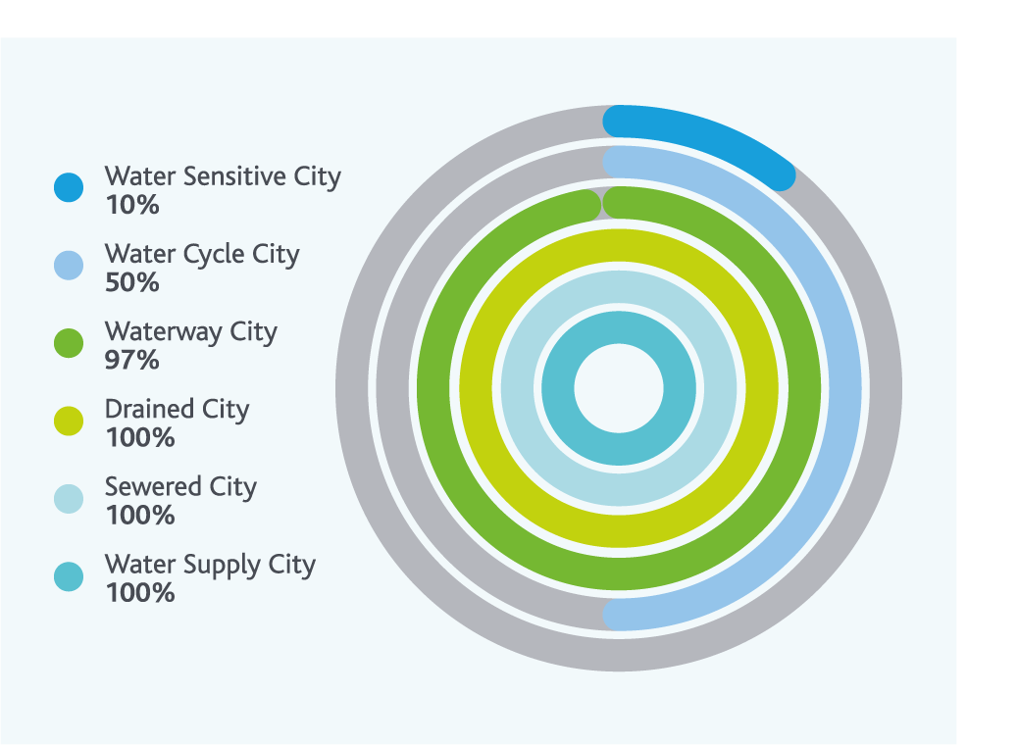

Highlight box - Reducing flood risks with distributed storage
Across Melbourne, more than 200,000 properties are considered at risk of flooding, meaning they are faced with at least a 1% chance they may be subject to flooding in any year. Flooding in Melbourne is estimated to cost, on average, around $400 million per year. As well as being a very expensive natural disaster, flooding creates serious hazards for some communities.
As Melbourne grows, and the climate continues to change, the potential impacts of flooding are expected to continue to escalate. While we expect the total rainfall in Melbourne to decrease into the future under climate change, we also expect there to be more intense storms, meaning what rainfall we do experience will fall in a shorter period of time, increasing the risk of flash flooding in the built-up city.
Melbourne Water has been working with DELWP to investigate how distributed storages across the city might reduce the impact of flooding during storms. Distributed storages are smaller pieces of infrastructure, predominantly rainwater tanks that capture stormwater wherever they are placed in the city and provide a source of water. Using a larger number of smaller storages scattered across the city means stormwater can be captured and stored, reducing the amount of water inundating the drainage system during storms.
The study found that these storages can provide benefits in many areas, reducing the impact of nuisance flooding, and in some cases more severe flooding that is expected to happen on average about once every hundred years.
The study also highlighted that the benefits of installing distributed storages depends on the physical characteristics of the catchment. The benefits tended to be highest in small, steep catchments that can funnel water to low lying areas quickly. Understanding when distributed storages can provide these benefits highlights the importance of taking a place-based approach to planning across the whole water cycle.
End highlight box.

Highlight box - Little Stringybark Creek
The Little Stringybark Creek Project, operating since 2008, is implementing new water saving and stormwater treatment initiatives within the 450 hectare catchment of Little Stringybark Creek in outer-eastern Melbourne.
For private land owners (both households and businesses), financial incentives and direct assistance (in design and plumbing advice) are offered to install rainwater tanks and other stormwater retention measures. For public land owners (local government, schools), staff are educated on the benefits of stormwater retention measures and financial incentives provided to support on-ground implementation.
To facilitate these works and ensure communication of any generated learnings, the project has run a comprehensive engagement program targeting residents of the catchment, the local government and the broader water and stormwater management industry.
It is anticipated that, this project will result in substantial benefits, including:
saving around 51 ML/yr of drinking water
restoration of natural flow regimes within the catchment (62 ML/year of stormwater retained with catchment, with increased dry-weather flows in the stream)
increased community awareness of stream health and stormwater management
provide insights into the use of market-based instruments for funding stormwater harvesting systems.
Importantly, the project will result in tangible improvements in the health of Little Stringybark Creek and will be a world-first demonstration of the ability of stormwater harvesting and retention to protect and restore urban waterways.
End highlight box.

Place-based planning
We are still learning how projects that utilise diverse sources of water can best contribute to a more liveable water sensitive city.
There is no one-size-fits-all solution as each project is unique and needs to be tailored to fit its location. The volume of water available, the potential demand for water, community support, and the economic costs and benefits of each project are all highly location specific.
Planning the use of rainwater, stormwater and recycled water requires the coordinated action of decision-makers at different scales across Melbourne.
DELWP recently released a draft Integrated Water Management Framework for Victoria that outlines a place-based approach to planning water services in Melbourne and the surrounding region. This approach includes:
Catchment-based integrated water management forums, to bring together key stakeholders and the community to identify key opportunities to use diverse sources of water in a particular waterway catchment.
Local integrated water management plans, developed in close consultation with the community and all stakeholders, which may include private organisations such as developers, not-for-profit organisations and health providers. The plans will explore the opportunities identified through the integrated water management forums, and to identify appropriate water servicing solutions for local communities.
This decentralised and collaborative approach to planning will promote innovation and efficiency and deliver outcomes that meet the needs of local communities.

The potential of diversifying sources of water
The retail and regional water corporations have already identified projects that will result in around 30 GL/yr being delivered from diverse sources of water by 2065. These volumes are reflected in the water demand scenarios presented earlier in this strategy in Chapter 2. However, as discussed in Chapter 3, there are significant volumes of rainwater, stormwater and recycled water available – nearly 350 GL/yr of stormwater alone was generated from impervious surfaces across Melbourne in 2015/16.
This strategy adopts a goal of working with stakeholders to deliver at least 30 GL/yr from diverse sources by 2065, with active investigation of an additional 50 GL/yr.
In total, up to 80 GL/yr could be delivered from a mix of rainwater, stormwater and recycled water projects by 2065 to reduce the volume of water needed from the water supply system, depending on the economic and technical viability of each individual project. These goals will help to unlock and drive all of the innovation and efficiency that can be delivered through the decentralised and collaborative approach to planning described in the draft Integrated Water Management Framework for Victoria.
To deliver up to 80 GL/yr, more opportunities to use rainwater, stormwater and recycled water will need to be identified and evaluated – on average, 1-2 GL/yr of additional capacity will need to be progressively delivered every year for the next 50 years to achieve this goal.
The map in Figure 35 highlights some of the existing and emerging potential opportunities to use rainwater, stormwater and recycled water across Melbourne and the surrounding region. This map highlights the place-based nature of these opportunities, with different challenges and opportunities in different areas.

Action 6.1
Collaborate through place-based integrated water management forums and plans to deliver up to 80 GL/yr (subject to further investigation) from diverse sources of water instead of the water supply system by 2065. This includes:
approximately 30 GL/yr that is already planned
approximately 50 GL/yr which will be delivered wherever business cases demonstrate value to the community.
Delivered by
Melbourne Water, retail water corporations, regional water corporations, local government, DELWP, and others as required, which may include private organisations such as developers, not-for-profit organisations and health providers.
Contributes to the following Sustainable Development Goals
Figure 35. Potential opportunities to use rainwater, stormwater and recycled water in the Melbourne region
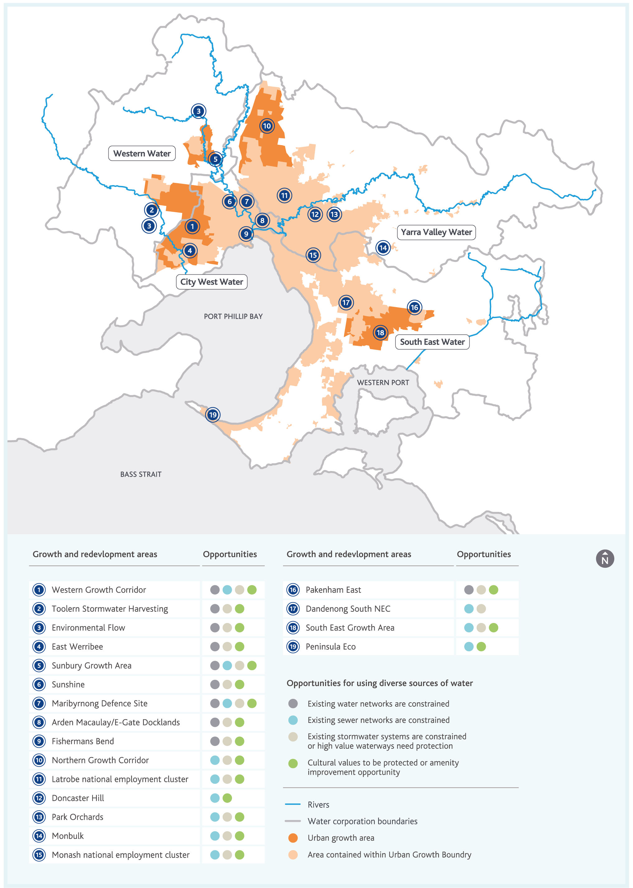

Water to keep the city green
During the Millennium Drought, many public spaces like sports fields were not watered due to water restrictions, leaving many unsuitable for use.
Rainwater, stormwater and recycled water have a role in helping to protect more sports fields, parks, and gardens from the impacts of future climate change and variability.
Using these sources of water can also help retain water in the urban landscape, for example through irrigating street trees, protecting them to help manage the impacts of the urban heat island effect, which is discussed more in Chapter 2.

Environmental water
In waterways that have suffered from changes in natural streamflow over the last two decades, and where declining trends in streamflow may continue into the future under climate change, using diverse sources of water to enhance the flow regime could potentially improve environmental outcomes provided the water is:
available at the right time
available in the right volumes
of sufficiently high quality.
Melbourne Water will continue to work with stakeholders to examine opportunities to use rainwater, stormwater or recycled water as sources of environmental water.

Action 6.2
Investigate opportunities to use rainwater, stormwater or recycled water for environmental purposes in flow-stressed rivers considering the timing, quantity and quality of flows available starting with a study to identify flow-stressed reaches of the Werribee River to be completed by June 2017.
Delivered by
Melbourne Water, retail water corporations, regional water corporations, DELWP, VEWH
Contributes to the following Sustainable Development Goals

The challenges of diverse water sources
Recent projects have highlighted many opportunities and challenges in increasing the use of rainwater, stormwater and recycled water. Key considerations include:
What volumes of rainwater, stormwater and recycled water are available in a given location?
What is the quality of the available water, and how variable is it?
How much water is actually needed by the community in a given location, and what proportion of that water demand can be safely and reliably met using rainwater, stormwater or recycled water?
Are there opportunities to integrate consideration of rainwater, stormwater and recycled water at the time of initial urban development or later redevelopment, to reduce the costs and disruption associated with retrofitting existing areas?
How much will it cost to capture, treat, store and distribute rainwater, stormwater or recycled water across the community?
What are the broader financial, environmental and social benefits of capturing rainwater, stormwater or recycled water in a given location?
How will the availability of rainwater, stormwater and recycled water vary between wet and dry periods, and how can storage capacity for these resources be integrated into the urban landscape?
How much water might be required from the water supply system as a backup supply if and when any other sources are unavailable?
These considerations are not straightforward. For example, the quantity and quality of stormwater is variable, depending on the magnitude and timing of the rain event that generates it, and transient sources of pollution in the catchment. To manage this variability, treatment processes generally have to be designed to cope with the highest volumes of the worst quality water, which increases costs, and means that the treatment assets are only utilised part of the time.
Finding space to build treatment plants to manage water quality, and storages that can balance the supply and demand for rainwater, stormwater and recycled water can be difficult in some areas. Already 30% of people who wouldn’t consider installing a rainwater tank cite the space needed as a reason, and this challenge will only continue to grow as our city becomes increasingly dense (endnote 19).
The opportunities to increase use of rainwater, stormwater and recycled water resources in the future may also depend on the demand for water from these sources. Water from diverse sources is currently commonly used for applications such as flushing toilets and watering gardens where lower water quality is acceptable – but these uses comprise less than half of total residential demand.
As Melbourne becomes increasingly dense, the average size of properties requiring landscape irrigation will decrease, and the efficiency of appliances such as toilets and washing machines will increase, potentially limiting the growth in the residential demand for water from diverse sources while it is only used for this limited range of applications.
Designing diverse water source projects requires detailed analysis not only of how the projects themselves work, but also how they could interact with the existing water supply system and future demands for water, sewerage system, drainage system, and waterways and bays. Although progress has been made, there is still further effort required to develop the sophisticated modelling tools needed to support this analysis.

Action 6.3
Continue to develop enhanced modelling capabilities to investigate the interactions between diverse sources of water and the water supply system by enabling an improved representation of localised demands and sources of supply by June 2018.
Delivered by
Melbourne Water
Contributes to the following Sustainable Development Goals

Highlight box - Aquifer storage and recovery
Storing rainwater, stormwater or recycled water on a larger scale can be challenging. One potential solution is to use natural groundwater aquifers for storage, injecting treated rainwater, stormwater or recycled water into the aquifer during periods of lower demand, and drawing water from the aquifer during periods of higher demand.
City West Water’s West Wyndham Dual Water Supply Scheme will supply recycled water for new residential developments and irrigation of public open space in the growth area to the north and west of Werribee. As part of this scheme, City West Water is trialling aquifer storage and recovery to enable recycled water to be stored in the Werribee Formation Aquifer under Melbourne Water’s Western Treatment Plant. The increased storage capacity enabled by aquifer storage and recovery will allow peak summer demands to be met while delaying the need to augment City West Water’s recycled water treatment plant. Stage 1 of this aquifer storage and recovery project was completed in 2016 with $11.4 million of funding from the Australian Government’s Water for the Future initiative, and operational trials are expected to begin shortly.
End highlight box.

Highlight box - Matching sources and uses of water
Technology exists that can treat rainwater, stormwater and recycled water to extremely high standards – making it safe to drink. Treated rainwater, stormwater and recycled water are used increasingly commonly as sources of drinking water elsewhere in the world.
When we asked the community, only a smaller proportion of people indicated that they would support using treated rainwater, stormwater or recycled water as sources of drinking water. On the other hand, the majority of people favoured using these sources for non-drinking purposes (endnotes 4 and 19).
In the context of our changing and growing region, and with climate change and variability, all available water resources will become increasingly valuable in the future. Advances in water treatment technologies and improved management of sources of pollution also could make it easier and less expensive to treat rainwater, stormwater and recycled water to extremely high standards. Over time, community perspectives and the science and technology associated with using rainwater, stormwater and recycled water could change.
Melbourne Water will continue to invest in research and observe developments in this area worldwide to ensure we can continue to deliver services consistent with community expectations, and make the most of sources of water like rainwater, stormwater and recycled water.
End highlight box.

Action 6.4
Monitor local and international applications of rainwater, stormwater and recycled water and associated community perceptions and expectations on an ongoing basis, and continue to invest in research that could enable broader use of these sources of water in the future.
Delivered by
Melbourne Water
Contributes to the following Sustainable Development Goals

Highlight box - Clearwater – building industry capacity for integrated water management
Harnessing the potential of sources of water like rainwater, stormwater and recycled water needs close collaboration across the water sector. Clearwater is a capacity building program that equips the water industry with the knowledge, networks and skills to drive the implementation of integrated water management practices across the water sector. Activities are informed by the needs of the water industry and can range from networking and knowledge sharing events, through to technical tours, organisational training and the provision of regular industry updates and online resources.
Clearwater offers a range of products and services that build the capacity of the Victorian water industry by:
building skills, knowledge and capability through professional development
• fast tracking research to practice
• fast tracking policy implementation
• facilitating information exchange
creating strong networks within and between organisations
fostering a deep understanding of industry barriers to integrated water management adoption and capacity building techniques.
Clearwater is hosted by Melbourne Water, and is currently co-funded by DELWP to facilitate capacity building not only in metropolitan Melbourne, but also more broadly across Victoria.
End highlight box.

Investment: balancing costs and benefits
Melbourne Water is committed to investing in projects that utilise diverse sources of water, particularly in locations where there are multiple benefits, such as reducing flooding, improving liveability, or enhancing waterway health, among others. These benefits can be quite site-specific. For example, projects that harness diverse sources of water in the western and northern growth areas of Melbourne may be able to help defer the need for additional capacity in the water supply transfer system between Silvan Reservoir and Greenvale Reservoir.
Assessing the extent to which diverse sources of water can deliver multiple benefits in any given location across Melbourne and the surrounding region requires an investment evaluation framework.

Investment evaluation framework
The purpose of the investment evaluation framework is to provide a robust and flexible tool that will assist stakeholders to make clear comparisons between servicing options.
Melbourne Water has collaborated previously with our customers and DELWP to investigate a range of investment evaluation metrics that could be used in the investment evaluation framework for rainwater, stormwater and recycled water projects. These metrics have included considerations such as the long-run marginal cost of supplying water from the water supply system, the cost of average annual damages linked to urban flooding, and the willingness of the community to pay for improved waterway health.
The investment evaluation framework will take into account not only the direct costs and benefits (e.g. construction costs or water treatment costs) attributable to a project, but also indirect costs and benefits (e.g. the public health benefits of reducing the urban heat island effect). The investment evaluation framework needs to take into account costs and benefits across liveability, affordability and environmental categories.
The investment evaluation framework is only one element of the broader integrated water management planning process as shown in Figure 36 – but it is a key element that is needed to support the delivery of place-based integrated water management plans.
The framework will enable evaluation of how the benefits of harnessing rainwater, stormwater or recycled water accrue to individual project stakeholders. This could potentially be used as a basis for sharing the costs of a project equitably between project stakeholders and could potentially provide an approach to evaluating possible pricing options for services associated with rainwater, stormwater and recycled water. This is a key consideration – funding projects in the short term that deliver benefits over the long term to a wide range of beneficiaries can be challenging.
Figure 36. Investment evaluation framework: investments that deliver shared benefits
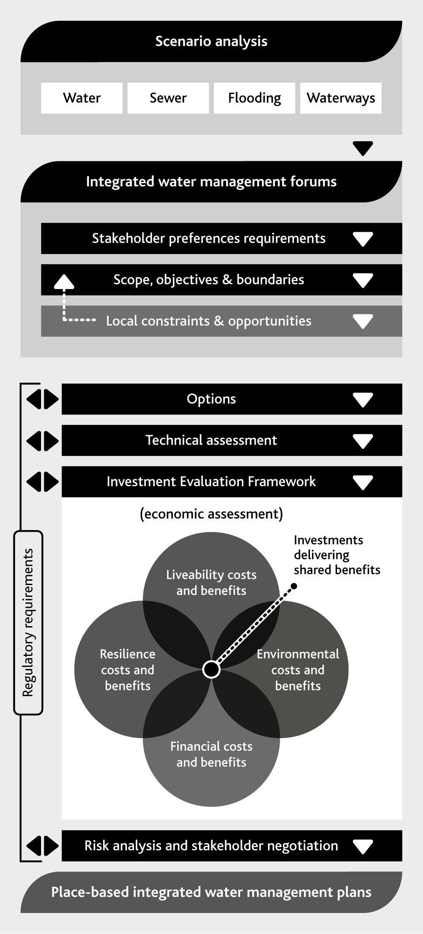

Action 6.5
Convene a water industry working group to deliver an investment evaluation framework that represents the range of benefits that can be delivered by projects that utilise diverse sources of water through activities including:
an independent review of the existing methodologies and recommendations for improvements by June 2017
appropriate models and results for the water supply system and water supply transfer system by December 2017
appropriate models and results for liveability and environmental values progressively developed through a series of methodology reviews and case studies by June 2019.
Delivered by
Melbourne Water, retail water corporations, regional water corporations, DELWP, local government
Contributes to the following Sustainable Development Goals

Highlight box - Riverwalk
Riverwalk is a 197 hectare development that will house around 6,600 people in Werribee when it is completed in 2027. The estate will include 14 hectares of parks, gardens, wetlands and other social and environmental assets, linked by 10 km of bicycle tracks and walking trails.
The Riverwalk estate is being developed by Places Victoria and the land owner, Melbourne Water – the site was previously used as part of our Western Treatment Plant.
Through extensive use of rainwater and recycled water, in combination with the water efficient appliances and fixtures that will be installed in each new home, each person living in Riverwalk should only need 65 litres of water from the water supply system supplied each day. This is significantly less than the 2015/16 average across Melbourne of 166 litres per person per day.
End highlight box.

Highlight box - Aquarevo
Aquarevo is a collaboration between South East Water and Villawood Properties to create a residential development in Lyndhurst. The 460 homes in the Aquarevo estate will use three types of water:
- recycled water for garden watering, toilet flushing and clothes washing
- treated rainwater for hot water for showering
- drinking water from the water supply system for all other needs.
Through using these diverse sources of water, households in the Aquarevo estate are expected to use up to 70% less drinking water than an average household in Melbourne.
This development will use a range of new technologies, such as smart rainwater tanks that know when rain is coming and empty themselves, to ensure the community’s needs are met while reducing demand on the water supply system and reducing the impact of stormwater and sewage on the environment.
End highlight box.

Highlight box - Greening the West
Greening the West is a regional initiative to enable sustainable, liveable and healthy communities on the rapidly growing western side of Melbourne through urban greening. Melbourne Water works with our customers City West Water and Western Water and more than 20 partners to support Greening the West.
Building and maintaining a greener landscape that provides the community with valuable open spaces for recreation and reducing the urban heat island effect in a low rainfall region relies on a range of water projects to underpin its success. Greening the West takes a holistic view of the water cycle, using diverse sources of water to support green assets.
Melbourne Water is closely involved in a number of Greening the West projects. For example, the Upper Stony Creek Transformation project will replace 1.2 kilometres of concrete lined channel in Sunshine North with a more natural stream. This award winning project aims to rehabilitate and reactivate water-based landscapes to improve both environmental and liveability outcomes for the local community.
Greening the Pipeline is a partnership project between Melbourne Water, Wyndham City Council, City West Water, VicRoads and supported by Greening the West. This project aims to revitalise land that contains the decommissioned main outfall sewer. The project vision is to transform a 27 kilometre strip of land through the western suburbs of Melbourne, from Millers Road in Brooklyn to Melbourne Water’s Western Treatment Plant in Werribee, into a natural and vibrant space that will connect communities and provide a unique place for residents to meet, play and relax.
These projects are examples of how Melbourne Water considers the recreational and amenity values that are so important to the wellbeing and social fabric of communities in our planning – reflecting a key policy direction outlined in Water for Victoria.
Figure 37. Upper Stony Creek today (left), and an example of how it could look in the future (right)
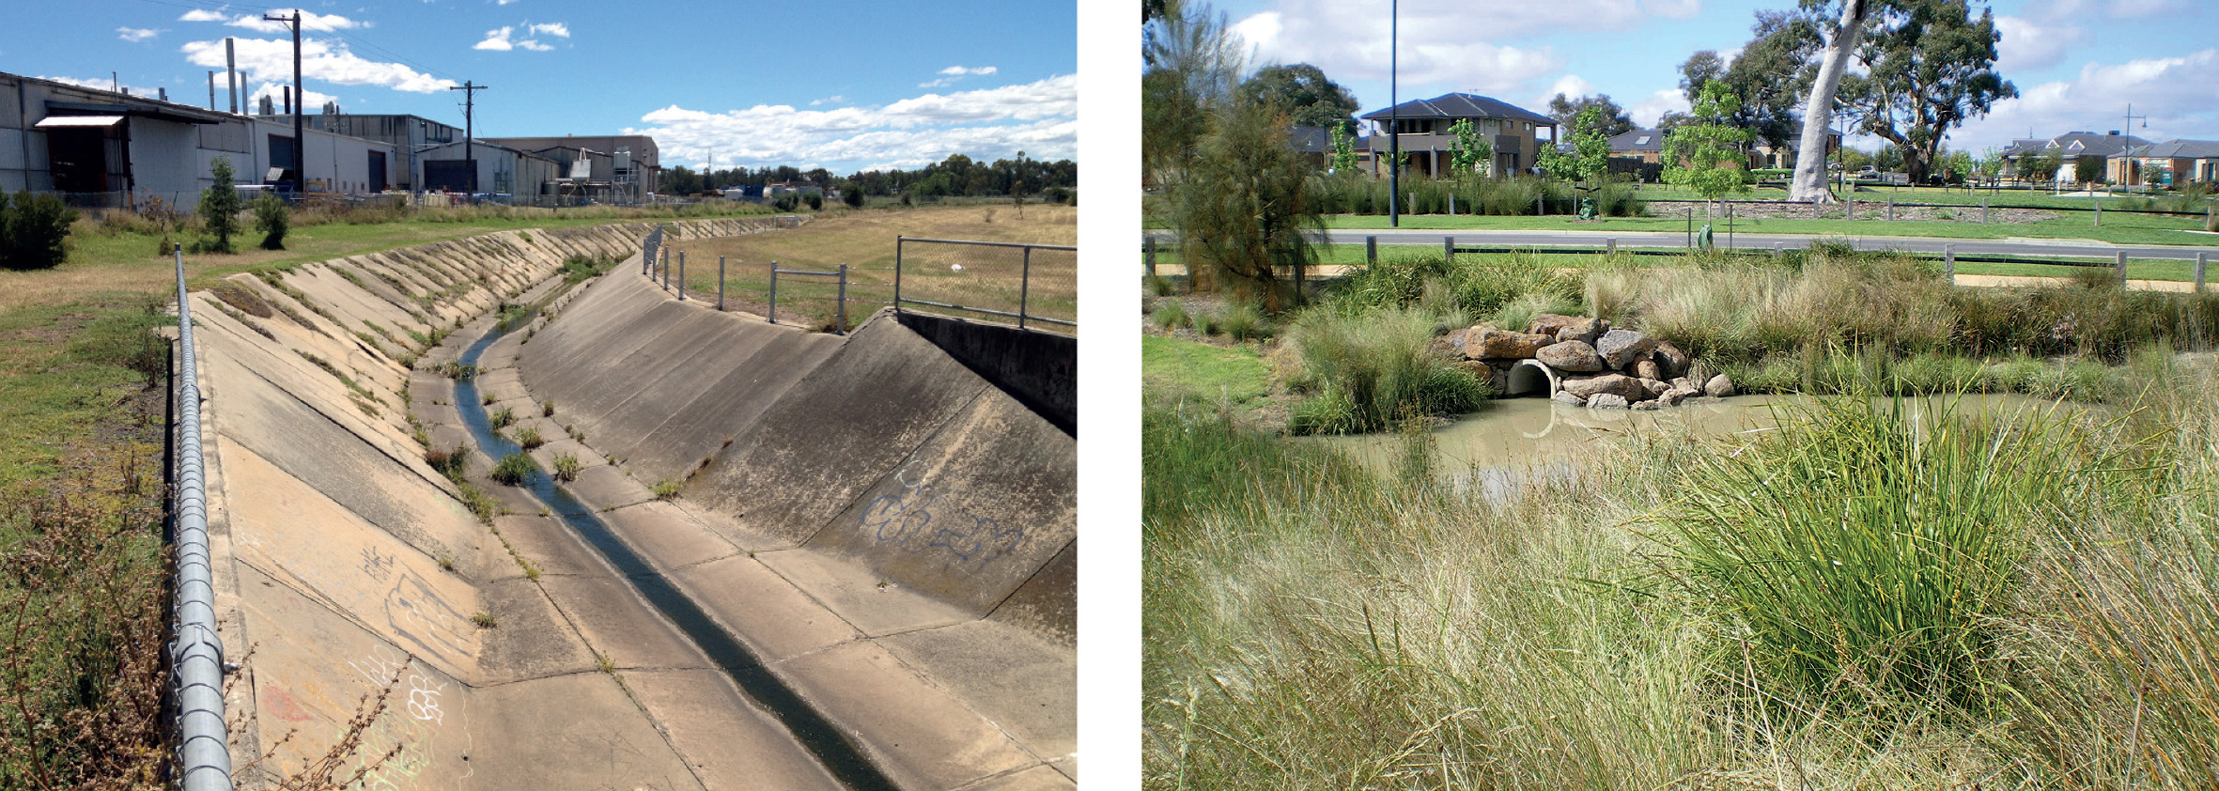
End highlight box.

7. Optimising the water grid and market
Our water supply system is now connected to other water supply systems across our region, creating a water grid that allows water to be shared across a much larger area.
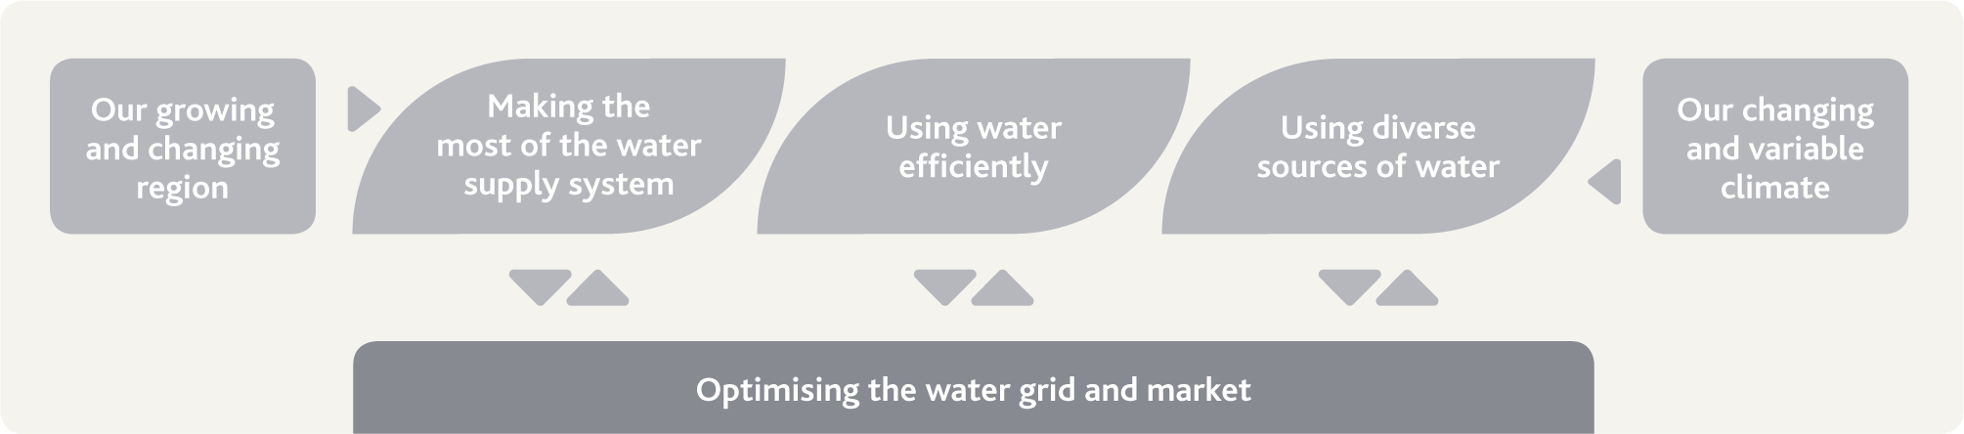

The challenge and our strategic response
Melbourne’s water supply system is connected to a number of neighbouring water supply systems. Climate change and variability, and population growth across southern Victoria means water resource shortfalls could emerge at different times in the future for different water supply systems.
The water grid will support opportunities to enhance water availability across Melbourne and the surrounding region, delivering efficient services through the south central water market. Melbourne Water will support the south central market trial to explore the opportunities and market mechanisms to support moving water across the region in the future.

Our actions and their benefits
Action number | Actions in chapter 7 relating to optimising the market and grid | Healthy People | Healthy Places | Healthy Environment
7.1 | Examine possible future Sugarloaf (North-South) Pipeline management options | •
7.2 | Support the development of a water grid oversight function | • |  | •
7.3 | Support the south central market trial | • |  | •
7.4 | Continue to identify and evaluate potential long-term water supply options that could add capacity to the water grid | •
7.5 | Develop a water resources information management plan | • |  | •
7.6 | Streamline our water allocation and accounting processes and information | •
7.7 | Enhance water resources modelling and analysis capabilities to improve decision support | • |  | •
7.8 | Review our network of streamflow, groundwater and climate information monitoring sites to support ongoing knowledge development | • |  | •

What is the water grid?
Victorian water supply systems have developed over the last 150 years to meet the needs of towns and cities and for irrigation. As the population has grown, many water supply systems have become linked through both built infrastructure and natural river systems. In this strategy, we refer to the linkages between water supply systems as the water grid.
The growing interconnection of water supply systems across the southern region of the state and water entitlement arrangements provide a foundation for ongoing water availability for a range of uses and values across the region.

Investments in the grid: enhancing water availability
Recent investments include:
connection of the Western Water system to the Melbourne system to supplement local supplies, particularly during drought periods
the Sugarloaf Pipeline, enabling a proportion of the water saved through improvements in irrigation systems in northern Victoria to be transferred to Melbourne during critical drought periods
the Melbourne–Geelong Pipeline, enabling supplemental supplies from the Melbourne system
the Goldfields Superpipe, connecting Ballarat and Bendigo to the Goulburn system
the Victorian Desalination Project, which has provided a climate independent source of up to 150 GL/yr.
These investments and the water entitlement framework in Victoria have enhanced the ability to move water across Melbourne and the surrounding region, ensuring that available water resources can be shared between users flexibly and adaptably. (Figure 38 shows the water grid across our region.)
Figure 38. The water supply system and linkages to transfer water out into the water grid
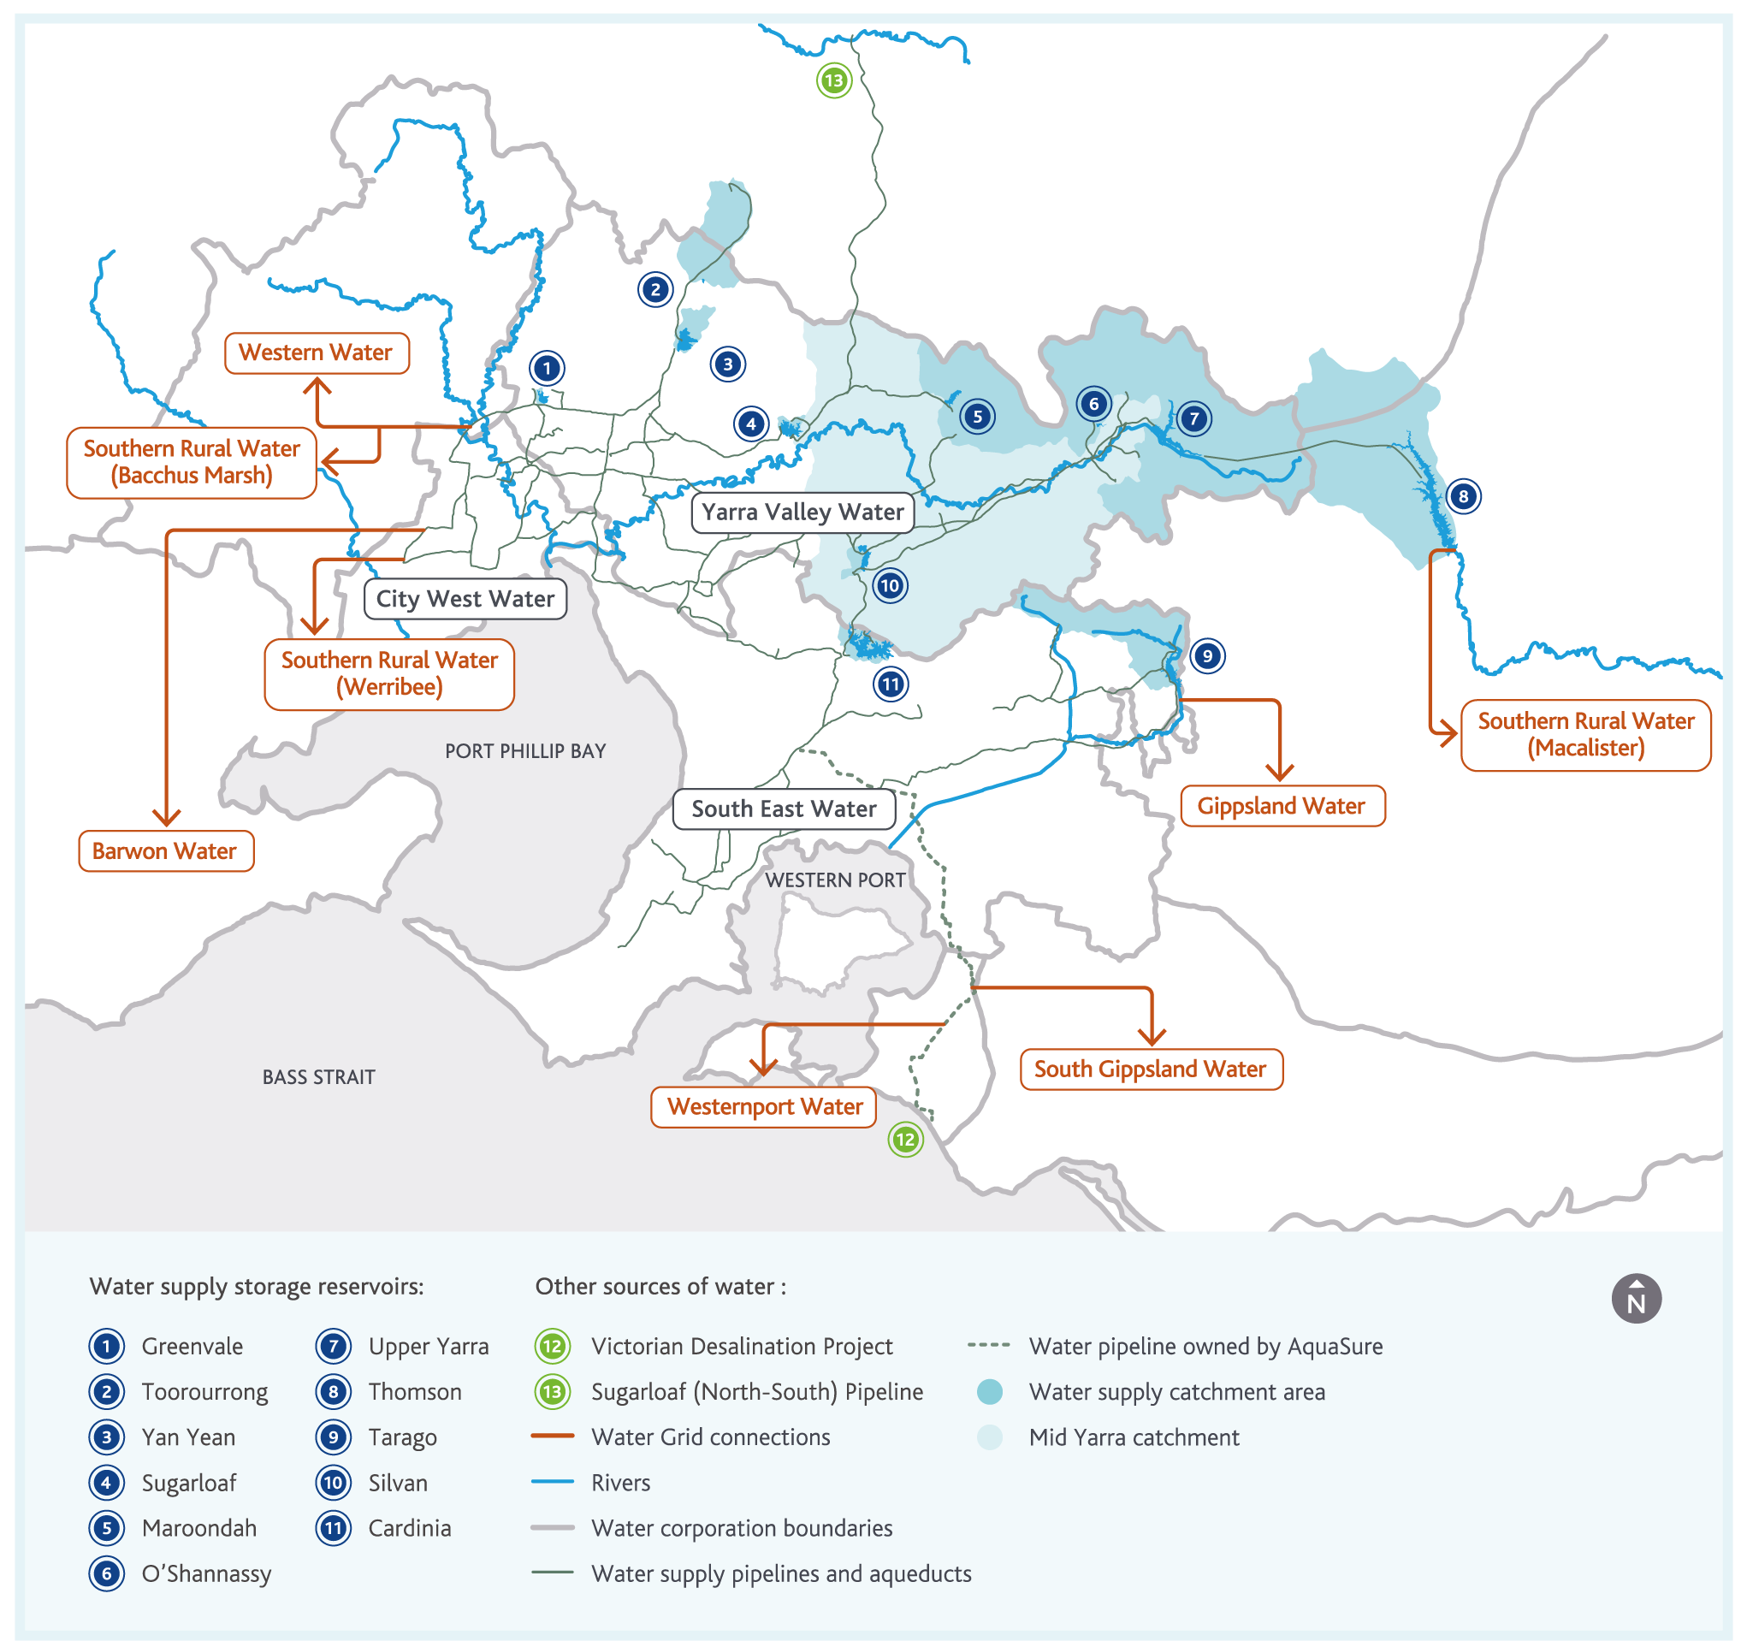

Highlight box - The Sugarloaf (North-South) Pipeline
In 2010, the Sugarloaf Pipeline was completed, delivering a new water grid connection between northern Victoria and southern Victoria. The Sugarloaf Pipeline starts on the banks of the Goulburn River downstream of Lake Eildon, and ends at Sugarloaf Reservoir in our water supply system. The retail water corporations hold water entitlements associated with the Sugarloaf Pipeline in the Goulburn and Murray systems.
The Statement of Obligations (System Management) currently allows the Sugarloaf Pipeline to be used when storages are below 30% on 30 November of any given year. Because we aim to keep storages well above 30%, very limited volumes can be expected to be transferred through the Sugarloaf Pipeline.
As the key source of water in the northern areas of Melbourne, Sugarloaf Reservoir plays a key role in our water supply system. Under some climate change and demand growth scenarios, it may become increasingly challenging to transfer enough water into Sugarloaf Reservoir from local sources. Under these scenarios, more flexible use of the Sugarloaf Pipeline in the broader context of the water grid and south central market trial could present an alternative option for managing climate change and demand growth, particularly in the northern areas of Melbourne.
End highlight box.

Action 7.1
Examine possible future management options for the operation of the Sugarloaf (North-South) Pipeline by June 2019.
Delivered by
Melbourne Water, retail water corporations, DELWP
Contributes to the following Sustainable Development Goals

Strategic oversight of the water grid
The Victorian Government is developing a water grid oversight function to make sure that developing and utilising the water grid delivers the best results for the community. This oversight function extends across water corporation boundaries to have a broader perspective on available water resources and emerging customer needs across Victoria.
Melbourne Water, in our role as Resource Manager, Waterway Manager and Storage Manager, has knowledge of the management of our water supply system and the associated grid connections, including data, models and system augmentation options. We already work closely with our customers across the water grid and DELWP to understand their needs and identify optimal infrastructure, operational and information solutions.
Melbourne Water is able to provide a leading role in supporting the development of the water grid objectives, through our oversight of whole-of-water-cycle management across the Port Phillip and Westernport region.
The increasing connectivity through the water grid, increasing diversity of supplies and local water servicing solutions, and water markets will drive a need for additional information and model development to support short and long-term water management decisions.
Our hydrological and meteorological data collection network and water resources modelling capabilities will enable us to support DELWP and our customers in the oversight of the water grid in Melbourne and the surrounding region.
Any longer-term augmentations of our water supply system or new connections to other water supply systems could have state significance, and Melbourne Water is also able support broader government processes to address broader water grid opportunities, as discussed later in this chapter.

Action 7.2
Support the development of a water grid oversight function that builds on existing water resources planning activities undertaken by water corporations across Victoria, including:
clarifying roles and responsibilities in grid oversight and the management and operation of our water supply system
defining information and operating rule requirements to improve long-term planning and optimal management of the water grid
providing expertise and support to assess options for additional future connections to our water supply system to more widely share the water availability benefits provided through recent augmentations of our water supply system
providing information on potential future grid augmentations to support the long-term future operation of our water supply system.

Delivered by
Melbourne Water, retail water corporations, regional water corporations, DELWP, VEWH, Southern Rural Water
Contributes to the following Sustainable Development Goals

Emerging opportunities to transfer more water through the grid
Through the development of their urban water strategies and other planning activities, the retail and regional water corporations have identified emerging challenges that could be addressed by transferring more water through our water supply transfer system and the water grid into their water supply systems.
While developing this strategy, we have taken into account the increased demands on our water supply system – these demands are driving many of the actions in this strategy.
The urban water strategies prepared by our customers have estimated the volumes of water that may be needed from our water supply system through the water grid in 2065:
Barwon Water: 20–25 GL/yr
Western Water: 15–54 GL/yr
South Gippsland Water: 2–5 GL/yr
Westernport Water: Up to 3 GL/yr
Gippsland Water: 2–4 GL/yr.
By 2065, up to 90 GL/yr may need to be transferred from the water supply system to the regional water corporations through the water grid. This is a substantial increase from current levels – in 2015/16, Melbourne Water supplied less than 7 GL to regional water corporations through the water grid.
The VEWH may also want to use the water grid to either physically, or through accounting, transfer water between different river systems across Victoria. Likewise, Southern Rural Water may wish to further access the water grid. These customers could drive even higher grid transfers than those we currently anticipate, so we need to ensure our planning of the water grid is regularly reviewed and adaptable.
Although water can be transferred across much of the Melbourne water supply system by gravity, transferring water into some parts of the water grid requires pumping. Additional energy consumption required to pump water, and any associated greenhouse emissions, will need to be taken into account in planning future use of the water grid.

Highlight box - Extending South Gippsland Water’s connection to the water grid
South Gippsland Water provides water and sewerage services for 21 regional centres and rural towns, including the towns of Korumburra, Poowong, Loch and Nyora. Water is currently supplied to these towns from relatively small water catchments with small reservoirs. In the past, these catchments and reservoirs have performed well, but good winter and spring rainfall is needed to fill the reservoirs – which can be impacted by both climate change and climate variability.
To support further development in these towns and the surrounding region, South Gippsland Water is now building a pipeline to link them with Lance Creek Reservoir – which is already connected to the water grid, and can be topped up as needed with water sourced from Melbourne’s water supply system. This extension of South Gippsland Water’s connection to the water grid will ensure reliable, high quality water services can be delivered to these towns and the surrounding region for many decades to come.
End highlight box.

The south central market
Water markets have been in place for many years in northern Victoria, and are effective as an enabler of financial transactions that support grid transfers.
These grid transfers can occur through the physical transfer of water from one place to another. Alternatively, grid transfers can occur as virtual transfers of water delivered through water accounting processes without actually physically transferring any water.
In Water for Victoria, the state government announced a major new initiative: a five-year trial beginning in 2017 to develop a new water market in south central Victoria to enable these transactions to occur.
Some issues to consider for the trial include:
developing clear purposes and objectives for the south central market aligned with community preferences and expectations
building an understanding of the implications of market operation under different climate change scenarios and during peak periods of resource scarcity, such as during droughts
understanding the characteristics of different water supply systems connected to the grid which could influence market operations in different seasons and years
considering market rules, the role of the Victorian Desalination Project, entitlement structures, pricing, allocation policies, and storage and delivery charges
sharing information during and on completion of the trial, including a review of the outcomes.
The south central market will support the directions outlined in this strategy by ensuring that available water resources can be made available for transfer through the water grid to support our customers across the region as their demands for water grow over time.

Opportunities in the south central market
The south central part of Victoria is dominated by urban water corporations, tasked with providing safe and secure supplies to metropolitan Melbourne and fast-growing regional areas.
In southern Victoria, the historical need for a water market has been limited, mainly because the Melbourne supply system has developed as an integrated system to provide for the growing needs of a large city and the surrounding region, and allocation of water resources has been achieved through a range of other non-market mechanisms.
The granting of water entitlements to the retail and regional water corporations from a share of the total resources in Melbourne’s water supply system to individual shares in 2014 provides for new opportunities to trade water between the retail and regional water corporations, the VEWH, and Southern Rural Water. These opportunities to trade could support and motivate water efficiency or local water management decisions such as diversifying supplies to help delay or avoid augmentations of the water grid.

Water trading so far
A small number of water trades have already occurred in southern Victoria and through Melbourne’s water supply system, but these have each been delivered through separate agreements and approved by the Minister for Water. Some of these have involved sales and physical transfers of water, while others have involved swapping water between entitlement holders in different systems.
Examples of water trading within the Melbourne system to date:
Southern Rural Water swapped water with Western Water, enabling Southern Rural Water to access water in Lake Merrimu that Western Water owned, and Western Water to access an equivalent volume of water in Thomson Reservoir that Southern Rural Water owned.
The VEWH traded water from the Yarra River system into the Thomson River system to manage environmental flows in the Thomson River.
The retail water corporations sold water allocated to them in northern Victoria.
Barwon Water sold water they owned in our water supply system to Western Water.

Enabling water efficiency and diverse sources of water
While water markets and grids often focus on large volume exchanges at a system level, water efficiency initiatives and sources of water like rainwater, stormwater and recycled water may also present local water market opportunities. These sources of water and water efficiency initiatives may reduce or offset demands for water that would otherwise need to be met from the water supply system. The water that would otherwise have been needed from the centralised water supply system could then be traded with other entitlement holders who may not have comparable opportunities to invest. In this way, the south central market can reveal the value of water and create incentives for investments in water efficiency initiatives and diverse sources of water.
The south central market may also present opportunities to consider greater involvement of the private sector.

Clear roles and responsibilities
In Victoria, we have a robust legal water entitlement framework that aims to provide certainty of legal rights and obligations, and flexibility. However, these entitlements are not straightforward and, in some cases, roles and responsibilities are not completely clear.
Since the introduction of water markets in northern parts of Victoria, water information products and trading have developed and become increasingly sophisticated. The development of the south central market trial will likewise lead to increasing information needs. It will also require clear definition of roles and responsibilities of market participants to support transparent and efficient water resource management and water trading decisions consistent with water entitlements, the broader objectives of the water grid and south central market trial, and community expectations.
As the water grid and associated market develop, it will be important to ensure we maintain a clear understanding of the levels of service expected by the community. These levels of service will need to be defined in terms the community can understand, but also in a form that can be used to support strategic and operational water resource management decisions, including decisions related to water trading. This will ensure that the increasingly complex strategic and operational decisions that need to be made remain clearly aligned with community expectations.

Action 7.3
Support the south central market trial, including:
defining clear objectives, outcomes and accountabilities for the trial
clarifying aspects of existing water entitlements to ensure roles and responsibilities for all participants in the south central market are clear
providing information to support the trial, including on the implications of demand growth and climate change in different water grid scenarios
exploring opportunities enabled by the south central market and the water grid for improving the portfolio of water resources management options and improving environmental flow outcomes across all grid-connected waterways.
Delivered by
Melbourne Water, retail water corporations, regional water corporations, DELWP, VEWH, Southern Rural Water
Contributes to the following Sustainable Development Goals

Potential long-term water supplies
This strategy outlines a diversified portfolio approach to managing water resources across Melbourne and the surrounding region for the next 50 years involving:
making the most of the water supply system
using water efficiently
using diverse sources of water
optimising the water grid and the south central market.
Chapter 3 shows the broad range of possible demand and supply scenarios we may have to manage with our growing population and changing, variable climate. Depending on the scenario, by 2065 the long-term additional water needs from the Melbourne water supply system may range from not needing additional water resources to a potential need of more than 450 GL/yr of additional water.

Requirements in the short to medium term
Even under the scenarios of higher demand and higher climate change impact, Melbourne Water anticipates that we will not need to invest in additional major augmentations of the water supply system for at least the next decade. However, depending on how and when the Victorian Desalination Project is operated, severe and protracted droughts, such as the Millennium Drought, could result in water storage volumes being drawn down to low levels, as discussed in Chapter 4.
Ensuring water availability for Melbourne and the surrounding region in the short to medium term will be achieved by investing in our adaptive portfolio, including by building drought reserves in storages through proactive operation of the Victorian Desalination Project, ensuring effective drought preparedness plans are in place, using water efficiently, and using diverse sources of water. This is discussed further in Chapters 4, 5 and 6 of this strategy. This will require Melbourne Water to work closely with the retail and regional water corporations and with our stakeholders to provide the necessary information to make informed decisions.

Longer-term water supplies
The range of supply and demand scenarios shows the potential need in some cases for additional large scale augmentations of our water supply system and the broader water grid across south central Victoria. The option, potential timing, and the volumes required will depend on a number of considerations including:
the growth in water demand
water use efficiency
diversification in sources of water
the extent to which climate change impacts on trends in streamflow or results in additional connections through the water grid
the longer-term operation of the Victorian Desalination Project.
The community have told us that affordability is a critical consideration for them. They have also told us that they would prefer investment in water efficiency initiatives and sources of water like rainwater, stormwater and recycled water before further augmentations of the water supply system are considered (endnote 4). This strategy aims to reflect these preferences of the community, as discussed in Chapters 5 and 6. We will continue to deliver water services to our customers at the lowest practicable cost.
A key lesson from the Millennium Drought and our climate research is that future climate conditions could be drier than we would expect based on our past experience, and changes can occur rapidly.
We also know from some of the scenarios we considered that rapid changes in climate conditions mean adequate time is needed to prepare for and manage any divergence of our capacity to supply and the demand for water. We need to ensure timely action can be taken should it become necessary – and given the long lead times associated with many water supply options, this means that planning and preparatory work needs to be undertaken years before additional water is actually needed.
To address this need, Water for Victoria outlines the development of a grid oversight function, which would, among other activities, coordinate the preparation of a biennial statement which includes a set of potential future grid augmentation options.
As shown earlier in Figure 7, Melbourne Water operates within a broader state water planning framework. We work closely with the Victorian Government to support processes such as the upcoming review of the Central Region Sustainable Water Strategy. Through these processes, we support consideration of all possible long-term major water supply augmentation options. As technologies and community perceptions and expectations continue to evolve, we will also support consideration of any new options that emerge in the future.
Around Australia and internationally, a range of long-term water supply options have been considered in the past, such as:
reintroducing existing infrastructure (current opportunities are limited, as discussed in Chapter 4)
harvesting more water from rivers
accessing groundwater resources
utilising seawater treated by desalination plants.
An ideal source of water would have:
minimal impacts on local communities and widespread community support
minimal environmental impacts
no requirement to reallocate water away from existing or potential future users
low capital and operating costs, including low energy consumption
capacity to supply consistent volumes of water, regardless of climate change and variability, or extreme events like bushfires
short lead times for planning, design, construction and commissioning.
There appear to be no options in the region surrounding Melbourne that have all of these characteristics. All possible options have advantages and disadvantages, including location-specific environmental, social, technical and financial aspects.
Rivers are the main source of water used for water supply purposes in Victoria. However, the volume of water available from rivers is strongly dependent on climate change and variability. Under climate change, streamflows in some rivers in the region surrounding Melbourne could decline by more than 45% by 2065 (endnote 2).
Harvesting water from rivers also requires the reallocation of water away from existing or potential users, including the environment. The removal of water from rivers, and the construction of any associated infrastructure such as weirs or dams, can have significant environmental and social impacts.
For these reasons, it is difficult to justify further investment in infrastructure to harvest more water from rivers.
Groundwater resources in Melbourne and the surrounding region are limited, and the higher quality resources are already largely allocated for agricultural and landscape irrigation purposes. Some deeper, more saline groundwater resources also exist, but the associated aquifer is already being used to support an aquifer storage and recovery trial, as discussed in Chapter 6.
Seawater desalination plants can produce consistent volumes of water regardless of climate change and variability. They also create a new water resource, which does not need to be reallocated away from existing or potential future users. The potential environmental impacts of seawater desalination can be managed through purchasing renewable energy, and designing brine outlets that maintain environmental values.
The marine intake and outlet tunnels, transfer pipeline and power supply for the existing Victorian Desalination Project are all sized to accommodate up to 200 GL/yr, which means that it may be possible to increase the capacity of the Victorian Desalination Project by up to 50 GL/yr relatively quickly and cost effectively.
This suggests that such a capacity increment of the Victorian Desalination Project should be among the options considered when an augmentation is needed in the future.
We will continue to work with DELWP and the retail and regional water corporations through the review of the Central Region Sustainable Water Strategy and other Victorian Government processes to ensure Melbourne and the surrounding region is well prepared for all potential scenarios of future demand growth and climate change. Engagement of Traditional Owners and the community during the processes of further identification and evaluation of potential longer-term water supply options will be needed to ensure possible options take their needs and perspectives into account. Engagement during the process of further identification and evaluation, including with the private sector, may also be able to provide innovative perspectives and further opportunities for consideration.

Action 7.4
Continue to identify and evaluate potential long-term water supply options by June 2021 that could supply water to Melbourne and the surrounding region in the long term through the water grid, including trigger points and adaptive pathways for flexible staged investments.
Delivered by
Melbourne Water, DELWP, retail water corporations, regional water corporations
Contributes to the following Sustainable Development Goals

Delivering the right information
Accurate, relevant and timely water resources information is needed to support the decisions related to the water grid and market that will be made by Melbourne Water, our customers, and our stakeholders.
Melbourne Water has been providing our customers and stakeholders with water resources information for many years, and we are investing in developing the next generation of water resources modelling tools to support the increasingly complex decisions that need to be made to optimally manage our water resources.
This investment will enable us to provide new information products to support the south central market and grid oversight function.

Providing enhanced information
Melbourne Water provides information about water resources to our customers and DELWP, and to the broader community through our website and other media. For example, every day we update water storage levels on our website, and every week we issue an update to the media regarding rainfall over our catchments, water use, and water storage levels. This information is also made available through our smart phone app.
Community research suggests that through these information products, about a third of the community have some knowledge of what current water storage levels are (endnote 4).
Reporting water storage levels, both as raw information and by comparing them against the water outlook zones, has served our customers and the community well. In the future, other metrics and information may be needed to complement existing approaches to more clearly identify the extent to which available water supplies can actually meet the changing needs of our customers and the community. In the future, we will need to provide increasingly detailed information products, which link information about the whole system with information relevant to individual customers.
We have already started to deliver more detailed information to our customers; for example, every month we deliver seasonal determinations to each of the retail and regional water corporations, outlining how much water they each have available in their water accounts. We aim to continue to develop innovative approaches to providing our customers with the information they need on an ongoing basis.

Action 7.5
Prepare a strategic water resources information management plan in consultation with DELWP and our customers, outlining how we will collect and manage water resources information in the future.
As part of this, we will undertake a preliminary scoping study by June 2018 to identify and evaluate information technology options that could improve information access and visualisation for external stakeholders.
Delivered by
Melbourne Water

Contributes to the following Sustainable Development Goals
There is scope to further enhance and streamline some of Melbourne Water’s information products, making them easier to produce quickly, and easier for our customers to understand and use them to support their decisions. Melbourne Water identifies and pursues opportunities to enhance all of our information products on an ongoing basis.
In the longer term, further development of the water grid and the south central market trial may require development of increasingly sophisticated water accounting and allocation processes. This could require additional resourcing that should be considered during the south central market trial.

Action 7.6
Streamline and enhance our water allocation and accounting processes and associated information products on an ongoing basis to ensure we are providing information that is easy to understand and useful to our customers.
Delivered by
Melbourne Water, retail water corporations, regional water corporations
Contributes to the following Sustainable Development Goals
These types of enhanced information products related to market activity and grid transfers are created through modelling and analysis. As our operating environment becomes increasingly complex, we need to ensure that:
our modelling and analysis capabilities continue to improve to provide timely, relevant and useful water resources information to our customers and DELWP, including the VEWH
we continue to collect and manage the raw data that is the key input to our value-adding modelling and analysis activities
we make our information easily accessible to DELWP and our customers, including the VEWH, including through use of the Victorian Water Register.

Action 7.7
Develop enhanced water resources modelling and analysis capabilities to ensure we can provide the water resources information our customers and stakeholders need now and in the future, including:
develop the capability to assess optimal water allocation management options of individual water entitlement holders by December 2017
improve the transparency of modelling assessments through an online documentation system accessible by internal and external stakeholders, supplemented by automated model configuration reporting, by December 2017.
Delivered by
Melbourne Water
Contributes to the following Sustainable Development Goals
To underpin the provision of information to support decisions related to making the most of the water supply system, using water efficiently, using diverse sources of water, and optimising the water grid and market, we need to ensure we are collecting the right data across our network of water consumption, streamflow, groundwater and climate information monitoring sites – taking into account the needs of all of our customers, and the opportunities presented by emerging digital metering technologies.
For example, our streamflow monitoring sites have been developed over a long period of time, principally with the objectives of monitoring floods and consumptive water resources. These streamflow monitoring sites are generally useful for monitoring flows related to environmental values too, but there are some sites where our abilities to monitor low flows in particular are limited. Low flows play a role in supporting some environmental values, provided they are not too low for too long.
To improve our understanding of low flows in some waterways, and how environmental water can be used to manage low flows, we may need to extend our network of streamflow monitoring sites.

Action 7.8
Review our network of water consumption, streamflow, groundwater and climate information monitoring sites on an ongoing basis to ensure we are collecting all of the information we need to build our understanding of our water resources to support decisions made by all of our customers and stakeholders. In the short term, the environmental water monitoring, evaluation, reporting and improvement framework will be reviewed to identify any gaps by December 2018.
Delivered by
Melbourne Water
Contributes to the following Sustainable Development Goals

Appendix A.

Exploring possible implementation scenarios
The MWSS is an adaptive strategy, and will result in different actions being taken depending on the observed climate and demand conditions.
Here, we outline three scenarios of supply and demand, and discuss in broad terms the types of actions needed for each focus area of our portfolio approach:
- low change scenario: lower growth in water demands and low climate change
- incremental change scenario: medium growth in water demands and medium climate change
- rapid change scenario: higher growth in water demands and high climate change.
The climate scenarios are described in the Guidelines for Assessing the Impact of Climate Change on Water Supplies in Victoria prepared by DELWP. The demand scenarios are based on information provided by the retail and regional water corporations.
When we combine yield estimates with the long term demand forecasts provided by the retail and regional water corporations, we gain insight into how the water supply system will cope with future droughts, and the timing and magnitude of potential water resource shortfalls that could emerge over time. When demand exceeds supply, we use the term ‘water resource shortfalls’ to describe the risk that existing sources of supply may not be able to continue to deliver the base level of service we aim to deliver (aiming to keep storages above the water outlook low zone).
These scenarios were selected to reflect a range of timing of demand exceeding supply. Although there were other scenarios, these three key scenarios highlighted a broad range of possible futures to guide the development of an adaptable strategy.
The Guidelines for Assessing the Impact of Climate Change on Water Supplies in Victoria prepared by DELWP say there is no ‘most likely’ scenario for future climate in Victoria, and that ‘future planning needs to be built around consideration of a range of plausible climate futures’. On this basis, we have not assigned any probabilities to the three key strategic scenarios of supply and demand used to guide the development of this strategy. Further to this, the guidelines also note that ‘scientists globally and in Victoria have observed that climate change can occur as both gradual and step changes’ and for each of the three scenarios of supply discussed in this appendix, any ‘projected climate change impact could occur earlier or later than anticipated by this interpolation’ (endnote 2). On this basis, it is possible that projected water resource shortfalls for the three scenarios described in this appendix could occur earlier or later than the indicative timing suggested here. Further to this, extreme events like bushfires could also potentially cause additional short-term and long-term water resource shortfalls.

1. The low change scenario: lower demand and low climate change

Challenges in this scenario
A growing and changing city | Around 7.9 million people will live in Melbourne by 2065 under this scenario, and many more will live in the surrounding region. This population growth will drive growth in the demand for water from our urban customers across the Greater Melbourne region.
A variable and changing climate | The low climate change scenario (based on the Guidelines for Assessing the Impact of Climate Change on Water Supplies in Victoria prepared by DELWP) will lead to a 1–8% reduction in streamflow in rivers across our region by 2065 relative to the post-1975 current climate baseline, with rivers in western areas most strongly impacted. Additional water may also be required for the environment to maintain environmental values.
Potential water resource shortfall by 2065 | No water resource shortfall by 2065 under this scenario, although shortfalls could begin to emerge shortly beyond 2065.

Figure 39. Potential water resource shortfalls in the low change scenario
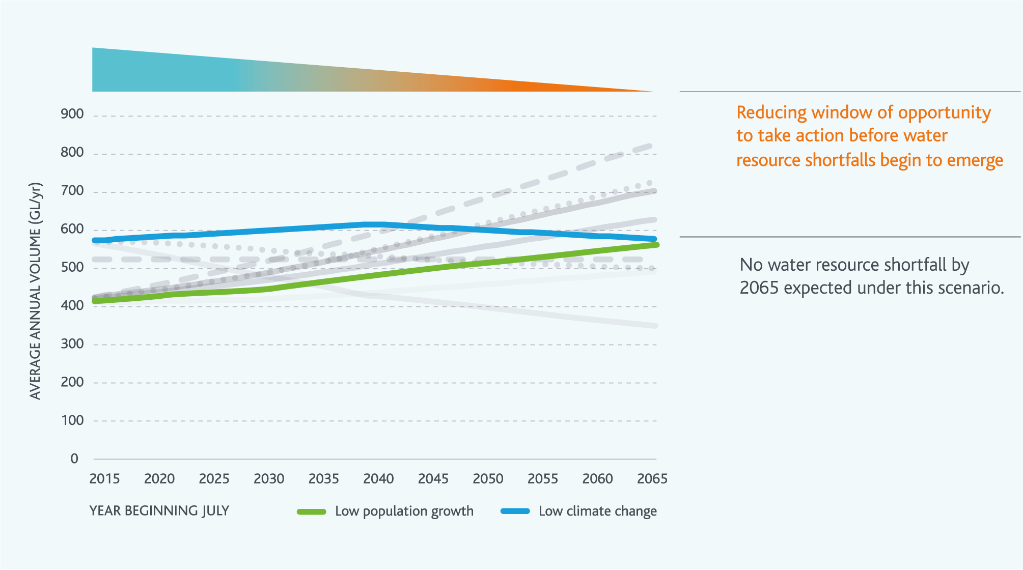

Strategy directions for each element of our portfolio approach
Using water efficiently | The community have a clear expectation that the water businesses will continue to promote water efficiency. Further to this, even if climate change does appear to be tracking along the low scenario, climate change could occur rapidly in step changes. Given this, it is prudent to maintain investment in water efficiency to meet community expectations and retain capacity in water corporations to ensure we are ready to deliver additional water efficiency initiatives as required.  Although no water resource shortfall emerges under this scenario by 2065, it is clear that water resource shortfalls could begin to emerge just beyond 2065. In this context, ongoing investment in water efficiency over the next 50 years is still needed, to position us well for the 50 years beyond that. Technological developments and regulatory changes that reduce water consumption without requiring further behavioural change will be a key means of driving water efficiency under this scenario.
Using diverse sources of water | The slower rate at which supply and demand converge under this scenario present an opportunity to invest gradually in diverse sources of water over the next 50 years. Within the next 50 years, improvements in water treatment technology could emerge, enabling a broader range of residential and non-residential applications.  Ongoing investment in diverse sources of water over the next 50 years will help to ensure that water resource shortfalls do not begin to emerge until beyond 2065.
Making the most of the water supply system | Supply and demand do converge over the next 50 years, requiring increased utilisation of the existing Victorian Desalination Project. In this context, smaller initiatives to ensure we are making the most of the existing water supply system have a role to play in making water services as affordable as possible over the next 50 years, enabling optimisation of the Victorian Desalination Project. On this basis, actions include consideration of our entitlements to divert water from Cement Creek and Bunyip River, which are currently underutilised; these two sources alone could potentially contribute up to around 10 GL/yr by 2065.  Under this scenario, it is less likely major augmentations of the water supply system will be needed. However, we will still work with our customers and DELWP to consider major augmentation options and trigger points, so that we are prepared to respond if a step change in climate or some other unforeseen event occurs.
Optimising the water grid and market | Although no water resource shortfalls emerge until beyond 2065 for the Melbourne system, some shortfalls may emerge before 2065 for some of our customers, where they require more water than their existing entitlements allow them to take from our water supply system.  To ensure that available resources are directed to where they are needed most, including for environmental flows, the water grid will need to be used, supported by the market. Market activity and grid transfers are likely to be lower under this scenario than under other scenarios characterised by more rapid shifts in the balance of supply and demand. However, market activity and grid transfers may be only partially driven by long-term considerations. Under this scenario, market activity and grid transfers could still be driven by short-term droughts or extreme events. Under this scenario we will still need to work with DELWP and our customers to support the development of the water grid and markets.

2. The incremental change scenario: medium demand and medium climate change

Challenges in this scenario
A growing and changing city | Around 8.9 million people will live in Melbourne by 2065 under this scenario, and many more will live in the surrounding region. This population growth will drive growth in the demand for water from our urban customers across the Greater Melbourne region.
A variable and changing climate | The medium climate change scenario (based on DELWP’s Guidelines for Assessing the Impact of Climate Change on Water Supplies in Victoria) will lead to a 14–20% reduction in streamflow in rivers across our region by 2065 relative to the post-1975 current climate baseline, with rivers in western areas most strongly impacted. Additional water may also be required for the environment to maintain environmental values.
Potential water resource shortfall by 2065 | There is an imbalance between supply and demand of more than 100 GL/yr by 2065.  Water resource shortfalls could begin to emerge by 2043.  On average, between 2043 and 2065, around an additional 6 GL/yr of capacity will need to be added every year under this scenario.

Figure 40. Potential water resource shortfalls in the incremental change scenario
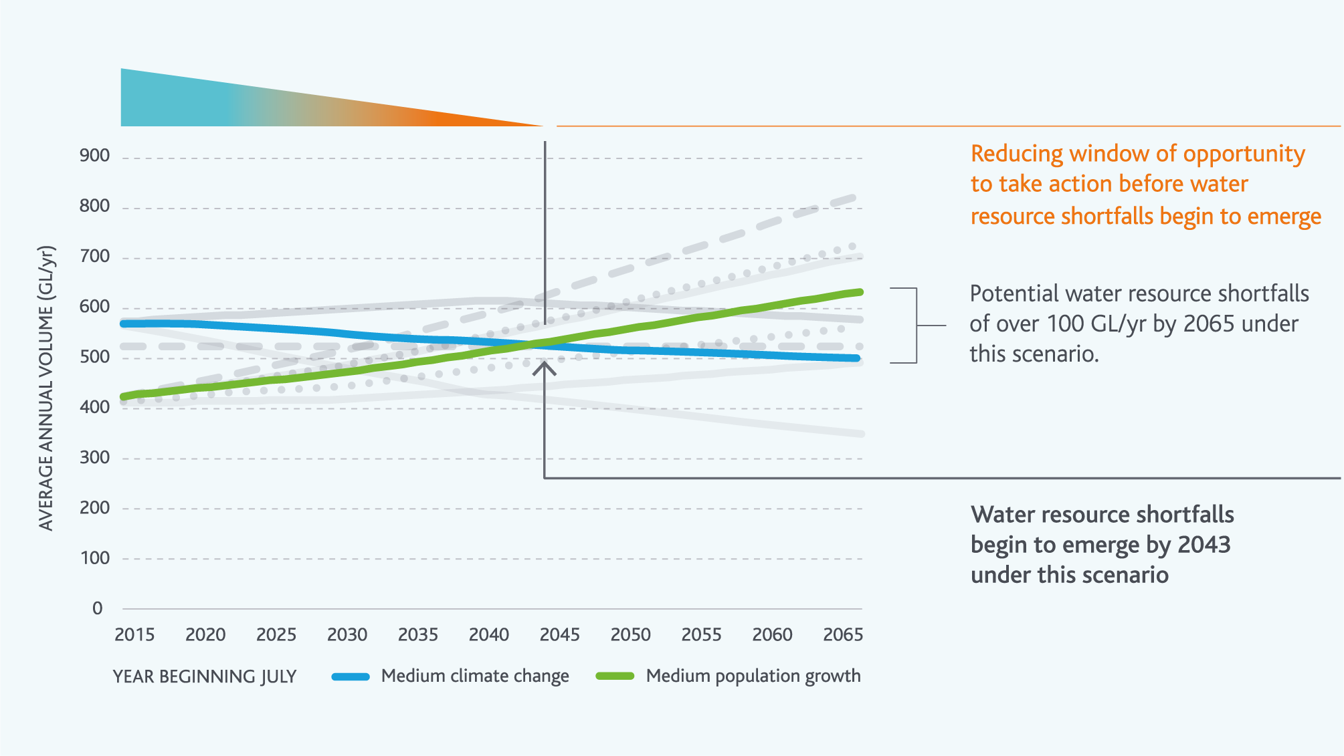

Strategy directions for each element of our portfolio approach
Using water efficiently | To manage potential water resource shortfalls under this incremental change scenario, savings over and above the natural expected reduction in per person water consumption linked to increasingly efficient appliances and behaviours would need to be of the order of 25% of total projected residential demand in 2065. This would be a very challenging goal. Given that water resource shortfalls are unlikely to emerge until 2043 under this scenario, technological developments and regulatory changes that reduce water consumption further without requiring further behavioural change could be a means of driving water efficiency at least for the next 20–30 years.
Using diverse sources of water | Under this scenario, supply and demand diverge gradually, meaning a series of smaller incremental actions could be effective rather than periodically implementing very large new sources of supply. Given the water resource shortfalls of over 100 GL/yr by 2065, diverse of sources of water like rainwater, stormwater and recycled water could play a key role in managing climate change and population growth under this scenario. For this to happen, rainwater, stormwater and recycled water will need to be treated to high standards, supported by appropriate regulatory and health frameworks to enable a broader range of residential and non-residential applications.
Making the most of the water supply system | Under this scenario, smaller initiatives to ensure we are making the most of the existing water supply system have the potential to contribute to managing the projected water resource shortfalls of over 100 GL/yr by 2065. Key actions include consideration of our entitlements to divert water from Cement Creek and Bunyip River, which are currently not fully utilised; these two sources alone could potentially contribute up to around 10 GL/yr.  Depending on the contribution of water efficiency initiatives and diverse sources of water, it may also be necessary to consider major augmentations of the water supply system under this scenario. Under this scenario, we would need to work with our customers and stakeholders to regularly provide a forward view of water availability, and to consider options and trigger points for major investments in the water supply system, including the potential 50 GL/yr expansion of the Victorian Desalination Project.
Optimising the water grid and market | Water resource shortfalls across the whole Melbourne system start to emerge by 2043 under this scenario, but they start to emerge at different times for different entitlement holders. To ensure that available resources are directed to where they are needed most, including for environmental flows, the water grid will need to be used, supported by the market. The existing water grid could require augmentation under this scenario, since some customers may require more water from our water supply system than the existing transfer capacities within the networks can transfer. Under this scenario, we will need to work with DELWP and our customers to support the development of the water grid and markets.

3. The rapid change scenario: high demand and high climate change

Challenges in this scenario
A growing and changing city | More than 10 million people will live in Melbourne by 2065 under this scenario, and many more will live in the surrounding region. This rapid population growth (greater than the current Victoria in Future projections) will drive significant growth in the demand for water from our urban customers across the Greater Melbourne region. The demand growth in this scenario will be further increased by climate change. Under this scenario, demand on a per person basis continues to decline over the next 50 years, but it does so at a lower rate than the other scenarios.
A variable and changing climate | The high climate change scenario (based on DELWP’s Guidelines for Assessing the Impact of Climate Change on Water Supplies in Victoria) will lead to a 42–55% reduction in streamflow in rivers across our region by 2065 relative to the post-1975 current climate baseline, with rivers in western areas most strongly impacted. Change may be gradual but could also occur as a series of rapid step changes. Additional water may also be required for the environment to maintain environmental values.
Potential water resource shortfall by 2065 | There is an imbalance between supply and demand of more than 450 GL/yr by 2065.  Water resource shortfalls could begin to emerge by 2028.  On average, between 2028 and 2065, more than an additional 12 GL/yr of capacity will need to be added every year under this scenario.

Figure 41. Potential water resource shortfalls in the rapid change scenario
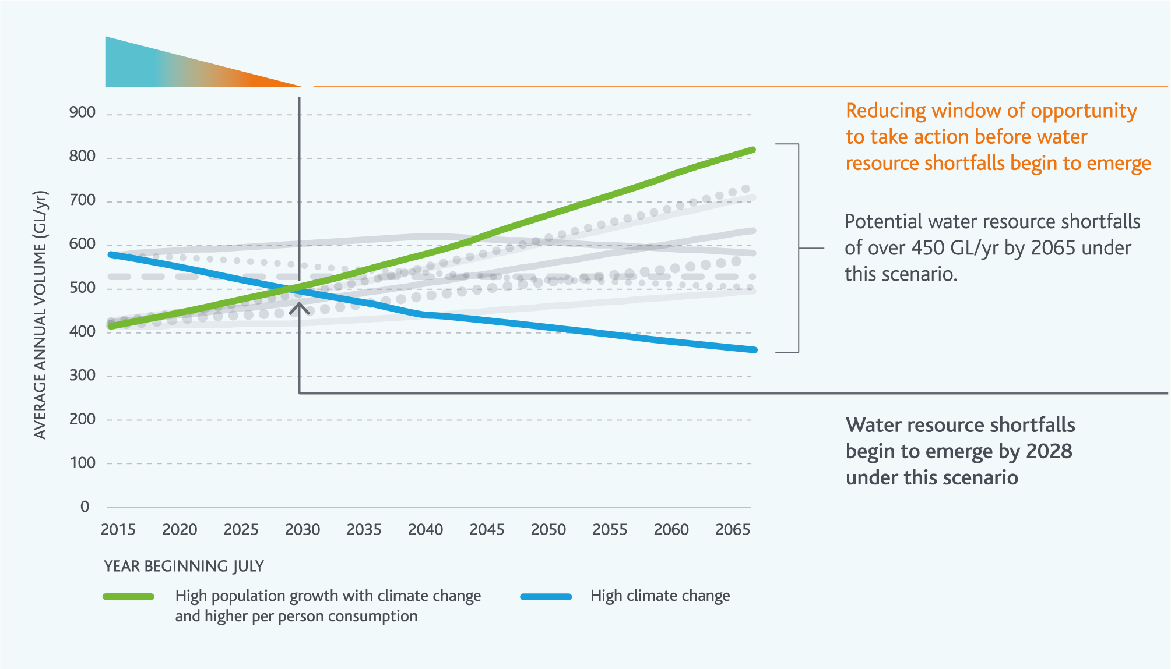

Strategy directions for each element of our portfolio approach
Using water efficiently | Under this scenario, rapid climate change will stress water supplies and focus attention on water efficiency. Significant water efficiency initiatives may be needed, potentially including:  further behavioural change programs  rebates for water efficient appliances and landscaping  buy back of inefficient water appliances  regulatory changes to ensure water efficiency at housing ownership or tenancy change over  extension of permanent water use rules and water use target campaigns  targeted commercial, industrial and institutional water use programs  consideration of alternative pricing arrangements.  With over 450 GL/yr of water resource shortfalls to manage by 2065, water efficiency initiatives will have a major role to play. However, 450 GL/yr is more than 75% of total projected urban residential demand in 2065. Given this, water efficiency alone is unlikely to be sufficient to meet such a large shortfall, so water efficiency initiatives will need to be complemented by other actions.
Using diverse sources of water | Rapid climate change and population growth and increasing potential for water scarcity in drought periods under this scenario would increase attention on availability of diverse water sources to substitute water from the water supply system to maintain liveability, and to provide for environmental flows. This attention will need to be balanced between uses such as irrigation of open space and sporting fields and other opportunities across a broader range of residential and non-residential applications.  Increasing potential for water scarcity underpinned by a strong investment evaluation framework should drive increased levels of investment in diverse sources of water. However, large water resource shortfalls, and higher capital costs of retrofitting existing suburbs and building infrastructure to keep ahead of growing demand and falling supplies could present challenges in identifying and delivering enough additional projects to manage the water resource shortfalls (including environmental flow shortfalls) that emerge under this scenario through diversification of sources of water alone.
Making the most of the water supply system | Under this scenario, we will need to optimise the value we get out of the existing water supply system. This optimisation will need to be achieved quickly before shortfalls begin to emerge in 2028. Actions will need to be focussed on optimising the elements of our system that can make the biggest difference to the balance of supply and demand. For example, we will need to work closely with our customers and DELWP to increase our utilisation of the Victorian Desalination Project and consider options for using existing infrastructure such as the Sugarloaf Pipeline. Operating the water supply system to keep a buffer of water in storage will be particularly critical under this scenario for maintaining supply throughout future droughts, which could last for more than a decade. Keeping a buffer of water in storage will also assist to manage the impacts of other extreme events, like bushfires, which could occur more frequently in the future under this particularly dry climate change scenario.  Without significant water efficiency gains or high volumes from diverse water sources options, the scale of the water resource shortfalls and the rapid rate at which they develop under this scenario means that they may be difficult to manage without further investment in major augmentations of the water supply system. Among other actions, we will need to work with our customers and DELWP to consider options and trigger points for major augmentations of the water supply system, including the 50 GL/yr expansion of the Victorian Desalination Project, and potentially other seawater desalination plants elsewhere in Victoria. The typical lead times for these types of augmentation options means that action needs to be taken well before water resource shortfalls begin to emerge.
Optimising the water grid and market | The water grid and south central market will have key roles to play under this scenario. Water resource shortfalls across the whole Melbourne system start to emerge by 2028, but they start to emerge at different times for different entitlement holders, when they require more water than their existing entitlements allow them to take from our water supply system. The rapid rate of climate change under this scenario, which could also potentially occur as a series of rapid step changes, may also exacerbate water stresses in areas surrounding Melbourne resulting in increasing pressures for connections to the Victorian Desalination Project. Growth in the need for environmental water to support environmental values of waterways and wetlands will also increase pressure on consumptive users, which will need to be managed through state government processes and water markets.  To ensure that available resources are directed to where they are needed most, the water grid will need to be used extensively, supported by the market. The existing water grid will require augmentation under this scenario, since some customers may require more water from our water supply system than the existing transfer capacities within the networks can currently transfer. Under this scenario, we will need to work closely with our customers and DELWP to develop the grid and markets to ensure we are ready to respond to both climate change and climate variability.

Appendix B.

Reference guide to Melbourne’s water supply system
Melbourne’s water supply system is a complex network of natural and built infrastructure, which includes:
catchments – the land areas that produce streamflow when it rains
rivers, creeks and streams – the natural flow paths for water through the landscape
weirs and dams – built structures to capture and either divert (weirs) or store (dams) water from a river, creek or stream
reservoirs – the storage for water formed behind a dam
aqueducts and pipes – open (aqueducts) and closed (pipes) conduits used to transfer water between two locations
pumps – used to move water where gravity transfer is not possible
treatment plants – used to improve the quality of water for use.
This appendix includes detailed information on various aspects of the water supply system and the associated entitlements to address the requirements of the Guidelines for the Development of Urban Water Strategies and the Melbourne Water System Strategy prepared by DELWP.

Water supply reservoirs
The Melbourne water supply system includes infrastructure that enables water to be harvested from the Thomson, Yarra, Bunyip and Goulburn basins, and transferred from the Victorian Desalination Project.
Within the Melbourne water supply system there are on-stream reservoirs, used to harvest streamflow, and off-stream reservoirs, used to store and transfer diverted flows. Details of these are in Figure 42.

Figure 42. Table of water supply reservoirs
Reservoir | Year Built | Type | Water sources | Capacity at Full Supply Level [ML] (table note 1) | Maximum Reservoir Capacity [ML] (table note 3) | Dead storage [ML] | Catchment Area [ha] | Top Water Level Elevation [m AHD]
Thomson | 1984 | On-stream | Thomson River | 1,068,000 | 1,123,089 | 55,089 | 48,700 | 453.5
Upper Yarra | 1957 | On-stream | Yarra River | 200,579 (table note 2) | 204,985 | 4,406 | 33,670 | 366.6
Maroondah | 1927 | On-stream | Watts River and diversions from Graceburn Creek | 22,179 | 28,199 | 6,020 | 12,904 | 139.4
O’Shannassy | 1928 | On-stream | O’Shannassy River | 3,123 | 3,123 | N/A | 11,880 | 363.5
Tarago | 1968 | On-stream | Tarago River | 37,580 | 37,580 | N/A | 11,400 | 157.9
Yan Yean | 1857 | On-stream | Diversions from Silver and Wallaby Creeks and Plenty River via Toorourrong Reservoir | 30,266 | 33,085 | 2,819 | 2,250 (Minimal catchment) | 183.2
Silvan | 1932 | Off-stream | Transfers from Thomson and Yarra system reservoirs and weirs | 40,445 | 40,581 | 136 | 904 (Minimal catchment) | 246.5
Cardinia | 1973 | Off-stream | Transfer from Silvan Reservoir and Victorian Desalination Project | 286,911 | 288,964 | 2053 | 2,540 (Minimal catchment) | 167.0
Sugarloaf | 1981 | Off-stream | Pumped from Yarra and Goulburn Rivers, transfer from Maroondah Reservoir | 96,253 | 99,222 | 2969 | 900 (Minimal catchment) (table note 4) | 178.0
Greenvale | 1971 | Off-stream | Transfers from Silvan Reservoir | 26,839 | 27,501 | 662 | 350 (Minimal catchment) | 167.2

Note 1. Does not include dead storage.
Note 2. Upper Yarra Reservoir is held at a level below 185,000ML for spill and flood mitigation.
Note 3. Including dead storage.
Note 4. Water is pumped into Sugarloaf Reservoir from the mid-Yarra catchment at Yering Gorge, which has an area of approximately 136,773 hectares.

The four major harvesting catchments
Most of Melbourne’s four major water supply catchment areas are national parks or state forests, set aside for the purpose of supplying high quality water. Public access to our four major water supply catchments is restricted. The vegetation and geology specific to the four major water supply catchments in the system is described below for the Thomson, Upper Yarra and Maroondah and O’Shannassy catchments.
Bushfires pose a threat to forests in the catchment. In order to minimise the risk of bushfires, there are measures in place, such as:
planned burns to reduce undergrowth
access roads maintained for fire crew access
early detection systems and other controls.

Thomson
Vegetation in the Thomson Catchment is predominantly mixed species eucalypt forest (47%), Alpine Ash (Eucalyptus delegatensis) (20%) and Mountain Ash (Eucalyptus regnans) (14%). The catchment geology is a mixture of Devonian granites (Baw Baw Plateau), Silurian and Devonian sediments (majority) and small patches of Tertiary volcanics and Quaternary alluvial deposits. Very little information is available on the spatial distribution of Australian mountain soils, particularly from a hydrological standpoint. Examination of surface soils, however, suggests that many areas of the Thomson catchment exhibit more skeletal, shallower soils than Melbourne Water’s other catchments (endnote 23).

Upper Yarra
The Upper Yarra Catchment is located 90 km east of Melbourne. Vegetation is predominantly mixed species eucalypt forest (47%), Mountain Ash (Eucalyptus regnans) (27%) and Alpine Ash (Eucalyptus delegatensis) (12%). The forest in the Upper Yarra and Thomson catchments is generally younger than in the Maroondah and O’Shannassy catchments, as a result of regrowth after bushfires in 1939. The geology of the catchment is within the fractured palaeozoic zone. This is characterised by Silurian and Devonian sedimentary rocks such as sandstones, siltstones and shale that have been metamorphosed adjacent to igneous intrusive rocks to form hornfels.

Maroondah
Maroondah Reservoir receives streamflow from both the Watts River and Grace Burn catchments. The catchments are located 55 km north east of Melbourne. The vegetation is predominantly Mountain Ash (Eucalyptus regnans) (59%), mixed species eucalypt forest (22%) and Alpine Ash (Eucalyptus delegatensis) (6%). Catchment geology is acid volcanic rocks, formed in the Late Middle to Upper Devonian period. There are deep (up to 15 m) gradational clay-loam soils in the area (endnote 24).

O’Shannassy
O’Shannassy catchment is located 80 km east of Melbourne. The catchment is completely forested. The vegetation is 92% wet sclerophyll forest comprising Mountain Ash (Eucalyptus regnans), Alpine Ash (Eucalyptus delegatensis) and Shining Gum (Eucalyptus nitens). Geology of the catchment is part of the Marysville Igneous Complex; it is generally felsic. The O’Shannassy catchment generally produces the highest volume of runoff per hectare of all Melbourne’s catchments. It is steep (promoting fast runoff) and southerly facing (reducing soil drying), with both these factors contributing to its high productivity.

Catchment hydrology
Each of the four major harvesting catchments has unique hydrological characteristics. The differences in vegetation, geology and rainfall, amongst other factors, influence the volume of inflow into each reservoir. Figure 43 provides a brief summary of parameters that indicate the different hydrological behaviours of the four major catchments.
Annual average inflows, rainfall and rainfall-runoff coefficients for the periods 1975–2016 and 1997–2016 are both included to reflect the two climate scenarios outlined in the Guidelines for Assessing the Impact of Climate Change on Water Supplies in Victoria prepared by DELWP that we could currently be experiencing.

Figure 43. Table of rainfall and runoff in Melbourne’s four major harvesting catchments
Time period | Reservoir | Reported reservoir storage [GL] | Catchment Area [hectares] | Average annual inflows [GL] | Average annual rainfall [mm] | Average annual rainfall-runoff coefficient [-] | Ratio of Reservoir Capacity to Average Annual Inflows [-]
July 1975 – June 2016 | Thomson | 1,068 | 48,700 | 206 | 1,017 | 0.42 | 5.2
July 1975 – June 2016 | Upper Yarra | 201 | 33,170 | 129 | 1,050 | 0.36 | 1.6
July 1975 – June 2016 | Maroondah | 22 | 12,904 | 82 | 1,058 | 0.60 | 0.27
July 1975 – June 2016 | O’Shannassy | 3 | 11,880 | 91 | 1,287 | 0.58 | 0.03
July 1997 – June 2016 | Thomson | 1,068 | 48,700 | 173 | 978 | 0.36 | 6.2
July 1997 – June 2016 | Upper Yarra | 201 | 33,170 | 96 | 993 | 0.28 | 2.1
July 1997 – June 2016 | Maroondah | 22 | 12,904 | 74 | 983 | 0.57 | 0.30
July 1997 – June 2016 | O’Shannassy | 3 | 11,880 | 78 | 1,236 | 0.52 | 0.04

Reservoir capacity volume relative to volume of inflows
The ratio of reservoir capacity to average annual inflows (shown in Figure 43) indicate that the annual average volume of inflows from Maroondah catchment are more than three times the full supply capacity of the reservoir. Maroondah Reservoir typically spills during the wetter months each year. Thomson Reservoir is quite different in that the annual average inflows are approximately one fifth of the reservoir full supply volume. The relationship between reservoir volume and inflow volume affects the way the water supply system is operated. For example, Maroondah Reservoir is managed to minimise spill volumes and Thomson Reservoir is managed to minimise transfers out to Upper Yarra Reservoir to maximise drought reserves.

Rainfall-runoff responses
The rainfall-runoff coefficients shown in Table 2 indicate the annual average percentage of rainfall that is converted into inflows that enter the storages. The rainfall-runoff coefficients vary throughout the year, largely depending on how wet the catchment is prior to a rainfall event. Melbourne Water has studied the influence of antecedent soil moisture conditions on runoff generation.
Findings from the study indicate that if rainfall is very low (e.g. 2006) but it falls on a catchment that is moderately wet (e.g. beginning of 2012), the runoff would be higher than the runoff that would be observed if the same rainfall occurred over a catchment that had been experiencing low rainfall for three to four months beforehand. Conversely, if very high rainfall (e.g. 2011) were to fall on the same moderately wet catchment (e.g. beginning of 2012), the runoff would be lower than the runoff that would be observed if the same rainfall occurred over a catchment that had been experiencing high rainfall for six to eight months beforehand.
In summary, it takes a shorter amount of time for our catchments to dry out than it takes for our catchments to become very wet, and antecedent soil moisture conditions have a large influence on the runoff response to rainfall.

Bulk entitlements and sharing arrangements for the Melbourne water supply system

Bulk entitlements for the Greater Yarra System – Thomson River Pool
There are four source bulk entitlements that permit Melbourne Water to take water directly from the Thomson, Yarra, Silver and Wallaby and Tarago and Bunyip river basins to supply water to our customers. These bulk entitlements are:
Bulk Entitlement (Yarra River – Melbourne Water) Order 2014
Bulk Entitlement (Silver & Wallaby Creeks – Melbourne Water) Order 2014
Bulk Entitlement (Tarago & Bunyip Rivers – Melbourne Water) Order 2014
Bulk Entitlement (Thomson River – Melbourne Water) Order 2014.
The retail and regional water corporations (except Gippsland Water and Southern Rural Water) are Primary Entitlement Holders in the Greater Yarra System - Thomson River Pool. Melbourne Water allocates water to the Primary Entitlement Holders against their bulk entitlements through seasonal determinations issues each month. The volumes of each bulk entitlement held by the retail and regional water corporations are shown in Figure 44. These volumes establish the relative proportions of the total available water resources that will be allocated against each entitlement – they do not reflect the actual volume of water that will be allocated.
Figure 44. Table of bulk entitlement volumes for Primary Entitlement Holders in the Greater Yarra System – Thomson Pool
Primary Entitlement Holder | Entitlement Volume (ML) | Relative proportion to total entitlement volume in the pool (%)
City West Water | 155,227 | 24.9
South East Water | 209,562 | 33.6
Yarra Valley Water | 223,271 | 35.8
Barwon Water | 16,000 | 2.6
South Gippsland Water | 1,000 | 0.2
Western Water | 18,250 | 2.9
Westernport Water | 1,000 | 0.2
TOTAL | 624,310

Apart from the Primary Entitlement Holders in the Greater Yarra System-Thomson Pool, Gippsland Water and Southern Rural Water are also our customers. Each of them hold one or more bulk entitlements within the Melbourne water supply system, these are:
Bulk Entitlement (Thomson Macalister – Southern Rural Water) Conversion Order 2001
Bulk Entitlement (Tarago River – Southern Rural Water) Conversion Order 2009
Bulk Entitlement (Tarago River – Gippsland Water) Conversion Order 2009.

Seasonal determinations
Each month we assess the annual volume of water that is likely to be available from the Greater Yarra System-Thomson Pool. The assessment results are used to make water allocations to the Primary Entitlement Holders based on their relative entitlement volumes in the pool. This is referred to as a seasonal determination.
Water resources available for allocation through seasonal determinations include:
volume of water stored in the Melbourne Headworks system (excluding Southern Rural Water’s share and VEWH’s share) at the start of the month
volume of water delivered to Primary Entitlement Holders from 1 July to the start of the month
estimated historical minimum inflows for the remainder of the year.
The following volumes are not available for allocation through seasonal determinations:
dead storage
carryover volumes from previous water (financial) year(s)
transfers from the Victorian Desalination Project, North-South Pipeline or other water systems
water reserved for making passing flows and other commitments in the environmental entitlements
water reserved to supply for Gippsland Water and Southern Rural Water bulk entitlements
estimated headworks or transfer system losses for the remainder of the year.
Melbourne Water maintains an extensive hydrologic data collection network and associated records and databases to support the administration of bulk entitlement accounting and allocation processes.

Carryover rules
The Primary Entitlement Holders (except Gippsland Water and Southern Rural Water) are entitled to carry over any unused water allocation (from the final water allocation announced on 1 June) from one financial year to the next. This is subject to conditions such as available storage space in the Melbourne water supply system, reservoir spills and evaporation losses.

Diversion limits
A diversion limit is the maximum amount of water that Melbourne Water can take from a system in any year. The diversion limits applied for bulk entitlements in the Melbourne water supply system are shown in Figure 45.
Figure 45. Table of diversion limits for the Greater Yarra System – Thomson Pool
System | Diversion Limit (cap)
Silver and Wallaby Creeks | 66 GL/y (assessed using three year rolling average)
Tarago and Bunyip | 24.95 GL/y and 5.6 GL/y (assessed using five year rolling average)
North-South Pipeline | 75 GL/y (refer to note 2 below)
Victorian Desalination Project | 150 GL/y averaged over five years
Yarra River | Refer to note 1 below
Thomson River | Refer to note 1 below
Combined Yarra River, Silver and Wallaby Creeks, Thomson River | Refer to note 1 below

Note 1. The interim diversion limits for the combined Yarra River, Silver and Wallaby Creeks and Thomson River are 400 GL/y (assessed using 15-year rolling average), 171.8 GL/y (assessed using 15-year rolling average) and 555 GL/y (assessed using 15-year rolling average) respectively. We have proposed a new diversion limit compliance method as required by our source bulk entitlements. This new method, when finalised, will use a hydrologic model to determine a new maximum diversion limit each year that varies depending on the observed streamflow and water use each year.
Note 2. The transfer of water from the North-South pipeline is subject to conditions in the Statement of Obligations (System Management), explained further below.

Sugarloaf (North-South) Pipeline bulk entitlements
The retail water corporations have contributed funding towards irrigation system modernisation works in northern Victoria to receive one-third (one-ninth for each authority) of the water savings recovered across the Goulburn Murray Irrigation District. This water can be transferred to Sugarloaf reservoir via the Sugarloaf Pipeline under the conditions set in the Statement of Obligations (System Management). There are six bulk entitlements that give Melbourne retail authorities their entitlement volumes in both the Goulburn System and River Murray, these are listed below:
Goulburn System | River Murray
Bulk Entitlement (Goulburn System – South East Water) Order 2012  Bulk Entitlement (Goulburn System – City West Water) Order 2012  Bulk Entitlement (Goulburn System – Yarra Valley Water) Order 2012 | Bulk Entitlement (River Murray – South East Water) Order 2012  Bulk Entitlement (River Murray– City West Water) Order 2012  Bulk Entitlement (River Murray– Yarra Valley Water) Order 2012
In addition to the conditions set out in the above bulk entitlements, the Minister for Water issued a Statement of Obligations (System Management) to Melbourne Water and the retail water corporations to impose obligations related to operating the Sugarloaf Pipeline. Under the Statement of Obligations (System Management) the Sugarloaf Pipeline cannot be used during the period 1 December to 30 November unless all of these conditions are met:
Melbourne’s total system storage level is less than 30% on the day before 1 December.
Allocations have been made against high-reliability water shares in the Goulburn system for the irrigation season current at 1 December.
There is sufficient storage space forecast to be available in the Yarra Basin Reservoirs to accept water from the Sugarloaf Pipeline without increasing the risk of spills.
With an exception that up to 300 ML of water can be used each year to maintain the operational capability of the pipeline so that it is kept in good working order and is ready for fire-fighting purposes.

Victorian Desalination Project bulk entitlements
The retail water corporations each have an entitlement to water sourced from the Victorian Desalination Project and transported to the Melbourne Water headworks system, these are:
Bulk Entitlement (Desalination Water – City West Water) Order 2014
Bulk Entitlement (Desalination Water – Yarra Valley Water) Order 2014
Bulk Entitlement (Desalination Water – South East Water) Order 2014.
Water orders are placed annually by the Minister for Water by 1 April for volumes of 0, 50, 75, 100, 125 or 150 GL. The decision is supported by advice from Melbourne Water and the retail water corporations.

Environmental water entitlements
The VEWH hold a number of water entitlements within the Melbourne water supply system:
Bulk Entitlement (Thomson – Environment) Order 2005
Yarra Environmental Entitlement 2006
Tarago and Bunyip Rivers Environmental Entitlement 2009
Silver and Wallaby Creeks Environmental Entitlement 2006
The VEWH also hold a water entitlement in the Werribee River:
Werribee River Environmental Entitlement 2011.
These entitlements give the VEWH rights to inflows, passing flows, and storage capacity as summarised in Figure 46. Passing flows are also specified in a number of related water entitlements held by Melbourne Water, Gippsland Water, and Southern Rural Water.
Melbourne Water prepares seasonal watering proposals for the rivers we manage (Werribee, Maribyrnong, Yarra and Tarago Rivers) – in consultation with our community advisory groups. The West Gippsland Catchment Management Authority prepares the seasonal watering proposal for the Thomson River. These proposals outline the environmental water releases needed to support environmental values throughout the year.
The proposals are submitted to the VEWH to support their preparation of the seasonal watering plan for Victoria, which sets the priorities for where, when, how and why environmental water will be used annually in rivers and wetlands under wet, dry and average climate scenarios. The seasonal watering plan is implemented adaptively in response to the climate conditions actually observed through the year.
Melbourne Water plays play a number of roles in its implementation once the VEWH finalises the seasonal watering plan.
For the Yarra and Tarago Rivers, we plan and deliver environmental water releases through the year.
In the Werribee and Maribyrnong Rivers, we plan environmental water releases, and then we work with Southern Rural Water to deliver the releases from the storage reservoirs on those rivers which they manage.
In the Thomson River, the West Gippsland Catchment Management Authority plans environmental water releases, and then our operators deliver the releases from Thomson Reservoir.

Figure 46. Table with details of VEWH entitlements in the Melbourne water supply system and the Werribee River system
System | Share of storage capacity [ML] | Share of inflows [ML/y] | Passing flow requirements
Thomson | 10,000 | 10,000 (note 1 and 2) | Yes (note 3)
Yarra | 17,000 | 17,000 (note 1) | Yes
Tarago and Bunyip | 3,000 | 10.3% of net inflows | Yes (note 4)
Silver and Wallaby | - | - | Yes
Werribee | Note 5 | 10% of inflows to Lake Merrimu and the lesser of 15 ML/d and natural flows into Melton Reservoir (based on certain conditions) (note 6) | Yes (note 7)

Note 1. Volume is allocated to VEWH at the start of each financial year.
Note 2. VEWH will have an additional 3.9% share of inflows into the Thomson Reservoir upon approved by the Minister.
Note 3. Southern Rural Water’s Bulk Entitlement (Thomson Macalister – Southern Rural Water) Conversion Order 2001 also specifies more passing flow requirements downstream of those specified in Melbourne Water’s Bulk Entitlement (Thomson River – Melbourne Water) Order 2014.
Note 4. In addition to the passing flow requirements specified in the VEWH Environmental Entitlements, there are more passing flow requirements specified in Bulk Entitlement (Tarago and Bunyip Rivers – Melbourne Water) Order 2014 and Bulk Entitlement (Tarago River – Gippsland Water) Conversion Order 2009 for the Tarago and Bunyip Rivers.
Note 5. VEWH are entitled to store their share of inflow in any of the other entitlement holders’ shares of capacity in Lake Merrimu and Melton Reservoir not being used by the other entitlement holders.
Note 6. Between May to August (inclusive) when Melton Reservoir is above the target storage volume for minimum passing flows, VEWH is entitled to the lesser of 15 ML/d and the natural flow at Melton Reservoir less the Melton Target passing flow, until such time as Melton Reservoir spills.
Note 7. The Werribee River passing flows are specified in Bulk Entitlement (Werribee System – Irrigation) Conversion Order 1997.

Changes in entitlement arrangements in the last five years
The current entitlement and water sharing arrangements were established from 1 July 2014. Prior to that (back to 2006), the retail water corporations held equal shared source bulk entitlements to water in the Yarra River, Thomson River, Tarago and Bunyip Rivers and Silver and Wallaby Creeks. All of these entitlements formed a collective ‘pool’, with a joint water account in each of these systems.
The regional water corporations, including Western Water, South Gippsland Water, Barwon Water and Westernport Water, had bulk entitlements to the Melbourne headworks system which allow them to take and use water sourced from the system. All of these bulk entitlements were revoked in the bulk water reforms on July 2014.
These reforms introduced a source and delivery bulk entitlement model for Melbourne with a seasonal determination process and rights to carry over unused water allocations over time. The Minister granted Melbourne Water source bulk entitlements to the Greater Yarra System – Thomson Pool and granted each Primary Entitlement Holder an individual delivery bulk entitlement. Individual water accounts were created for the first time for each Primary Entitlement Holder in the pool, and the reforms allow them to manage their own water accounts separately and enable water trading through wholesale water markets.

Appendix C.

Notes on water balance for Melbourne
Figure 20 presented in Chapter 3 provides a snapshot of the volumes of water, stormwater and sewage generated, harvested, transferred and/or used around Melbourne in 2015/16. The values presented are estimated volumes based on the best available information collated from a variety of sources. There are a number of uncertainties in the estimates, so the values are best interpreted as representative volumes rather than precisely accurate measurements. The estimates are mostly based on 2015/16 data; however, there are a few exceptions where annual averages or data from neighbouring years is used where 2015/16 data was unavailable. These exceptions are indicated in the list below along with an explanation of each of the values:
- Includes all creeks and rivers within the Melbourne metropolitan region.
- Inflows into Melbourne’s water supply catchments, measured as the total inflow into the reservoir or weir where water is harvested. At Yan Yean Reservoir and Sugarloaf Reservoir, the volume of diverted water is measured because their own catchments are minimal.
- Diversion volume from the Goulburn system to Sugarloaf Reservoir via the Sugarloaf Pipeline.
- Outflow volume from the Victorian Desalination Project to the Melbourne water supply system.
- Water stored from earlier years refers to the drawdown on storages over the period between 1 July 2015 and 30 June 2016. The diagram shows that the Melbourne system used 162 GL more water than inflows over the same period, leading to a corresponding drop in storage levels. There is slight inaccuracy in the balance between storage change, water supplied to the system and release to waterways. This is due to factors such as measurement accuracy and losses unaccounted for in this snapshot diagram.
- Water consumption from the Melbourne water supply system. This is the total volume of water billed to our retail and regional water customers.
- Releases and spills to waterways from water storage reservoirs and weirs across the Melbourne water supply system. Includes releases for environmental, operational and irrigation purposes.
- Groundwater licences for the following groundwater management units: Wandin Yallock, Deutgam, Kooweerup, Frankston, Kinglake, Nepean, Moorabbin, and Cut Paw Paw.
- Volume of groundwater extracted from the licenced bores in the groundwater management units mentioned above.
- Licenced volume for diversions directly from regulated and unregulated waterways (including farm dams) in the Yarra and Maribyrnong catchments.
- Estimated volume extracted from metered and unmetered waterways in the Yarra and Maribyrnong catchments.
- Melbourne region consumption from the Melbourne water supply system, groundwater extraction, diversions from waterways and alternative sources.
- Estimated volume of additional runoff due to impervious surfaces during 2015/16. It is estimated that there was approximately 456 GL of runoff generated from impervious surfaces in total. 349 GL of this is estimated to be in excess of natural runoff that would have occurred before the natural landscape was replaced with impervious surfaces, assuming vegetation cover of metropolitan Melbourne pre-1750 was 19% forest cover. The estimate of excess runoff volume due to impervious surfaces varies between 333 GL (if pre-settlement vegetation was entirely grassland) and 416 GL (if pre-settlement vegetation was entirely forest).
- Sum of stormwater harvesting licence volumes that divert water from Melbourne Water drainage areas and estimated annual volume of stormwater diverted from council drainage areas.
- Estimate of harvested rainwater from residential and non-residential rainwater tanks. Estimate based on a study by Yarra Valley Water and Melbourne University, Estimating current volumetric rainwater use in Melbourne (endnote 25). The estimate reflects annual average rainwater consumption for Melbourne as of December 2013.
- Additional urban landscape runoff that is not harvested and drains to the waterways.
- Sewage transferred via the sewerage system to Melbourne’s sewage treatment plants, including the Western Treatment Plant, Eastern Treatment Plant and local treatment plants.
- Sewage that is treated to a level suitable for reuse.
- Sewage flows into Lake Borrie, both a sewage treatment pond and a key element of the Ramsar wetlands site at Western Treatment Plant.
- Evaporation from sewage treatment ponds.
- Onsite reuse at the sewage treatment plant (e.g. for onsite irrigation).
- Sewage that is recycled through the treatment process after one cycle through the treatment process (e.g. backwash water).
- Total volume of sewage treated is the sum of sewage inflows and in process reuse. There is a slight imbalance between the sewage inflows and the sewage outflows – this could be due to factors such as measurement error.
- Treated sewage that is discharged to the landscape, bays and oceans.

Abbreviations
DELWP | Department of Environment, Land, Water and Planning
MWSS | Melbourne Water System Strategy
VEWH | Victorian Environmental Water Holder

Glossary
Term | Definition
Aboriginal Victorians | An Aboriginal Victorian is a person of Aboriginal descent who identifies as an Aboriginal and is accepted as such by the Victorian Aboriginal community in which he or she lives.
Adaptive management | Systematic process of continuously updating and improving water resource management practices, to ensure they always reflect the latest available information and technology.
Amenity | The pleasantness of a place to visitors and the ability of a place to provide a restorative escape from the urban landscape.
Aquifer | A natural underground groundwater storage formed by porous geological formations that can hold water.
Asset | Natural or constructed features that are of value including natural assets such as waterways or constructed assets such as water storage reservoirs and pipelines.
Bulk entitlement | The legal right to water held by water corporations and specified entities defined in the Water Act 1989. Bulk entitlements define the amount of water that an authority is entitled to from a river, water storage or aquifer, and may also specify the rate at which it may be taken and the reliability of the entitlement.
Catchment | An area of land where runoff from rainfall flows into one river system. Water supply catchments are an area of land where runoff from rainfall flows to a point where water is extracted for water supply purposes.
Climate change | A long-term shift in regional and global weather patterns, in particular the shift evident from the mid-20th century above and beyond natural variability and attributed to human activities.
Climate variability | The variation in climate conditions from season to season and year to year around the average climate state. Climate change interacts with climate variability, shifting not only average climate conditions but also increasing the range over which the climate varies.
Community | The people who live, work or visit Melbourne and the surrounding region.
Customer | Any individual or group who receives services from Melbourne Water, including the retail water corporations, regional water corporations, Victorian Environmental Water Holder, Southern Rural Water, local government, land developers, businesses that divert river water, and households across the Port Phillip and Westernport region who receive waterways and drainage services.
Dam | A structure built across a river or creek to obstruct the flow of water and form a water storage.
Desalination | A process that removes salt from water. This process can be used to convert seawater into freshwater suitable for drinking and other purposes.
Diverse sources of water | A term used in this strategy to refer to rainwater, stormwater and recycled water.
Environmental values | The ecological and amenity values of an asset. With respect to waterways, key environmental values include amenity, birds, fish, frogs, macroinvertebrates, platypus and vegetation.
Environmental water | Water used to maintain the environmental values of regulated waterways.
Environmental Water Reserve | The share of water resources set aside by the Victorian Government to maintain the environmental values of regulated waterways, even though water is being diverted from a waterway to support urban centres and agricultural activities.
Flood | Flooding is a natural phenomenon that occurs when water covers land that is normally dry.
Flow regime | The typical, predictable pattern of flows experienced by a waterway over many seasons and years.
Geology | The physical features of an area as defined by the types of rocks and soils.
Gigalitre (GL) | 1 billion (1,000,000,000) litres. This is the equivalent of around 400 Olympic swimming pools of water.
Groundwater | All subsurface water, filling the porous spaces in geological formations. Some waterways lose water into groundwater, while others gain water from groundwater, depending on the geology and hydrology of the area.
Hydrology | The scientific study of water and its movement, distribution and quality.
Impervious surface | Any surface that covered by materials such as asphalt, concrete, stone, brick, metal, etc, through which water cannot penetrate. In the urban environment, roads, footpaths, roofs, carparks, and other constructed assets often create impervious surfaces.
Inflows | Water flowing into a storage or waterway. Sometimes this term is used interchangeably with streamflow measured at a particular location.
Integrated water management | Integrated water management brings together consideration of all facets of the water cycle to maximise social, environmental and economic benefits. By considering the whole water cycle when planning and delivering services, as well as key interfaces with urban development and broader land and resource management processes, integrated water management takes advantage of links between different elements and develop solutions that have broader benefits over a long period of time.
Kilolitre (kL) | 1 thousand (1,000) litres.
Liveability | Liveability reflects the wellbeing of a community, and the many characteristics that make a place where people want to live, now and in the future. A liveable city or region meets the basic social, environmental and economic needs of its people. It also addresses community values and preferences for amenity, wellbeing and a sense of place.
Megalitre (ML) | 1 million (1,000,000) litres.
Millennium Drought | The drought in Melbourne and the surrounding region that started in 1997 and ended in 2009.
Non‑residential water use | Water used for industrial, commercial, institutional purposes and for irrigating public parks, gardens, and sports fields.
Non-revenue water use | Water use related to fire-fighting, leaks, and operational uses of water.
Pervious surface | Any surface covered by materials through which water can penetrate into the soil.
Rainwater | Water that runs off roofs when it rains.
Ramsar wetland | Wetlands listed as internationally significant under the Convention on Wetlands held in Ramsar, Iran, in 1971.
Storage Manager | As Storage Manager, Melbourne Water plans, delivers, maintains and operates the infrastructure used to harvest, store, treat and transfer water across the Greater Melbourne region. The responsibilities of Melbourne Water to undertake these activities are formally defined in section 171B of the Water Act 1989.
Stormwater | Water that runs off impervious surfaces like roads and footpaths when it rains, that would have seeped into the ground and been taken up by vegetation before urban development occurred; unless rainwater is captured, it also contributes to stormwater.
Streamflow | Water that flows in a river or creek.
Sustainable water strategies | Long‑term planning documents legislated under the Water Act 1989, to address threats to, and identify opportunities to improve water security and river health outcomes for each region of Victoria.
Traditional Owners | People who, through membership of a descent group or clan, are responsible for caring for Country. Aboriginal people with knowledge about traditions, observances, customs or beliefs associated with a particular area. A Traditional Owner is authorised to speak for Country and its heritage.
Uncertainty | According to the Intergovernmental Panel on Climate Change, uncertainty can be broadly defined as ‘a state of incomplete knowledge that can result from a lack of information or from disagreement about what is known or even knowable. It may have many types of sources, from imprecision in the data to ambiguously defined concepts or terminology, or uncertain projections of human behaviour’ (endnote 26).
Unregulated river | A river that does not have structures such as dams or weirs which enable water to be extracted from the waterway.
Urban | Areas that are built up with human dwellings or buildings.
Urban water strategies | Strategies prepared by the retail and regional water corporations, which establish how water supplies and water demands will be balanced over the long‑term for their customers.
Victorian Desalination Project | The Victorian Desalination Project, commissioned in 2012, is a rainfall-independent source of water capable of supplying up to 150 GL/yr of high-quality water produced by desalinating seawater at Wonthaggi.
Victorian Environmental Water Holder | An independent statutory body responsible for holding and managing Victoria’s environmental water entitlements.
Water conservation | Water conservation relates to using the minimum amount of water possible. In some cases, and in contrast to water efficiency, water conservation can carry a risk of compromising the desired outcomes of water use, and the liveability of our city and region.
Water consumption | The volume of water used for a particular purpose, which could include for residential, non-residential, non-revenue, irrigation, and other purposes.
Water demand | The volume of water needed for a particular purpose, which could include for residential, non-residential, non-revenue, irrigation, and other purposes.
Water efficiency | Water efficiency relates to using the minimum amount of water possible without compromising the desired outcome or the liveability of our city and region.
Water entitlement | A legal right to water, used as a general term for various specific legal instruments, such as bulk entitlements.
Water grid | Many water supply systems across Victoria are linked by built infrastructure and natural river systems. The water grid is the term used to refer to the linkages between water supply systems.
Water quality | The physical, chemical and biological characteristics of water in relation to a set of standards.
Water sector | Any entities with a stake or role in water management; for example water corporations, catchment management authorities, local government and environmental water holders.
Water industry | A term used in this strategy to refer to Melbourne Water and the retail and regional water corporations.
Water storages | A hydrological feature in which water is stored. Surface water storages include natural and artificial ponds, lakes, reservoirs and lagoons, also the bodies of water held behind weirs and dams.
Water supply system | The water supply system is the network of reservoirs, water treatment plants, pipelines, pump stations, and other infrastructure used to supply water to Melbourne and the surrounding region.
Water supply transfer system | The water supply transfer system is the network of service tanks, pipelines and pump stations used to transfer water from large storage reservoirs to our customers across Melbourne and the surrounding region. The water supply transfer system is part of the water supply system.
Waterway | Waterway is a collective term that refers to rivers, estuaries and wetlands. In this strategy, we have also referred in some cases to ‘waterways and wetlands’ to highlight the inclusion of wetlands in this term.
Waterway Manager | The agency or authority responsible for the management of waterways. Melbourne Water plans and delivers services to manage waterways across the Port Phillip and Westernport region under section 188(A) of the Water Act 1989.
Weirs | A low dam built across a river or creek to raise the level of water upstream to enable extractions.
Wetlands | A wetland is any area of land that is waterlogged or inundated with water - that may be standing or running and fresh to saline – with sufficient frequency and/or duration for the water to influence the plant and animal communities and ecological processes that occur there.
Yield estimate | Yield estimates are the expected volumes that can be reliably supplied from the water supply system over the long term.
Reach | A length or section of waterway. Often used in reference to a relatively uniform section of a waterway with regard to the hydrology, physical form, water quality and environmental values.
Recreational benefits | The direct and indirect benefits derived from social interaction, physical activity and relaxation linked to water-related recreational activities such as sporting events, fishing, water skiing, rowing, camping, walking and gathering with friends and family.
Recycled water | Water derived from sewage or trade waste that has been treated for the purposes of re-use.
Regional water corporation | Any of the five regional water corporations connected to the Melbourne water supply system: Western Water, Barwon Water, South Gippsland Water, Westernport Water, Gippsland Water.
Regulated river | A river that has structures such as dams or weirs which enable water to be extracted from the waterway.
Reservoir | A natural or artificial lake or tank used to store water.
Residential water use | Water used by households for purposes such as showering, flushing toilets, washing clothes, washing dishes and watering gardens.
Resource Manager | Formal role as appointed by the Minister for Water to provide water allocation and water accounting services across the Greater Melbourne region.
Retail water corporation | Any of the three retail water corporations connected to the Melbourne water supply system: City West Water, South East Water, Yarra Valley Water.
River | This term refers to rivers, creeks and streams and their tributaries, and includes the bed, banks and streamside land.
Seasonal watering plan | A planning document developed each year by the Victorian Environmental Water Holder that sets the priorities for where, when, how and why environmental water will be used annually across Victoria.
Seasonal watering proposals | Planning documents developed each year by Melbourne Water and catchment management authorities across the state to inform the seasonal watering plan developed by the Victorian Environmental Water Holder.
Sewage | Wastewater produced as a result of residential and non-residential uses of water that needs to be collected for treatment before further use or discharge to the environment.
Sewerage | The pipelines, pump stations, treatment plants, and other infrastructure used to collect, remove, treat and dispose of sewage.
Shared benefits | Shared benefits are achieved when water is managed primarily to meet the needs of the entitlement holder, but also to deliver other types of benefits through planning that deliberately targets other compatible outcomes.
Southern Rural Water | Southern Rural Water is a water corporation that operates the Macalister, Bacchus Marsh and Werribee Irrigation districts, manages seven major dams, and licences groundwater users and river diverters across the southern half of Victoria (except for the Yarra River catchment, lower Maribyrnong River, and minor western tributaries of Stony, Kororoit, Laverton and Skeleton creeks where Melbourne Water licences river diverters).
Stakeholder | An agency, organisation, group or individual with a direct or indirect interest in a project or program, or who positively or negatively affects or is affected by the implementation and outcome of it.
Statement of Obligations | Statements made under section 41 of the Water Industry Act 1994 that specify the obligations of Victoria’s water corporations in relation to the performance of their functions and the exercise of their powers.

Endnotes
- Department of Environment, Land, Water and Planning (2017) Guidelines for the Development of Urban Water Strategies and the Melbourne Water System Strategy, DELWP.
- Department of Environment, Land, Water and Planning (2017) Guidelines for Assessing the Impact of Climate Change on Water Supplies in Victoria, DELWP.
- Melbourne Water (2016) Melbourne Water Reconciliation Action Plan 2016 – 2017, Melbourne Water.
- Newgate Research (2016) Melbourne’s Urban Water Strategies Customer and Stakeholder Research Report, unpublished project report, City West Water, Yarra Valley Water, South East Water and Melbourne Water.
- Melbourne Water (2013) Healthy Waterways Strategy, Melbourne Water.
- Melbourne Water (2013) Stormwater Strategy, Melbourne Water.
- Melbourne Water (2015) Flood Management Strategy Port Phillip and Westernport, Melbourne Water.
- Melbourne Water (2016) 2016 Operating Environment Scan: Our Strategic Context, Melbourne Water.
- Department of Environment, Land, Water and Planning (2016) Victoria in Future 2016 – Population and household projections to 2051, DELWP.
- Australian Bureau of Statistics (2016) 3218.0 - Regional Population Growth, Australia, 2014-15, ABS.
- Department of Environment, Land, Water and Planning (2017) Plan Melbourne 2017-2050: Metropolitan Planning Strategy, DELWP.
- TKP Market Research Consultants (2016) Waterways Perceptions Research Report, unpublished report, Melbourne Water.
- Cooper, B., Crase, L., Burton, M., Mayberry, D. and Cunningham, C. (2016) The Value of Melbourne’s Waterways: A Report on Preliminary Estimates Using Choice Modelling prepared for Melbourne Water and the Department of Environment Land Water and Planning, unpublished report, Melbourne Water and DELWP.
- Melbourne Water (2016) Management of the ecological impacts of urban land and activities on waterways, Issues Paper: understanding the science, unpublished issues paper, Melbourne Water.
- Australian Bureau of Statistics (2016) Population Projections by Region, 2012-2061, ABS.
- Gallant, A., Gergis, J. and Karoly, D. (2012) Estimating hydroclimatic variations in Melbourne’s water supply catchments using palaeoclimate proxy data 1788–1987, School Of Earth Sciences, University Of Melbourne.
- CSIRO (2012) Climate and water availability in south-eastern Australia: A synthesis of findings from Phase 2 of the South Eastern Australian Climate Initiative (SEACI), CSIRO.
- Melbourne Water and CSIRO (2005) Melbourne Water Climate Change Study: Implications of Potential Climate Change for Melbourne’s Water Resources, unpublished report, Melbourne Water.
- TKP Market Research Consultants (2016) Water Issues Tracking, unpublished report for Melbourne Water.
- NHMRC and NRMMC (2011) Australian Drinking Water Guidelines Paper 6 National Water Quality Management Strategy. National Health and Medical Research Council, National Resource Management Ministerial Council.
- Institute for Sustainable Futures (2017) Draft Report: Assessment of Future Water Efficiency Measures, unpublished report for Melbourne Water, City West Water, Yarra Valley Water, South East Water, Barwon Water and Western Water.
- Melbourne Water (1999) Melbourne Headworks System REALM model, Melbourne Water.
- Peel, M., Watson, F., Vertessy, R., Lau, A., Watson, I., Sutton, M., and Rhodes, B. (2000) Predicting the water yield impacts of forest disturbance in the Maroondah and Thomson catchments using the Macaque model. Technical Report 00/14, Cooperative Research Centre for Catchment Hydrology.
- Melbourne and Metropolitan Board of Works (1980) Water Supply Catchment Hydrology Research Second Progress Report Coranderrk, Melbourne and Metropolitan Board of Works.
- Tandjiria, S., Gan, K. and Arora, M. (2014) Estimating current volumetric rainwater use in Melbourne, unpublished report, Yarra Valley Water and University of Melbourne.
- Intergovernmental Panel on Climate Change (2014) Climate Change 2014: Synthesis Report. Contribution of Working Groups I, II and III to the Fifth Assessment Report of the Intergovernmental Panel on Climate Change [Core Writing Team, Pachauri, R.K. and Meyer, L.A. (eds.)]. IPCC, Geneva, Switzerland.

